

university of Dayton advancement IT

**Advancement Help Guide**

November 14, 2024

Version Number 1.0

Contents

**Access FoxIt PDF Editor in VDI** 6

VMWare Horizon Client 7

**Access Desktop Pool VDI** 11

VMWare Horizon Client 11

How to Merge Documents or Pages 15

Merge Documents or Pages by Dragging and Dropping 15

Merge Documents by the Windows Right-Click Context Menu 16

Merge Documents by Application Menus 19

Sign PDFs with Foxit PDF Editor/Reader 21

Sign PDFs with Fill & Sign 21

Sign PDFs with Digital Signature 22

Sign PDFs with Foxit eSign feature 27

Sign PDFs with DocuSign 27

**Access Google Group Management** 28

Log-in 28

Manage 29

**Add User to Google Group That You Own** 31

Advancement Video Conference: Community 33

Use the Room Computer 33

Use Your Own Laptop 35

Advancement Video Conference: Generosity 37

Power on the System 37

Advanced Display Controls 40

Presentation Mode (using your laptop) 41

Sign Out of Windows 43

System Shutdown 43

Troubleshooting Zoom 43

Check Your Device 44

Test Audio Settings Before a Meeting 44

Test Audio When Joining a Meeting 44

Block Spam Notifications 45

Box File Version Recovery 48

Change Default Printer 50

Clear Cache and Cookies 52

Configuring Your UD-Owned Windows Device to Use Campus Printers 53

Create a Google Contacts Group 56

**Create a Taskbar Shortcut in Edge** 58

Create an Email Filter in Gmail 59

Create Custom Paper Size for Printer 62

Delegate Email Account 64

Download a Zoom Recording 66

Download and Install GlobalProtect VPN 68

Duo Mobile Installation and Activation 69

Eduroam Wi-Fi Windows 11 73

Enable Google Chat Notifications 76

Grant Box Folder Access 77

Import Bookmarks 79

Install Approved Software from the Portal Manager 81

Update Your Portal Manager App 83

Install Google Chat App 84

iPhone/iPad Personal Hotspot 85

Set up a Personal Hotspot 85

Connect to Personal Hotspot with Wi-Fi, Bluetooth, or USB 85

Wi-Fi 85

Bluetooth 85

USB 86

Disconnect devices 86

Set or change your Wi-Fi password 86

Intelligent Hub Setup (Apple) 87

Intelligent Hub Security Features 87

Step 1: Download the Intelligent Hub Agent app on your iOS device 87

Step 2: Enroll in Intelligent Hub Device Management 87

Step 3: Set a passcode for your device 88

Step 4: Set your email password and activate your email 88

IT Loaner Laptops 89

Login Credentials 89

Connect to Wi-Fi 89

Monitors: Quick Guide 91

To set your monitors to Dual Screens: 91

To adjust the order of the monitors so they display in proper order from left to right: 91

Pair AirPods with HP Laptop 93

Troubleshooting an HP laptop Bluetooth connection with AirPods 94

To reset AirPods Max 95

Password Reset 96

Photos App Doesn’t Open 99

Files Downloaded from Email/Website 99

Change Default App 100

Repair Microsoft Store Apps 102

Update Photos App 105

Reset the App 106

Raiser’s Edge VDI View 108

Method One (Recommended): UD VDI Gateway 108

Sign Out 113

Method Two: Use the VMWare Horizon Client App 114

Verify VDI Client App Is Installed 114

Install VMWare Horizon VDI Using Portal Manager 114

Log In 116

Missing VDI Gateway Steps (2 Steps) 117

Log In (continued from above) 118

Exporting Reports 120

Export from RE VDI 122

RE Microsoft Office Export Error 124

Change File Export Type 124

Remote Support from Zoom 126

Restore Deleted Box Files or Folders 127

Setup Outlook for UD Email 128

Setup Outlook 128

Share Access to Your Google Calendar 131

Sign in to the Zoom App on Your Computer 135

TeamDynamix Guide 137

Request a Service 137

Search for a Service Request 139

Track a Service Request 139

**UD Email on Your Phone** 140

iPhone 140

Add to Mail App 140

Remove from Mail App 141

Add to Gmail App 142

Bonus: Account or Profile-Driven (User) Enrollment 150

Account-Driven Enrollment 150

Profile-Driven Enrollment 150

Install the Configuration Profile 151

Install the Google Device Policy App 151

Android 152

Add to Gmail App 152

Remove from Gmail App 152

UD Wireless 153

Windows 10 153

Windows 11 155

Update Microsoft Office 158

Update Zoom 160

Upgrade Office Using Ivanti Portal 161

Access Ivanti Portal 161

Using Advancement iPads 163

Log in to Wifi 163

View Rooms in Google Calendar 165

View rooms when creating an event. 165

View rooms from the main Calendar page 166

Avaya Aura Messaging Quick Reference Guide 168

GlobalProtect VPN Settings 169

Windows Updates 172

Run Windows Update 172

Zoom Delegate Schedule Privilege 174

Setup 174

**Zoom AI Companion** 177

Overview 177

Settings 177

Document Revisions, Review, and Approval 180

# **Access FoxIt PDF Editor in VDI**

**This section provides instructions on how to access the Desktop Pool VDI through VMWare Horizon (or, if using the web interface, by vdigateway.udayton.edu see the image below). Rather than using one of our Adobe licenses for Acrobat Pro, you can use the licensed version of FoxIt PDF Editor. This allows you to use an electronic signature to sign documents as well as edit PDF documents, combine multiple documents into one, and much more.**

**There is a wealth of information on using the features of FoxIt PDF Editor available at their website:** <https://www.foxit.com/support/tutorial.html>**.**

***NOTE: If you do not have the “Desktop Pool” VDI option available, you will have to put a TDX ticket in to UD IT to request that it be added as an option.***

**This will show you the process of accessing the VDI and getting FoxIT up and running.**

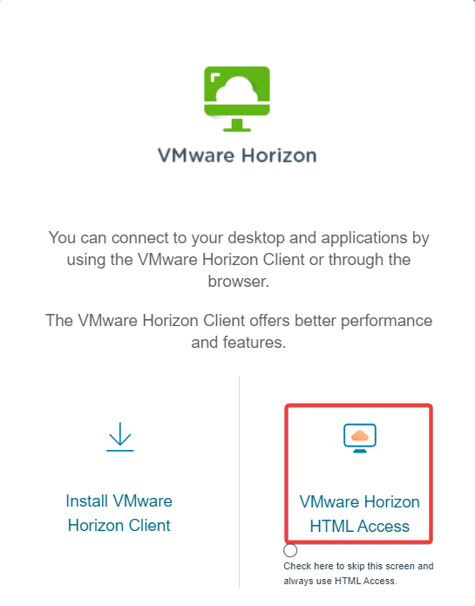

**Once you have selected VMWare Horizon HTML Access, you will be taken to the login screen, similar to Step 3 below.**

## **VMWare Horizon Client**

There are two ways to access the VMWare VDIs: VMWare Horizon Client app or the vdigateway website. If you have used Raiser’s Edge since the move to Affinaquest, you should be familiar with how to access VMWare.

***IMPORTANT!!!*** *Make absolutely certain that any documents that you want to work with are on Box. Once you are logged in to the VDI, be sure to log in to Box when it comes up.*

1. **In the Search field in the lower-left corner next to the start button, search for “VMWare” (without the quotes). Alternatively, if you have the following icon on your desktop, double-click it:**

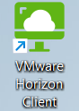

* 1. **Click the VMWare Horizon Client link in the *Best Results* section of the search window or click Open in the right column**
  2. **If there is a green VMWare icon in the taskbar, click it**

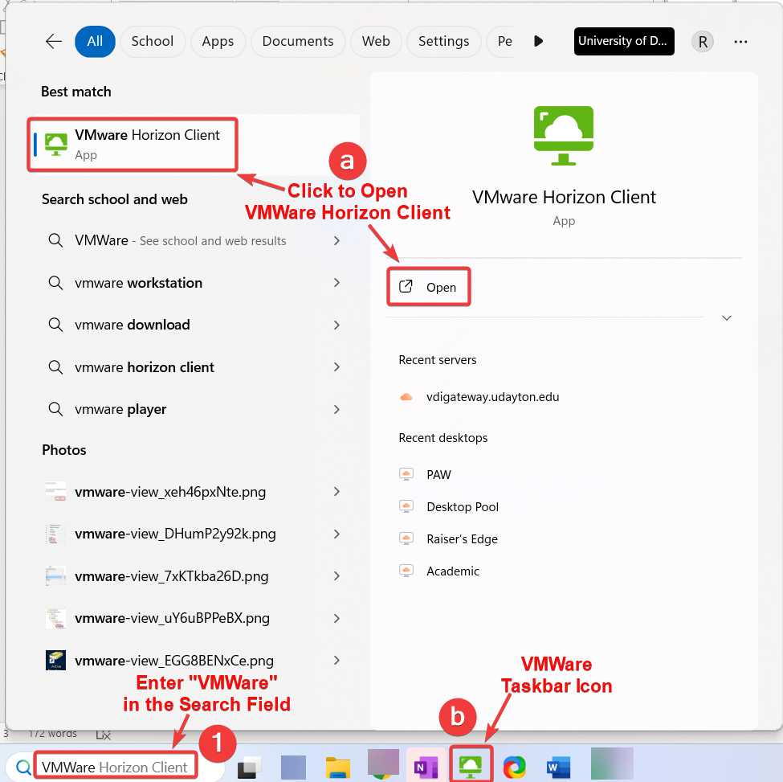

1. **Double-click the vdigate.udayton.edu option (which should be the only option available)**

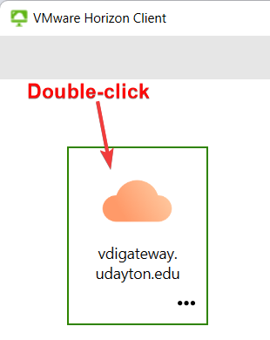

1. **Enter your UD username and password in their associated fields.**
2. **Click the Login button once it turns green**

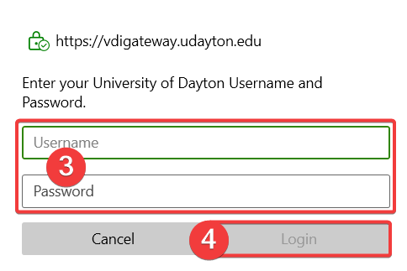

1. **Enter the number corresponding to how you receive a two-factor authentication request (“1” sends the push to your phone)**
2. **Click the Login button**

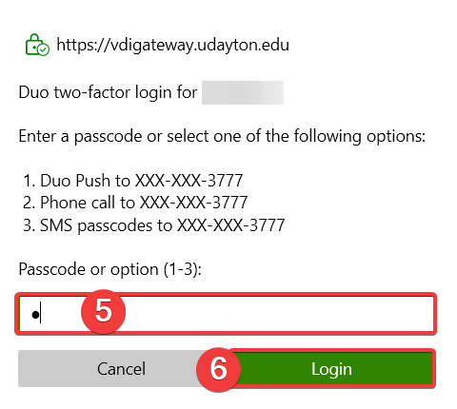

1. **Double-click the Desktop Pool VDI option**

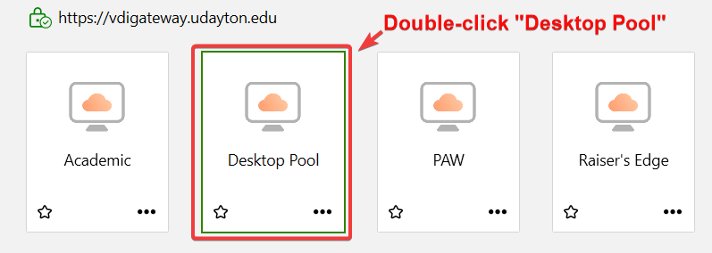

***NOTE: Your options of available VDIs will likely not look like this. You should have “Raiser’s Edge” and “Desktop Pool.”***

1. **Log in as you would your laptop or the Raiser’s Edge VDI with your UD username and password.**
2. **Once logged in, you should see a screen similar to the one below. Make sure you log in to Box when the login window comes up.**

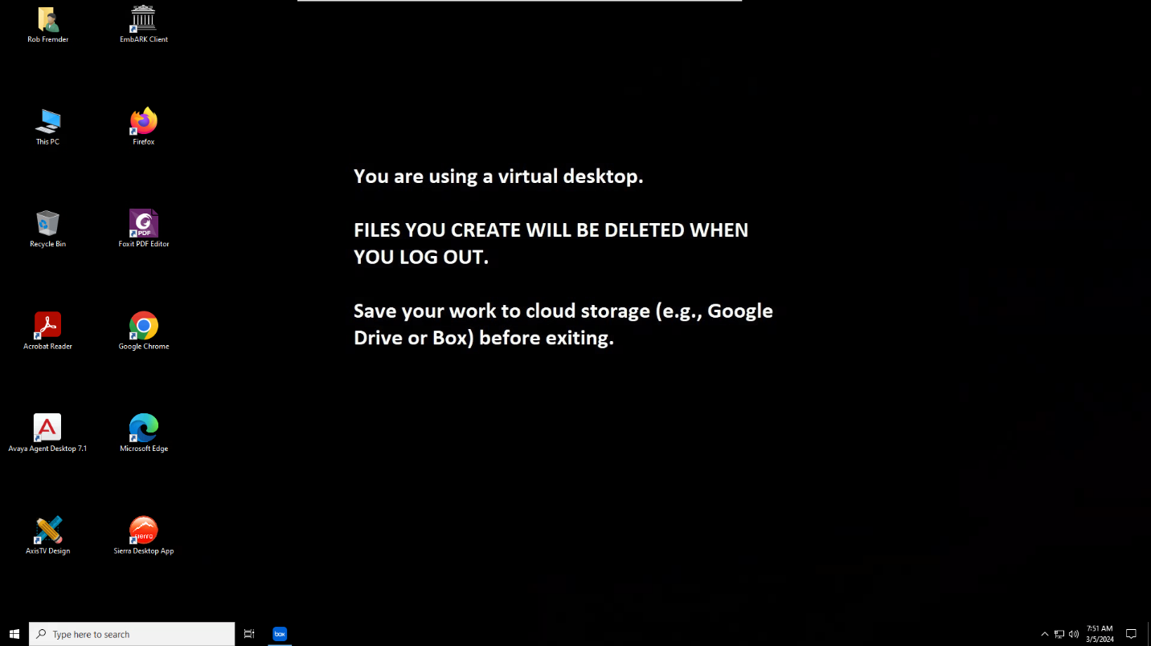

1. **Double-click the FoxIt icon on the desktop to open FoxIt PDF Editor**

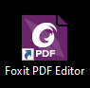

1. **Select Yes at this screen**

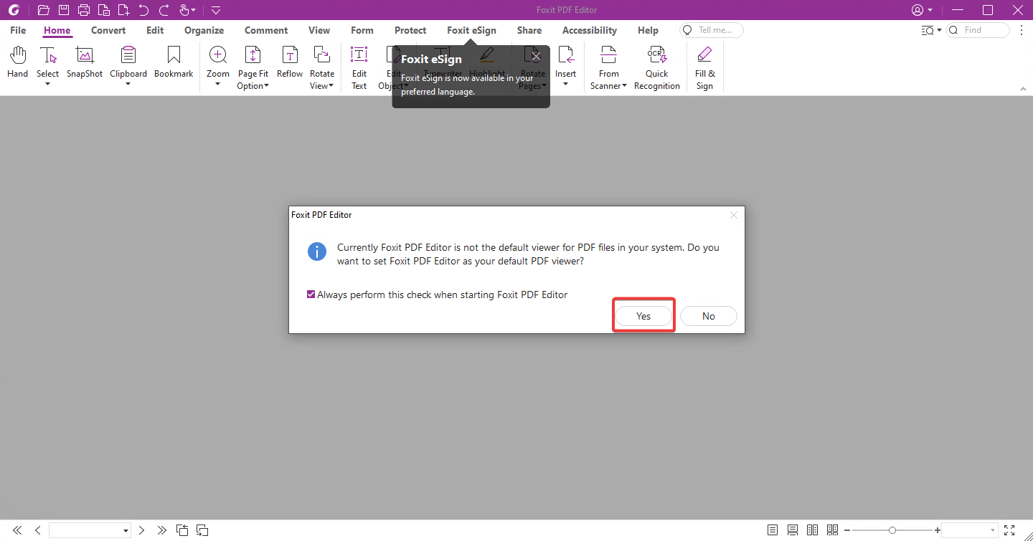

**The FoxIt screen will look similar to the following:**

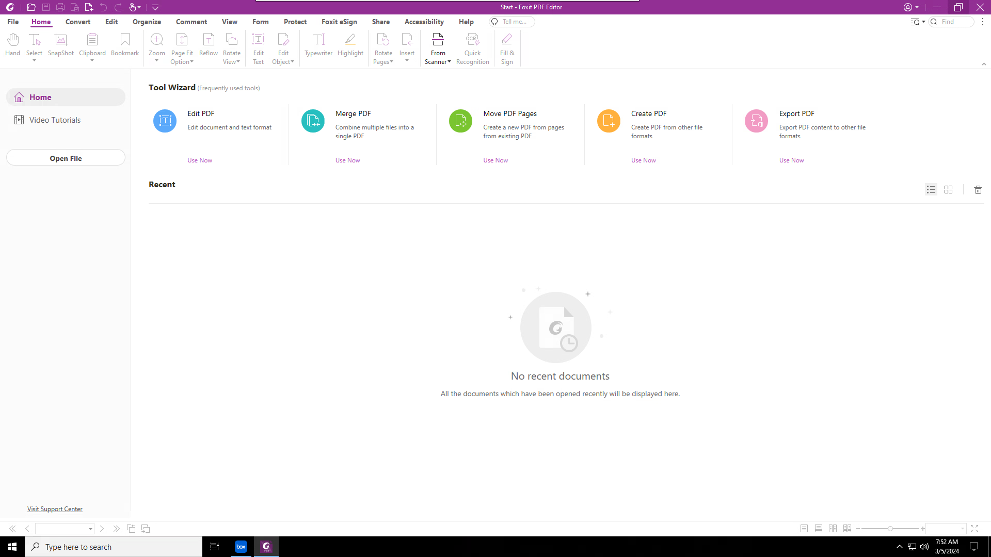

# **Access Desktop Pool VDI**

**This section is a continuation of the above accessing the Desktop Pool VDI through VMWare Horizon. That information is included in this document along with some processes that are good to know when using Foxit (instead of Adobe Acrobat Pro). Foxit PDF Editor is free for UD staff and faculty.**

**There is a wealth of information on using the features of FoxIt PDF Editor available at their website:** <https://www.foxit.com/support/tutorial.html>**. Additionally, UD-specific information is available at** <https://udayton.teamdynamix.com/TDClient/1868/Portal/KB/ArticleDet?ID=131651>**.**

## **VMWare Horizon Client**

There are two ways to access the VMWare VDIs: VMWare Horizon Client app or the vdigateway website. If you have used Raiser’s Edge since the move to Affinaquest, you should be familiar with how to access VMWare.

***IMPORTANT!!!*** *Ensure that any documents that you want to work with are on Box. Once you are logged in to the VDI, log in to Box when it comes up.*

1. **In the Search field in the lower-left corner next to the start button, search for “VMWare” (without the quotes). Alternatively, if you have the following icon on your desktop, double-click it:**



* 1. 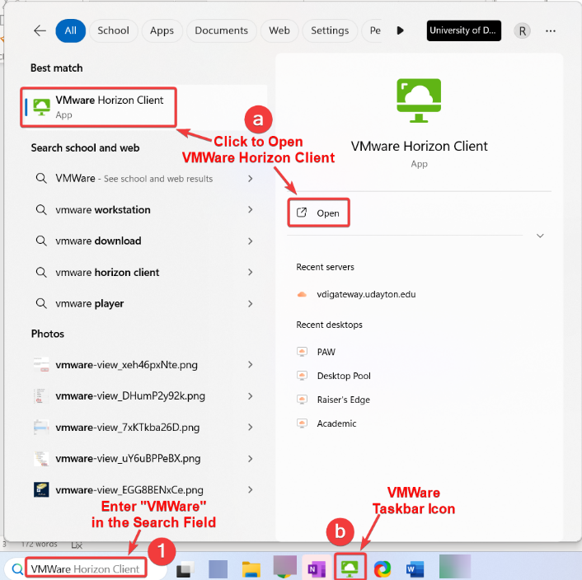**Click the VMWare Horizon Client link in the *Best Results* section of the search window or click Open in the right column**
  2. **If there is a green VMWare icon in the taskbar, click it**

1. **Double-click the vdigateway.udayton.edu option (which should be the only option available)**



1. **Enter your UD username and password in their associated fields.**
2. **Click the Login button once it turns green**



1. **Enter the number corresponding to how you receive a two-factor authentication request (“1” sends the push to your phone)**
2. **Click the Login button**



1. **Double-click the Desktop Pool VDI option**



***NOTE: Your options of available VDIs will likely not look like this. You should have “Raiser’s Edge” and “Desktop Pool.” If you do not have the “Desktop Pool” VDI option available, you will have to put a TDX ticket in to UD IT to request that it be added as an option.***

1. **Log in as you would your laptop or the Raiser’s Edge VDI with your UD username and password.**
2. **Once logged in, you should see a screen similar to the one below. Make sure you log in to Box when the login window comes up.**



1. **Double-click the FoxIt icon on the desktop to open FoxIt PDF Editor**



1. **Select Yes at this screen if you wish for Foxit to be your**



**The FoxIt screen will look similar to the following:**



## How to Merge Documents or Pages

There are a few ways to merge documents in Foxit PDF Editor. The supported commands are "drag and drop", Windows right-click menu, and the application built-in menus.

### Merge Documents or Pages by Dragging and Dropping

You can merge one or more files into an existing opened file.

1. Inside Foxit PDF Editor, open a PDF document that you want to merge other files into, open Pages navigation panel.
2. Browse your folder to locate a file or files, drag and drop them into the navigation panel.  
   ***NOTE:*** *the file type could be any supported files as listed below.*

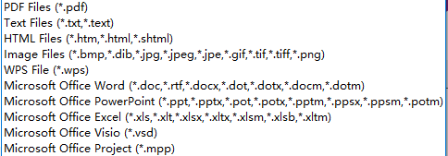

You can also merge only part of pages in an opened PDF document into another opened PDF document. Here is how to do that:

1. In the current opened document, for example say a.pdf, open Pages navigation panel.
2. Open the other PDF document where you want to extract pages from. Open Pages navigation panel, click to select a page or press "ctrl+ mouse click" to select multi-pages, drag and move your cursor to the tab name as a.pdf that you want to merge pages into (hold your mouse). You will notice your current tab is automatically switched to a.pdf.
3. Now, you are in the a.pdf document screen, move your cursor to the navigation panel, locate a position and release your mouse.

***TIP:*** *When your mouse is hovering over the pages down or up in the navigation panel, the pages will scroll down or up so that you can locate a desired place to drop your extracted pages.*

***NOTE:*** *"Merge documents/pages" feature in Foxit PDF Editor supports fewer document formats than "create PDF files" feature in Foxit PDF Editor.*

When you create PDF files from File tab > Create > From File within Foxit PDF Editor, you will find that it supports the following document formats:

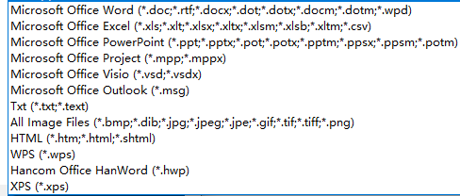  
Compared with the "Create PDF files" feature, the "Merge documents/pages" feature doesn't support the following document formats:  
*XPS(.xps);*  
*Hancom Office HandWord (.*hwp),*  
*Micrsoft Office Outlook(*.msg)*  
So when you drag and drop one of the above referred unsupported format documents into the navigation panel in Foxit PDF Editor, it won't be inserted into the currently opened PDF document, but it will be converted and opened as a new PDF file in Foxit PDF Editor.  
For the mentioned unsupported format document, you have to convert it into PDF file first before you are able to merge its converted PDF format document into another PDF file.

### Merge Documents by the Windows Right-Click Context Menu

1. Open Windows File Explorer.
2. Locate a folder, click to select a file or Ctrl + click to select multiple files, right-click the selections
3. Choose **Combine Files in Foxit PDF Editor**

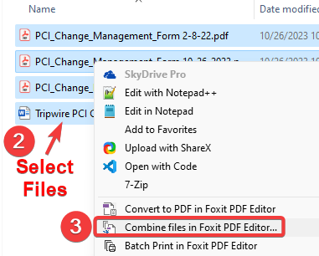

1. The Foxit PDF Editor program will open and display similar to the image below. Verify that the documents are selected correctly
2. Click the **Combine** button

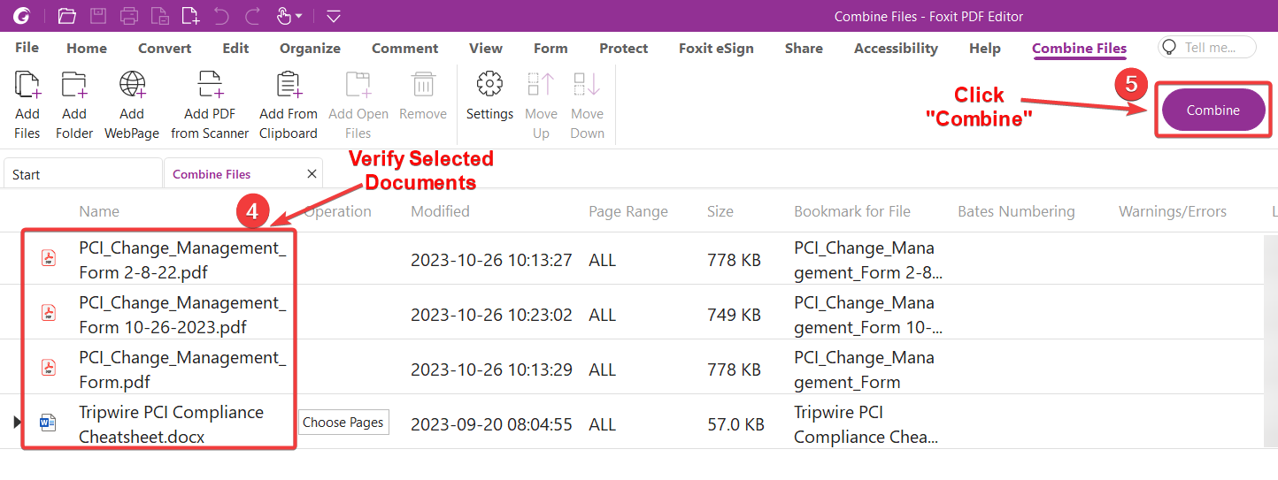

1. Once the combine operation has finished, your document should be displayed. Verify that everything looks correct.
2. To save the combined file, click **File** in the upper-left corner
3. Click **Save As**
4. Click the **Browse** button

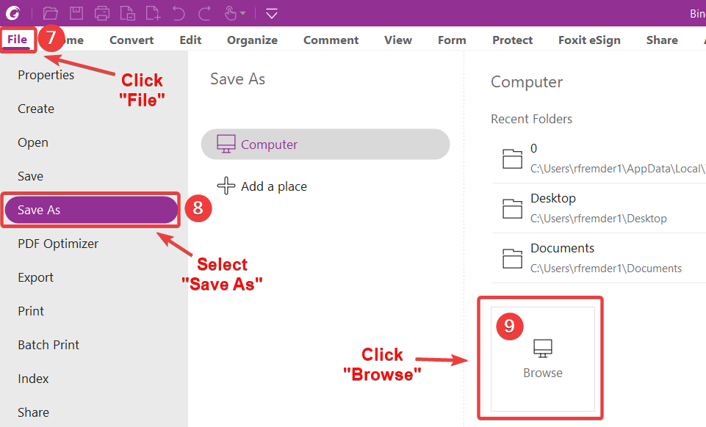

1. In the left-hand column, browse out to the location you wish to save the combined PDF
2. Enter a name for the file. Ensure that the *Save as type* is PDF
3. Click the **Save** button

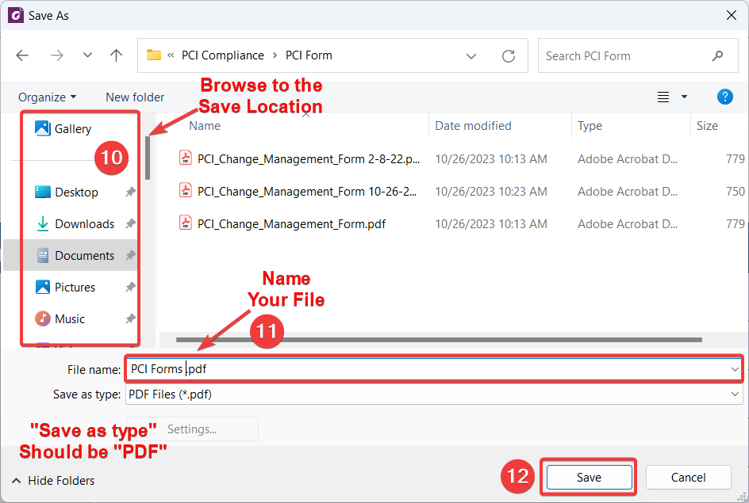

### Merge Documents by Application Menus

#### Use File > Create command

For Foxit PDF Editor 9.2 and above versions, please perform the following steps:

1. Inside Foxit PDF Editor, go to **File > Create** and select from the options. Click the corresponding button that appears to the right of the *Create* column. Depending on which selection you make, you will have different options. The following assumes “**From Multiple Files**”.
2. Click the **Add files...**button to choose one of the options <Add Files, Add Folder, or Add Open Files> to select the files you wish to combine. Click on the **Combine** button to complete the task.

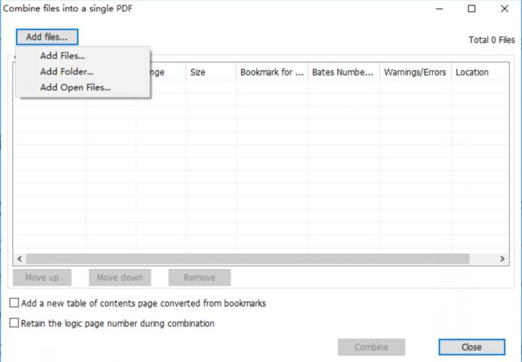

#### Use the Organize > Insert menu

1. Inside PDF Editor, open a file you want to merge pages into.
2. Go to **Organize > Insert** and choose one of the commands below to do merging.

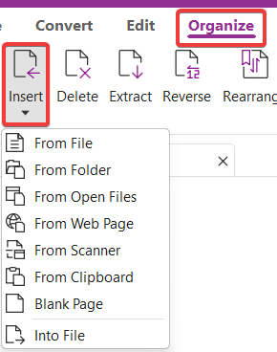

#### Use the Pages Right-Click Menu

1. Inside Foxit PDF Editor, open a file you want to merge pages into.
2. Open **Pages** navigation pane, right click on a page thumbnail where you want the merged pages to insert.
3. Choose **Insert Pages** and choose one of the commands below to do merging.

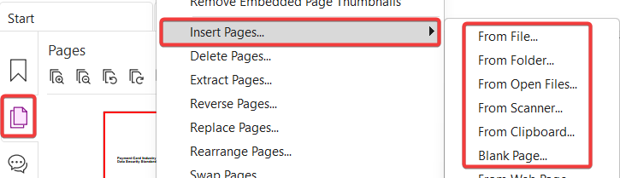

***NOTE:*** *The Merging PDF files feature is one of the advanced features and it is included in Foxit PDF Editor. If you can't find the****Create from Multiple Files****or the****Organize****menu in your Foxit PDF Editor, please go to****Help****>****About Foxit PDF Editor****to check if it has been downgraded to Express edition. If yes, please activate the software again to get the advanced features back.*

## Sign PDFs with Foxit PDF Editor/Reader

Foxit PDF Editor/Reader provides robust, secure and quick signature features, including digital signature, legally-binding eSignatures, ink signatures, and DocuSign. please try one of the following ways.

### Sign PDFs with Fill & Sign

The simplest way to simply sign a document is to create your own handwritten signature and sign a PDF. Follow these steps:

1. Choose the **Protect** tab >**Fill & Sign.**

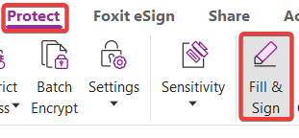

1. Click **+** in the signature palette to create signature.
2. In the *Create Signature* dialog box, you can draw a signature, import a file, copy from the clipboard, or type text content to create a signature. You may also click **Online** to choose a signature from online signatures that you saved previously.
3. Click **OK**. The cursor will be changed into a shape with the appearance preview of the signature. Place the cursor to the position you want to sign and click. If resize the signature is needed, please click on the signature to ensure it is selected and drag its lower-right corner handle of its surrounding rectangular box inward or outward to resize the selected signature.

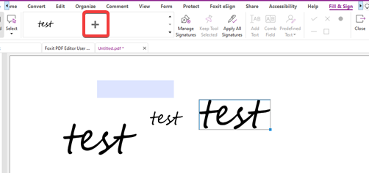

1. Right-click the newly added signature, choose the **Apply Signature** option in the pop-up context menu to apply the signature, or you may also choose to continuously add multiple signatures and then click on **Apply All Signatures** under the *Fill & Sign* tab to apply all signatures to document.

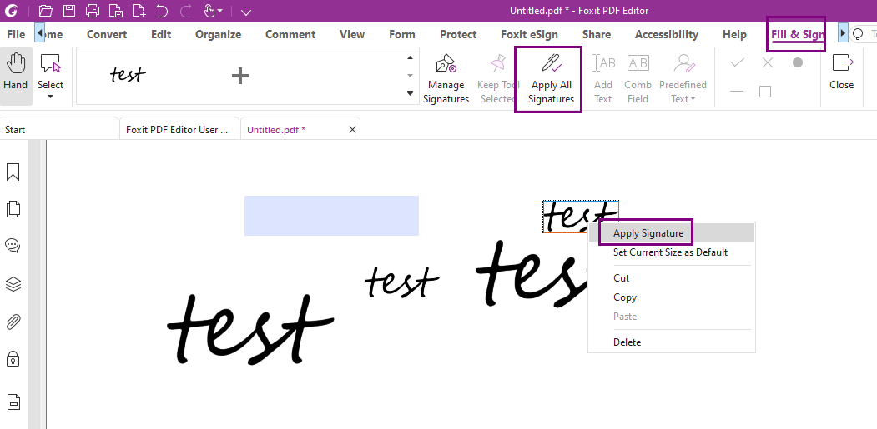

### Sign PDFs with Digital Signature

The following process allows you to not only sign the document but also encrypt it, if necessary. Before you sign a document, you will need to draw a signature field where the signature is placed, get a digital ID, and create the signature.

1. Choose Protect > Sign & Certify > Place Signature.

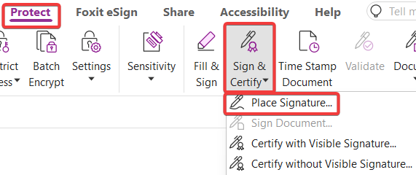

1. Press and hold the left mouse button down, and drag to draw a signature field for your signature.
2. In the *Sign Document* dialog box, choose a digital ID from the drop-down menu. If you can’t find the specified digital ID, you will need to get a certificate from Certificate Authority (CA) or create a self-signed digital ID. For how to create a self-signed digital ID, please refer to the following section for specificsteps*.*

#### Obtain Digital ID

Before you can add a digital signature to a PDF file, you need to get a digital ID, sometimes called a digital certificate. Certificates for digital signatures are normally issued by a trusted third-party provider called a Certificate Authority (CA), who are certified to do this. Ordering certificates from Certificate Authority often costs money depending on the type of certificate you need.

However, you can make your own digital ID with Foxit PDF Editor. Here are the steps on how to create a self-signed digital ID within the Foxit PDF Editor application:

Following from steps 1-3 in the previous section:

1. In the pop-up**Sign Documen**t dialog box, choose **New ID…**from the *Sign As* drop-down
2. In the *Add Digital ID*pop-up box, choose **A new digital ID I want to create now**
3. Click the **Next** button.

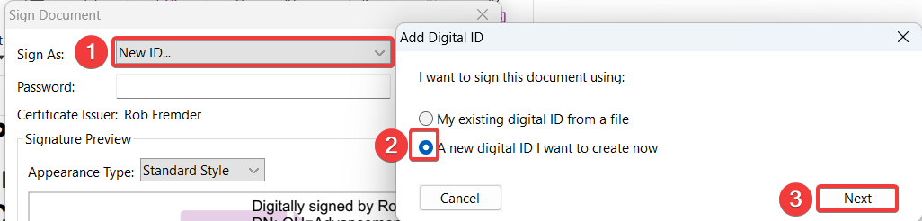

1. A new **Add Digital ID**dialog box appears asking you where you would like to store your self-signed digital ID. Please select a location to store the digital ID. If you select **New PKC#12 Digital ID file** item, the Digital ID will be stored on your computer in .pfx format. If you select the item **Windows certificate store**, the Digital ID will be stored in the Windows Certificate Store.

***IMPORTANT!!!*** *If you select the Windows certificate store, the certificate is valid only on that computer. When you get a new one, you will have to go through this process again. If you select the PKC#12 option, the certificate is a file (saved to your documents) that will go with you to the next computer.*

1. Click the **Next** button

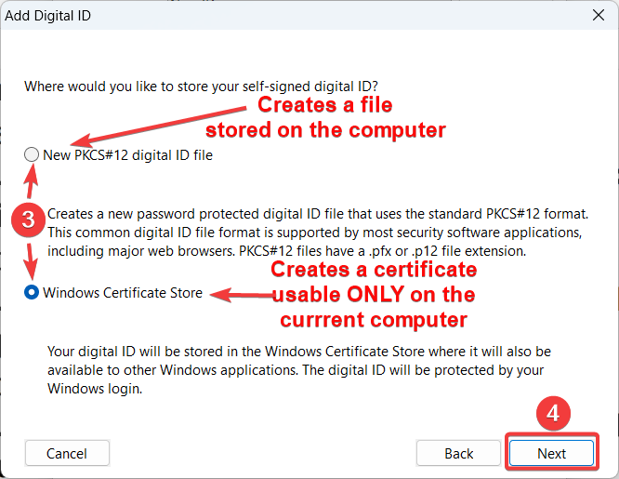

1. Enter your identity information such as name, organization unit, e-mail address, etc. to use when generating the self-signed certificate. For stronger encryption, select 2048-bit RSA in the **Key Algorithm** drop-down. In the **Use Digital ID for drop-down**, choose one option as needed.  
   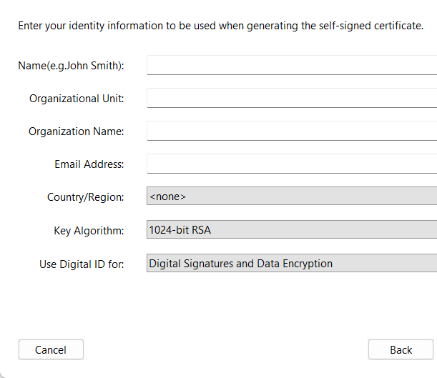
2. If you have selected the **Windows certificate store** item**,** just click the**Finish** button in the **Add Digitail ID** dialog box.  
   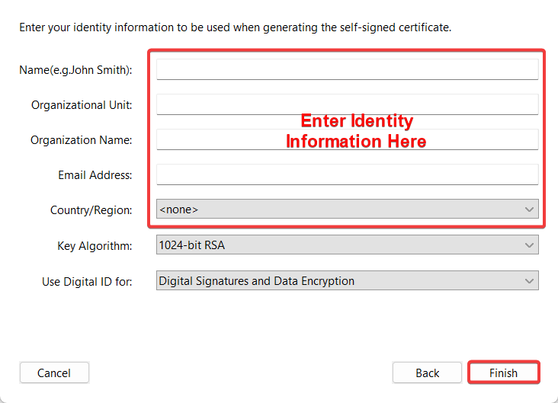
3. If you have selected the **New PKC#12 Digital ID file** item**,** click the **Next**button in the **Add Digitail ID** dialog box.

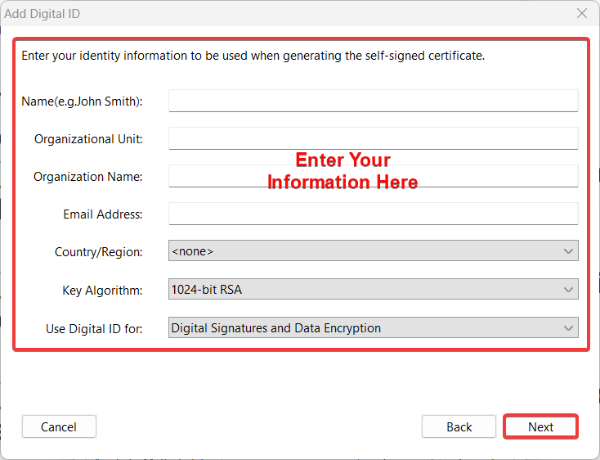

1. In the next screen, enter a file name, storage location and password for your new digital ID file. Confirm your password and click **Finish**.

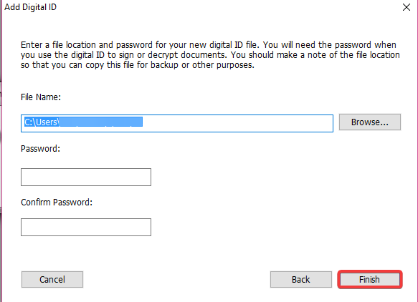

1. Finally, you will see the newly created Digital ID appears in the **Sign As** drop-down menu in **Sign Documen**t dialog box.

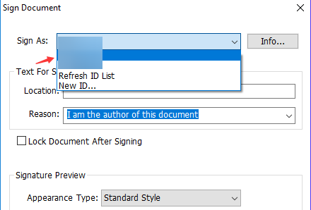

### Sign PDFs with Foxit eSign feature

Foxit integrated Foxit eSign into Foxit PDF Editor for Windows desktop since V11.2. The integration of best-in-class, easy-to-use eSignature capabilities with Foxit PDF Editor means that people can, for the first time, create, edit and sign legally binding documents without leaving their PDF editor.

For a quick look at how easily Foxit PDF users will be able to leverage all the benefits of eSign, you can view these short how-to videos: <https://www.foxit.com/PDF-Esign/>

For more details, please refer to Foxit eSign related Instructional Videos from [this](https://www.foxit.com/support/tutorial.html?tab=foxit-sign) page.

### Sign PDFs with DocuSign

To sign a PDF with DocuSign, you have to first follow [this](https://kb.foxit.com/hc/en-us/articles/4410103393044-How-to-obtain-DocuSign-plugin-) article to install the DocuSign plugin for Foxit PDF Editor.

1. Click **Help**in the ribbon near the top middle
2. Click the **About Foxit PDF Editor**option
3. Click the **Check for Update**… button

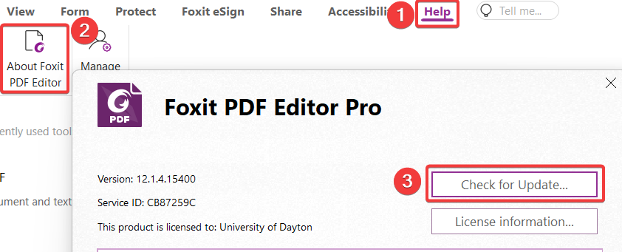

1. Place a check next to *Docusign* in the *Available Updates* pop-up window
2. Click the **Download and install** button to install the DocuSign plugin

Then refer to the following steps:

1. Open the PDF document you want to sign, click the Protect tab, and choose *DocuSign* > **Login to DocuSign**. Type your Email and password for DocuSign and click **Login**. If you do not have an account, please sign up first.
2. After signing in, choose *DocuSign* > **Sign with DocuSign**. The application will upload your PDF to DocuSign and you will enter into the DocuSign user interface.
3. Sign the Document*.*

# **Access Google Group Management**

**The purpose of this section is to explain how to connected to the Google Groups using your alternate login. In this case, we will log into the Alumni group management interface. It is advised that you use another web browser (or Chrome Incognito mode) such as Firefox or Edge to access this. In the following example, we will be using Firefox.**

## **Log-in**

**You can get to the Google group page in several different ways. The easiest of these is to go to the Google Groups page.**

1. **In the address bar, type groups.google.com and press the enter key on your keyboard.**
2. **Enter your Groups email address such as <username>@alumni.udayton.edu.**
3. **Click the Next button**

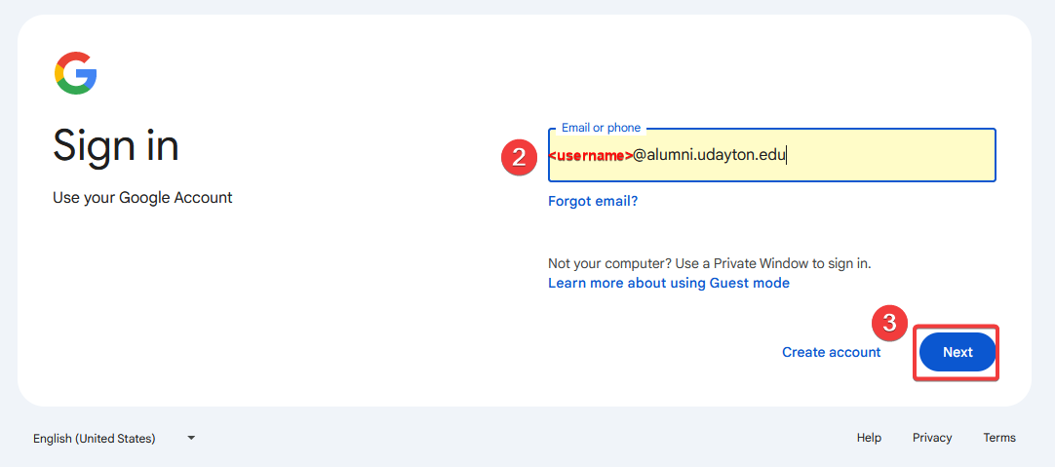

1. **Enter your password in the field  
   *NOTE: This password is NOT tied to your regular UD credentials, so you will have to manage it separately.***
2. **Click the Next button**

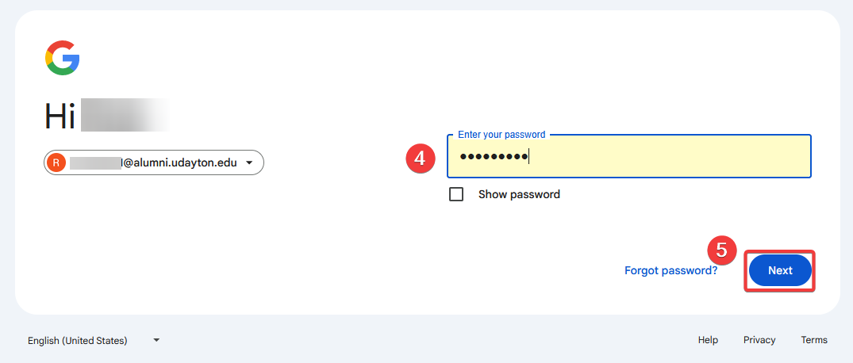

1. **The default view should be the *My groups* listing. Here you will see all the groups that you are a member of and can manage. The next section goes into more detail on how to manage Google Groups.**

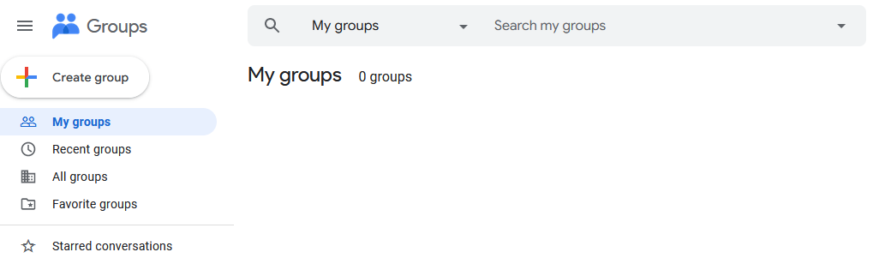

## **Manage**

1. 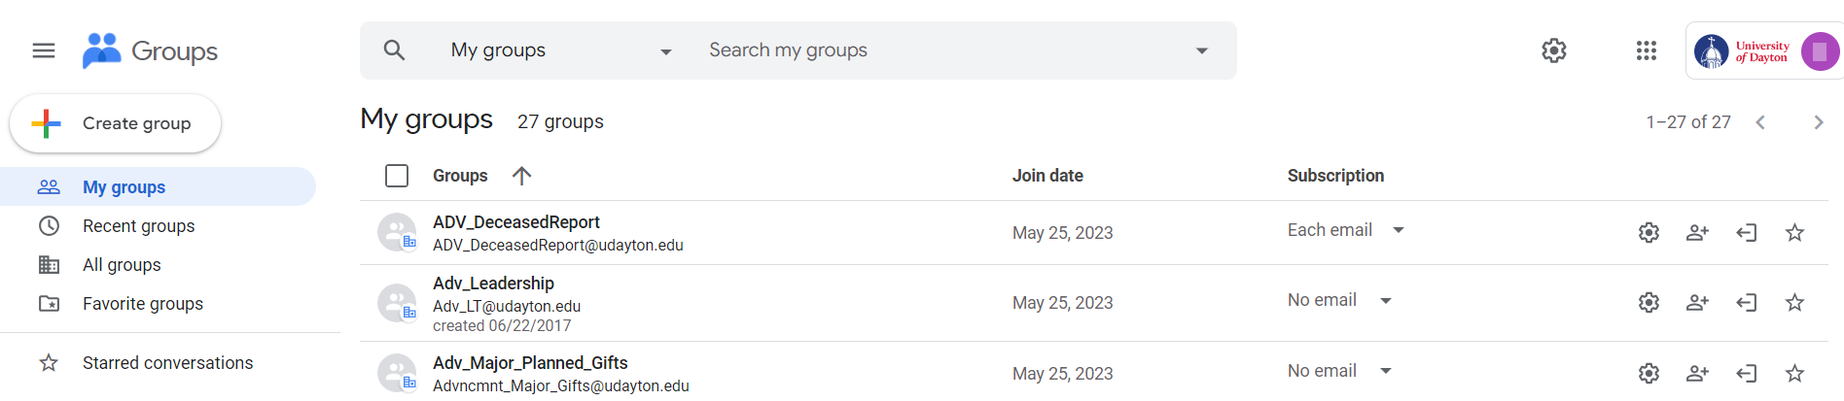**Enter the following URL into the address bar of your favorite web browser (we hope it’s Google Chrome):** <https://groups.google.com>**. Once you enter that web address, you should see a page similar to the following:**
2. **From this page, you can search for the group, scroll through the list, or you can select from All groups, Recent, Favorite, or groups that you own.  
   *NOTE: The simplest option is to click My Groups which only shows groups which you have access to and control of.***
3. **Once you narrow down the list of groups, you will notice four icons on the far-right side.**



1. **Click the**  **Add Member icon**
2. **Begin typing the person’s name that you wish to add to the group on the *Add Members* screen. Once their email address comes up, click to select them.**

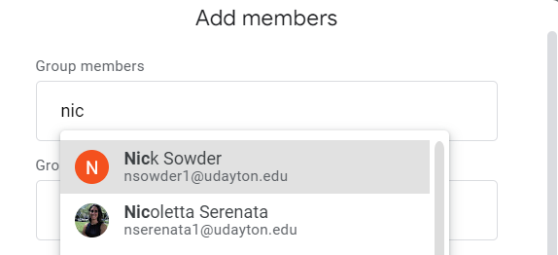

1. **You have the option to send a customized message (1,000-character limit), choose how they receive email from the group (the default *Each email* is preferred).**
2. **Leave the *Directly add members*** option toggled on (blue)
3. Click **Add Members**

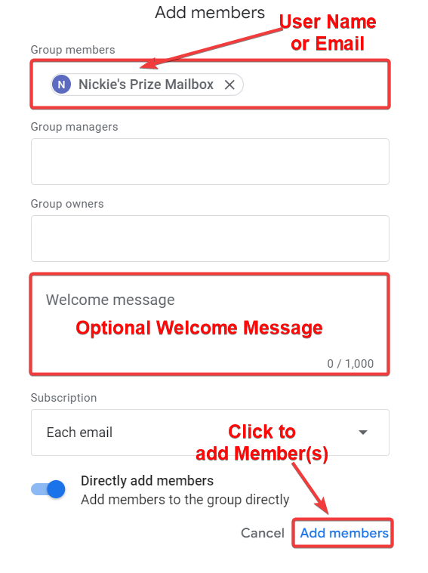

1. **You will be returned to the previous page where you can click the mailbox’s name to verify that the user was added.**

# **Add User to Google Group That You Own**

**The purpose of this section is to show how to add a person to a Google email group that you own and have control over. This assumes that you know how to use a web browser and enter a web address into the address bar.**

1. **Enter the following URL into the address bar of your favorite web browser (we hope it’s Google Chrome):** <https://groups.google.com>**. Once you enter that web address, you should see a page similar to the following:**
2. **From this page, you can search for the group, scroll through the list, or you can select from All groups, Recent, Favorite, or groups that you own.  
   *NOTE: The simplest option is to click My Groups which only shows groups which you have access to and control of.***
3. **Once you narrow down the list of groups, you will notice four icons on the far-right side.**



1. **Click the**  **Add Member icon**
2. **Begin typing the person’s name that you wish to add to the group on the *Add Members* screen. Once their email address comes up, click to select them.**



1. **You have the option to send a customized message (1,000-character limit), choose how they receive email from the group (the default *Each email* is preferred).**
2. **Leave the *Directly add members*** option toggled on (blue)
3. Click **Add Members**



1. **You will be returned to the previous page where you can click the mailbox’s name to verify that the user was added.**

# Advancement Video Conference: Community

This section provides instructions on how to use the Crestron video conferencing system in the **Community** conference room.

## Use the Room Computer

1. 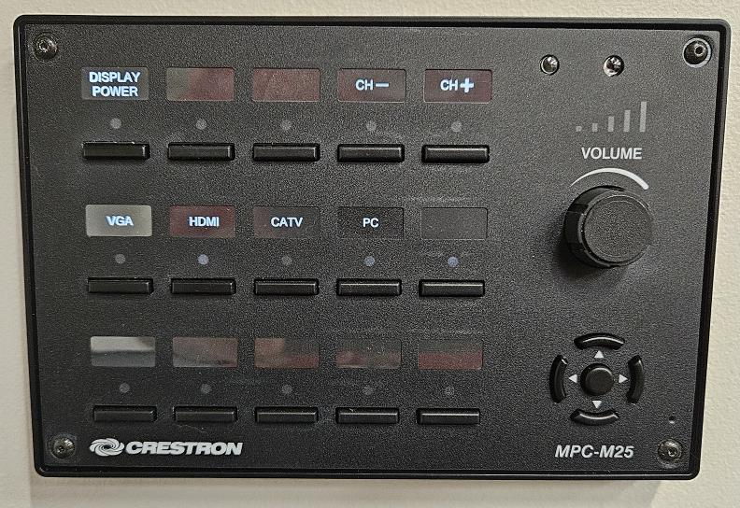The Video control panel is on the wall to the right as you walk into the room. *(Fig.1)*

***Figure 1*** *– Wall Mounted Control Panel*

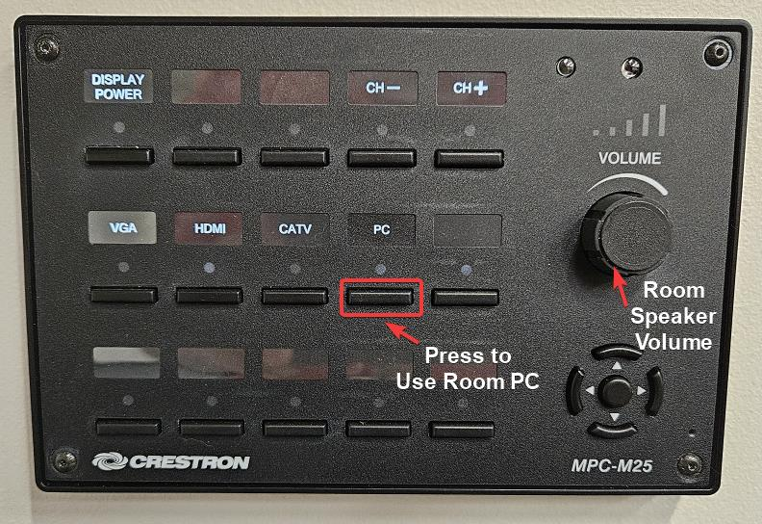

1. Press the button under *PC* to use the room computer (mounted to the back of the TV). The red LED will light up to let you know you are in PC mode. (*Fig. 2*)
2. If they aren’t already on the conference room table, collect the Logi (Logitech) keyboard and mouse from the top of the cabinet.

***Figure 2*** *– Control Panel: Select PC*

1. Slide the power switch in the upper-right corner of the keyboard to the right to power it on. *(Fig. 3)* Turn the mouse over and slide its power switch to “On”. (*Fig. 4*)

|  |  |
| --- | --- |
| ***Figure 3*** *– Keyboard Power On* | ***Figure 4*** *– Mouse Power On* |

1. By now, the TV screen should be displaying the familiar Windows logon screen. Log in with your UD username and password as you would normally do on your laptop.
2. Log in to Box with your UD email address. You will be asked to do two-factor authentication.
3. Double-click the **Zoom** shortcut on the desktop. Click **SSO** and log in that way (again, two-factor authentication).
4. Open your meeting presentation from Box and proceed as normal. The computer is set to automatically use the room video and speakers. When the meeting adjourns be sure you:

* Close Zoom
* Sign out of Windows: right-click the Start Button and hover over *Shut down or sign out*. Select **Sign Out** from the list.
* Turn the keyboard and mouse off. Place them back on the cabinet.

## Use Your Own Laptop

Unless the room computer isn’t working and ADV IT isn’t available to reboot it, we advise against using your laptop. The video conferencing capabilities of the room will be limited if your laptop is used.

1. Press the button under *HDMI* on the control panel. (*Fig. 5*) The red LED underneath it will light up to show it is selected.

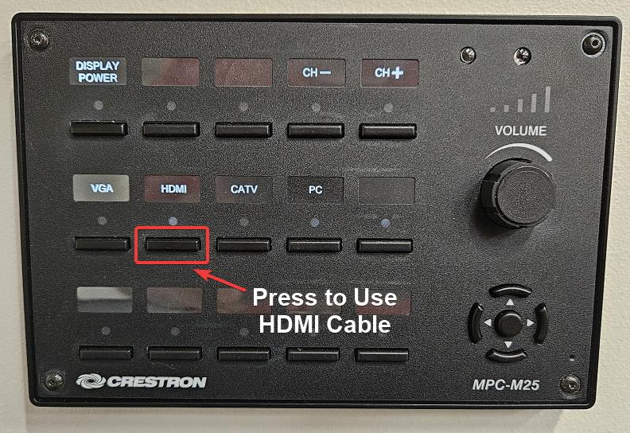

***Figure 5*** *– Select HDMI*

1. Connect the HDMI cable *(Fig. 6)* on the desktop to the HDMI port of your laptop (for best results, do this with your laptop powered off)

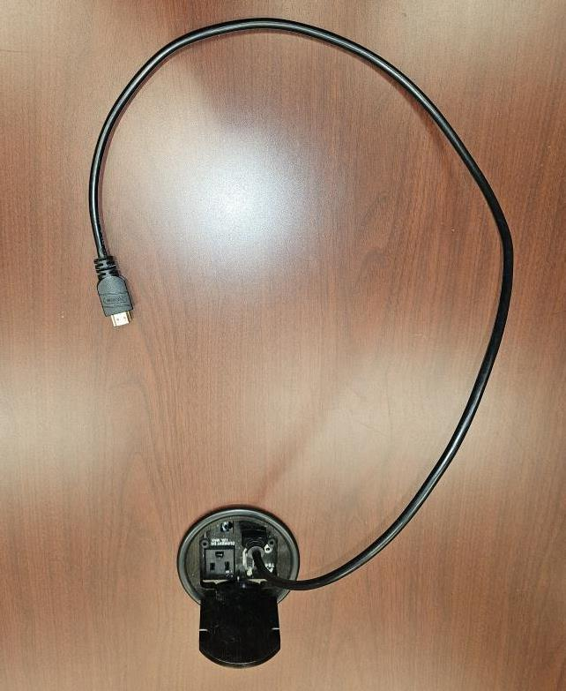

***Figure 6*** *– HDMI Cable*

1. Power on the laptop and log in as you would normally do.
2. Your screen will be duplicated on the TV. If you wish to extend your desktop, press the “Windows key” + “P” key at the same time.
3. Select **Extend** from the menu that appears on the right side of the screen. (*Fig. 7*)

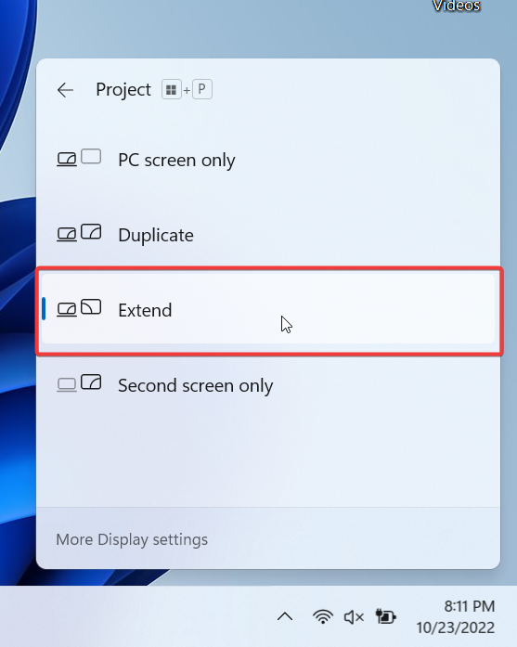

***Figure 7*** *– Extend Display*

1. Perform all the steps required to hold your meeting (i.e., open Zoom, start your presentation, etc.). Once finished, disconnect the HDMI cable. The TV can be powered off using the remote, but this isn’t necessary as it will go into sleep mode after a time.

# Advancement Video Conference: Generosity

This section guides you in using the Crestron video conferencing system in the **Generosity** conference room. It starts with powering on the Crestron system, using the room computer with audio/video, briefly discussing advanced display controls, covering how to use your laptop along with the room audio/video, and shutting the system down when finished. There is also a brief section on troubleshooting Zoom when the room audio/video isn’t working as expected.

## Power on the System

1. The Video Screen control is on the table. Touch the screen once and it will light up. *(Fig.8)* Touch it again to get to the main menu. *(Fig. 2)*

***Figure 8*** *– Power on Screen*

1. 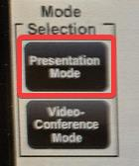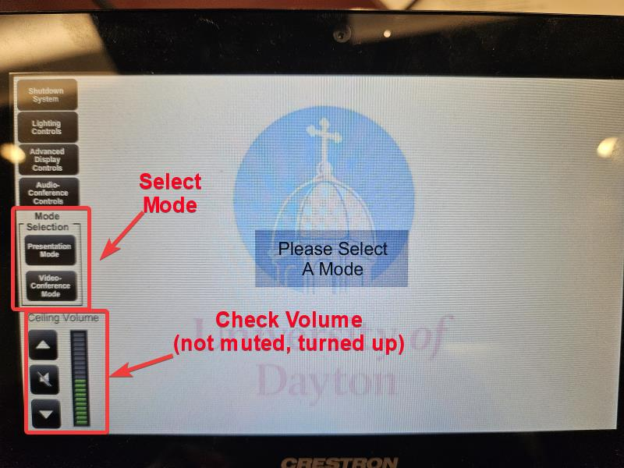Select a mode on the left-hand side under *Mode Selection* (*Fig. 9*). Select **Presentation Mode** *(Fig. 10)* to present from the room computer. Ensure the volume is not muted and is turned up halfway or slightly more.

***Figure 10*** *– Select Presentation Mode*

***Figure 9*** *– Mode Selection Screen*

1. Select **Table Box HDMI** from the *Please Select A Source* section.
2. Select **PC1** to use the room speakers and camera.
3. Select **Projector** to project to the screen. *(Fig. 11)*. This will wake up the ceiling projector and lower the video screen. Select **Flat Display** to send the video to the wall-mounted flat-screen TV.
4. Once you can see the screen, log in with your UD username and password. Log into Box if you need to access files from there. Run the Zoom meeting from that computer.

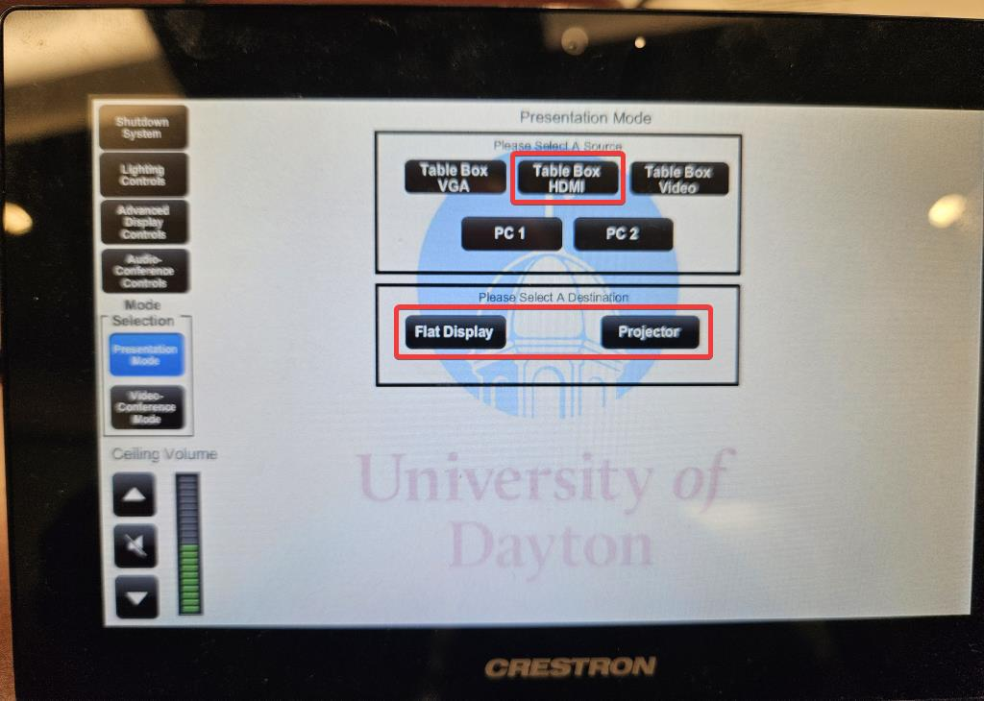

***Figure 11*** *– Presentation Mode Screen*

***NOTE:*** *The projector screen will take a moment or two to warm up.*

## Advanced Display Controls

Advanced Display Controls should only be used if you wish to use the flat panel TV to duplicate the conference room video (not recommended). The room speaker volume is accessible from the main screen.

1. From the main screen, click **Advanced Display Controls** in the upper-right corner *(Fig. 12)*

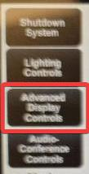

***Figure 12*** *– Select Advanced Display Controls*

1. The following options are available *(Fig. 13)*:
   1. 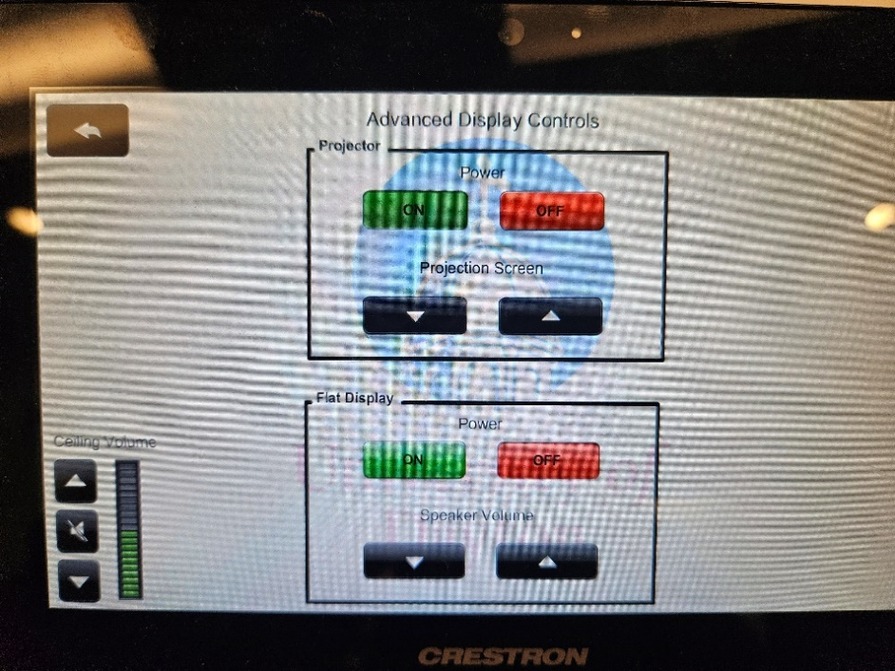**Projector**: turns the power to the projector on and off and allows the projection screen to be raised or lowered.
   2. **Flat Display**: turns the flat screen TV on.
   3. **Ceiling Volume**: allows the room speaker volume to be adjusted up or down or mute/unmute.

***Figure 13*** *– Advanced Display Controls*

## Presentation Mode (using your laptop)

Unless the room computer isn’t working and ADV IT isn’t available to reboot it in the server rack next to Amanda Nieman, we advise against using your laptop for a Zoom meeting. The video part of the conference room will not be available if your laptop is used.

We recommend you or someone else log into the room computer and run the Zoom conference there. This way, you can utilize the room's audio and video. From your laptop, you join the meeting as you normally would and share your presentation.

***NOTE:*** *To use the room speakers and video camera, you may have to run* ***Test Speaker and Microphone*** *by selecting that from the mic icon accessed by clicking the up arrow* ***^*** *in the lower left corner of the Zoom meeting window.*

1. Connect the HDMI cable *(Fig. 14)* on the desktop to the HDMI port of your laptop (for best results, do this with your laptop powered off).

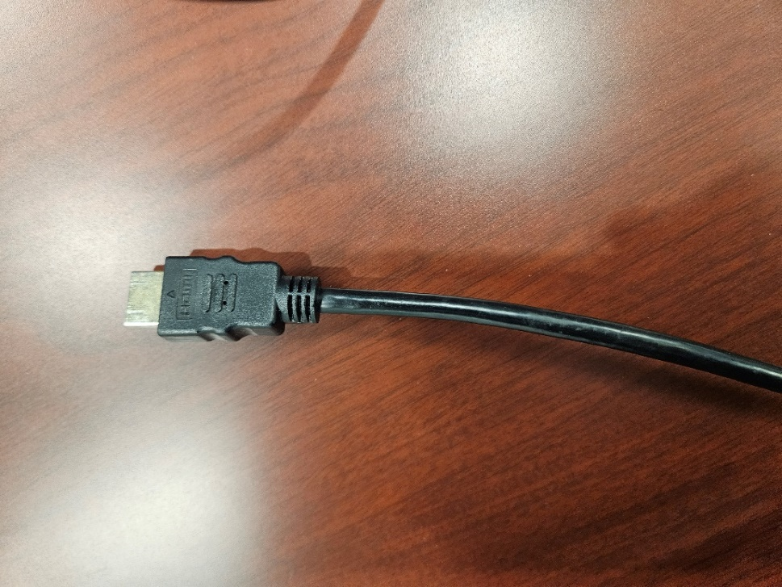

***Figure 14*** *– HDMI Cable*

1. Power on the laptop and login as normal.
2. On the Touch panel, select **Presentation Mode** *(Fig. 15)*

***Figure 15*** *– Mode Selection*

1. Select **Table Box HDMI** from the *Please Select A Source* section. (Select **PC1** to use the room speakers. Log in to the room computer with your UD username and password, when it displays. Run Zoom from that computer.)
2. Select **Projector** to project to the screen or **Flat Display** to send the video to the flat screen TV. *(Fig. 16)*



***Figure 16*** *– Presentation Mode Screen*

1. Select the “Windows” + “P” key and choose **Duplicate** to duplicate your laptop screen to the projector screen. Select **Extend** to make the projector a second screen.
2. 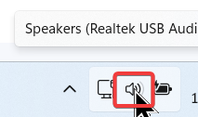***Optional:*** You may be able to point your laptop’s sound to the room speakers. Right-click the “speaker” icon (*Fig. 17*) in the lower-left corner of the screen. Alternatively, you can run **Test Speaker & Microphone** from Zoom Workplace.
3. 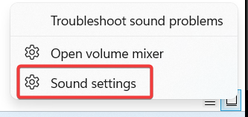Click **Sound Settings**.(*Fig. 18*)

***Figure 17*** *– Speaker Icon*

1. Under the *Output* section, select the Crestron speaker and close that screen.

***Figure 18*** *– Sound Settings*

## Sign Out of Windows

Once your meeting has concluded, and you are ready to leave, you will want to Sign Out of the room computer. Here’s how to do that:

1. Right-click the Start button.   
   ***NOTE:*** *It may be in the center of the taskbar at the bottom of the screen.*
2. Hover the mouse over *Shut down or sign out* so the flyout menu appears
3. Click on **Sign Out** (*Fig. 19*)

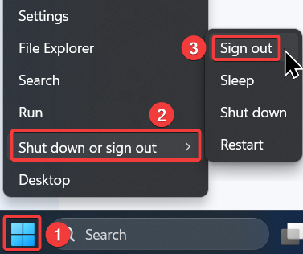

***Figure 19*** *– Sign out of Windows*

## System Shutdown

1. On the Touch panel, select **Shutdown System**.*(Fig. 20)*
2. 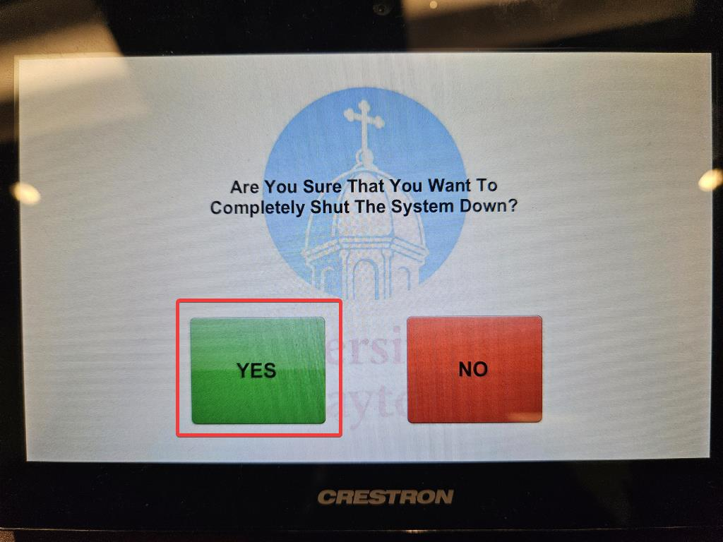Select **Yes** to confirm shutdown. *(Fig. 21)*

## Troubleshooting Zoom

***Figure 21*** *– Confirm System Shutdown*

***Figure 20*** *– Select Shutdown System*

This section offers some helpful tips should you find Zoom is not functioning properly.

### Check Your Device

* Check if the microphone, speakers, or headphones are plugged in and not muted.
* Unplug the device, then plug it back in.
* Ensure that no other applications are using the microphone at the same time.

There are two ways to join meeting audio: joining via computer or joining via telephone (not covered in this guide). Follow these sections to test your audio before or after joining a meeting.

### Test Audio Settings Before a Meeting

1. Sign in to the Zoom desktop client.
2. In the top-right corner, click your profile picture, then click **Settings**.
3. Click the **Audio** tab.
4. In the **Speaker** section, click **Test Speaker** to play a test tone.
5. If you cannot hear it, select a different speaker from the drop-down menu or adjust the **Volume.**
6. In the **Microphone** section, click **Test Mic** to test your microphone.   
   Your audio will start recording and you will see the **Input Level** bar move when Zoom is detecting audio. The audio will play back. Select another microphone from the menu or adjust the input level as needed.

### Test Audio When Joining a Meeting

If you didn’t select **Join with Computer Audio**, you can test your speaker and microphone right before you enter a Zoom meeting:

1. When joining a meeting, click the **Test Speaker and Microphone** button.  
   The meeting will display a pop-up window to test your speakers.
2. If you don't hear the ringtone, use the drop-down menu or click **No, Try Another Speaker** to switch speakers until you hear the ringtone. Click **Yes** to continue to the microphone test.
3. If you don't hear an audio replay, use the drop-down menu or click **No, Try Another Microphone** to switch microphones until you hear the reply. Click **Yes** when you hear the replay.
4. Click **Join with Computer Audio** to exit the speaker and microphone test.

***NOTE****: During a meeting, you can also click the arrow icon next to****Mute****/****Unmute****in the meeting controls toolbar to choose a different speaker or microphone.*

# Block Spam Notifications

1. Click on the ***3 dots*** in the upper right-hand corner of your browser.

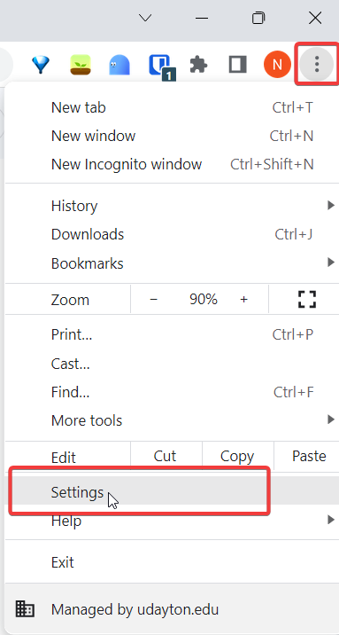

1. Click on ***Privacy and security***

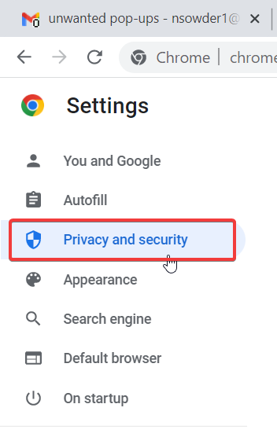

1. Click on ***Site settings***

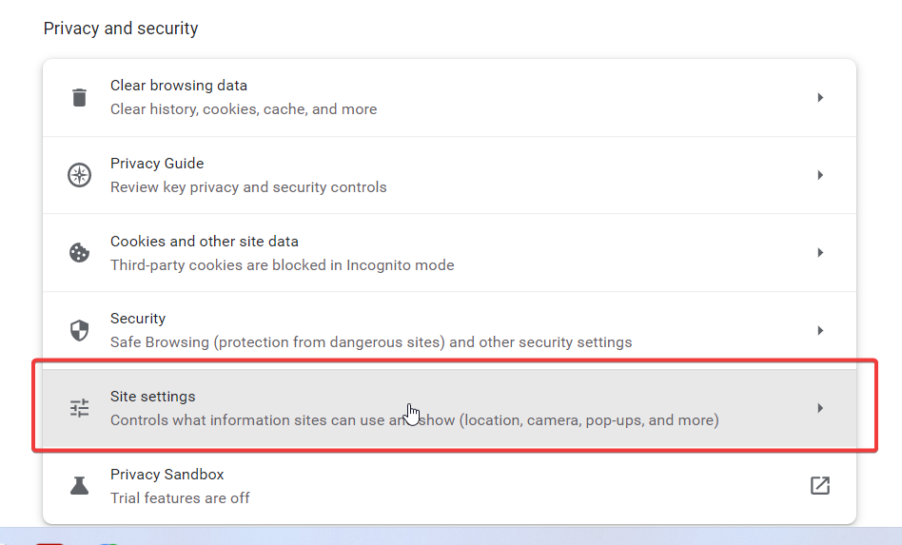

1. Under ***Permissions*** click on ***Notifications***

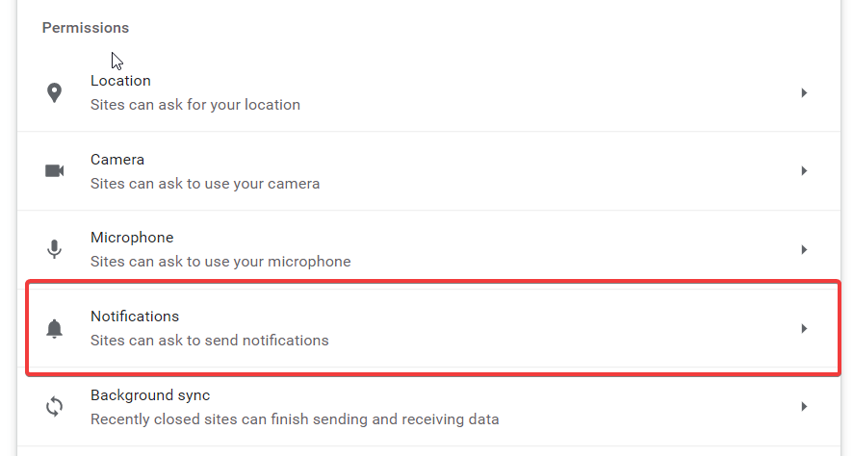

1. Under the ***Allowed to send notifications*** look for any websites listed that you do not recognize.
2. Click on the ***3 dots*** next to each site you do not recognize

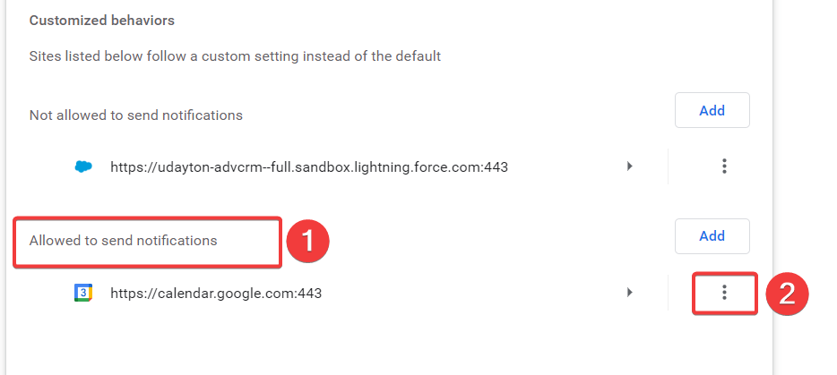

1. Select ***Block*** on each unfamiliar site

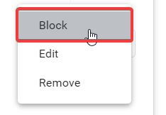

# Box File Version Recovery

The purpose of this section is to describe how to recover a corrupt, lost, or wrong version of a file that is on Box. If the file has been accidentally deleted, edited incorrectly, or you wish to return to a previous version, follow these steps to recover the document to a previous version.

1. Navigate to the box.com website through your favorite web browser (Google Chrome is recommended)

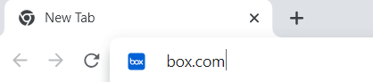

1. Log in using your UD username and password. Do the 2-Factor Authentication method of choice
2. Once inside the Box web interface in the *All Files* section, navigate to the folder in which the document resides

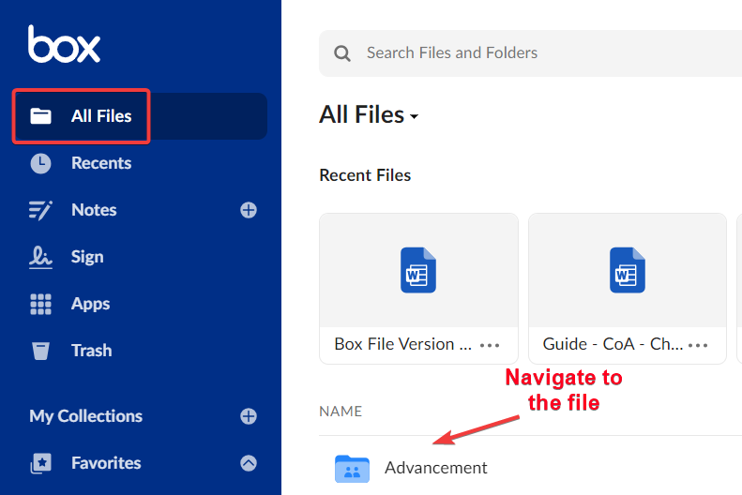

1. Once you have located the file, hover over the row to the far-right side and click the **Select** option

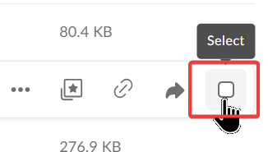

1. In the *Details* column on the right, scroll down and select the **N Saved Versions** option where “N” is the number of saved versions of the file

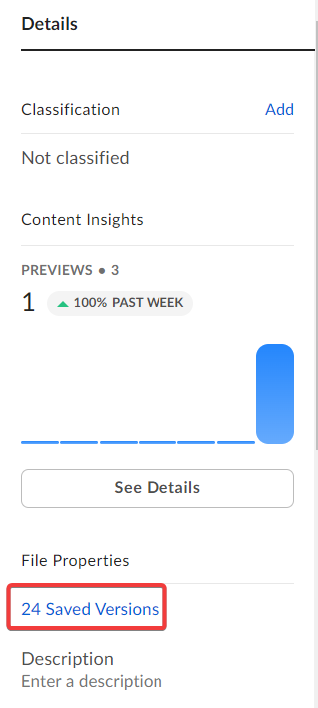

1. If you know the time and date of the version you want, click that version. Alternatively, you can view each file version to determine the one you require.
2. Once you have chosen the version you want, click the 3 horizontal dots at the end of the version in the *Version History* column and select **Make Current** to make that version the current version. You also have the option to download that version to another location.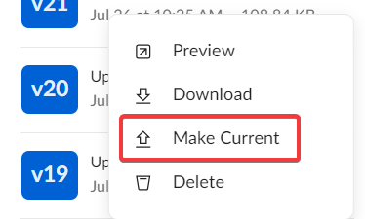

# Change Default Printer

1. **Open Settings.** You can use search to find it or right-click the Start button and select Settings.
2. Select **Bluetooth & devices** from the left column, and then **Printers & scanners** on the right.

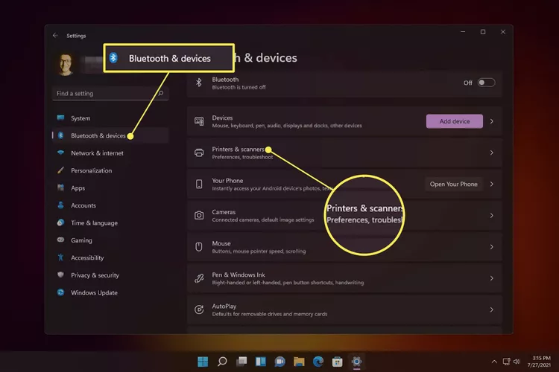

1. Find the option called **Let Windows manage my default printer**, and make sure it's toggled to the off position

. 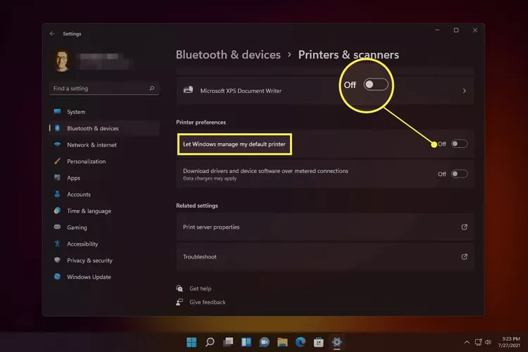

1. Scroll back up if you need to, and select the printer you want as default.
2. Select **Set as default**. The printer status should change indicating it is now the default printer.

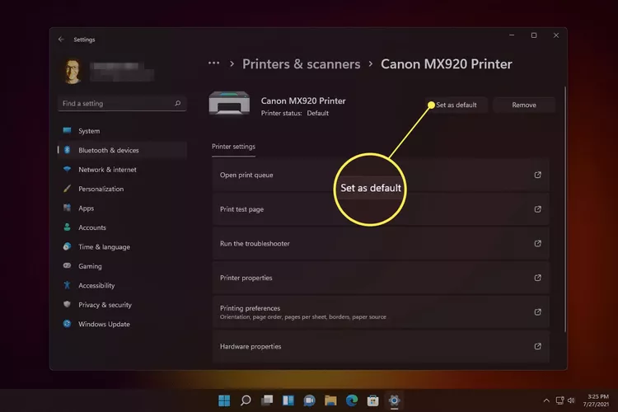

# Clear Cache and Cookies

1. Click the ***3 vertical dots*** in the upper right-hand corner of your browser
2. Select **Delete browsing data...**

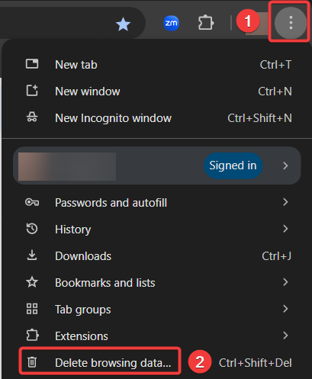

1. Select **All time** from the *Time range* drop-down
2. Ensure ***all 3 boxes*** are checked
3. 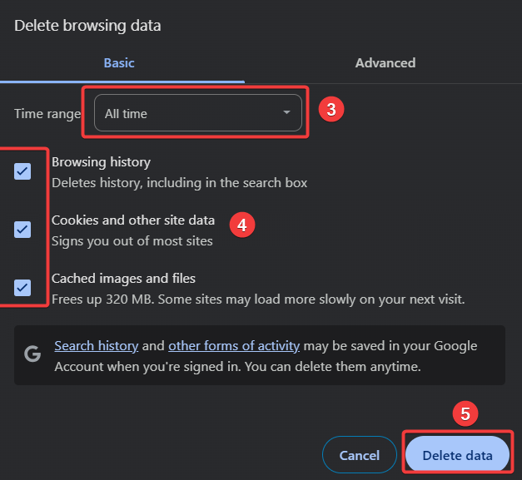Click **Delete data**

# Configuring Your UD-Owned Windows Device to Use Campus Printers

The directions below will allow you to send files from your UD-owned Windows computer to Multi-Function Devices (MFDs) across UD’s campus that provide print, copy, and scanning capabilities for University employees.

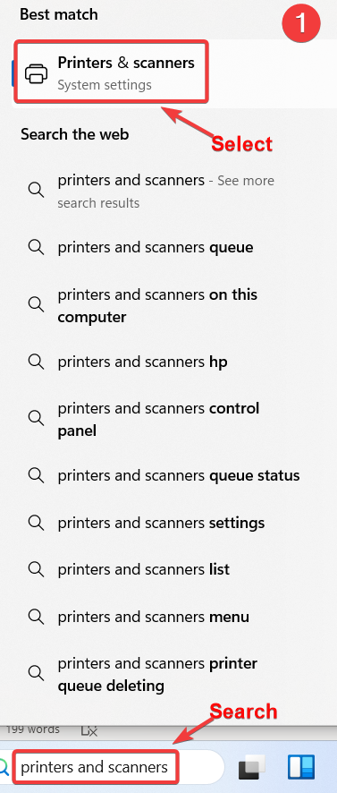**BEFORE YOU BEGIN:** Ensure you are **on campus** and connected to the UD network! This may also require Administrator privilege on the computer. If so, contact ADV IT.

1. On your Windows computer, search or navigate to **Printers & scanners**
2. Select **Add Device**. Windows will search (unsuccessfully) for printers and scanners.  
    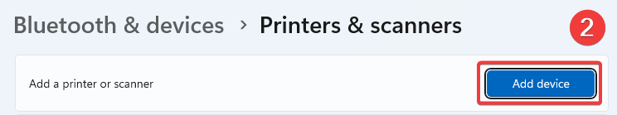
3. Select **Add manually**.  
    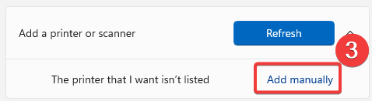
4. Select **Find a printer in the directory, based on location or feature**
5. Click **Next**.

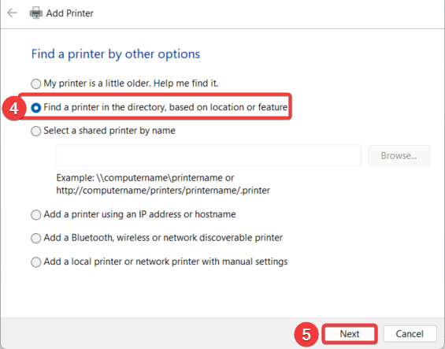

1. You’ll see a list of all campus printers by location.
2. Click the **In** drop-down list and choose **adws.udayton.edu**.
3. Click on **Find Now**.  
    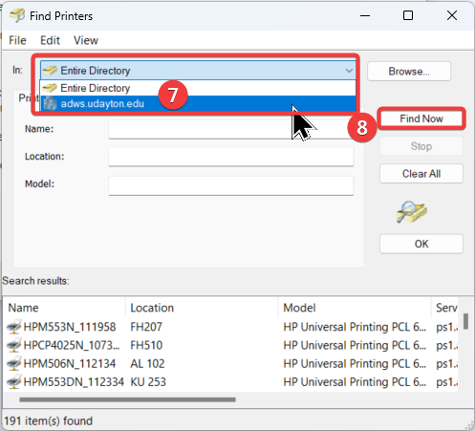
4. Double-click on either **FindMe_KM_greyscale** or **FindMe_KM_color**
5. Click **OK**. You’ll be prompted with a message saying "You've successfully added...".

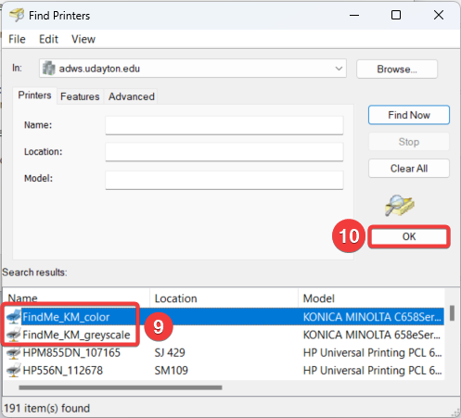

1. Click **Next**.  
   ***NOTE:****If you’re trying to add an HP printer, search for the printer based on its location.*
2. If you do NOT want the printer that you just added to be your default, uncheck **Set as the default printer**.
3. Print a test page and click **Finish**.

# Create a Google Contacts Group

In *Contacts*, you can organize your contacts in contact groups, using labels such as "sales" or "marketing".

**Create a Contact Group**

1. Go to [Google Contacts](https://contacts.google.com/).
2. On the left next to "Labels," click **Create label** .
3. Type a name, then click **Save**.

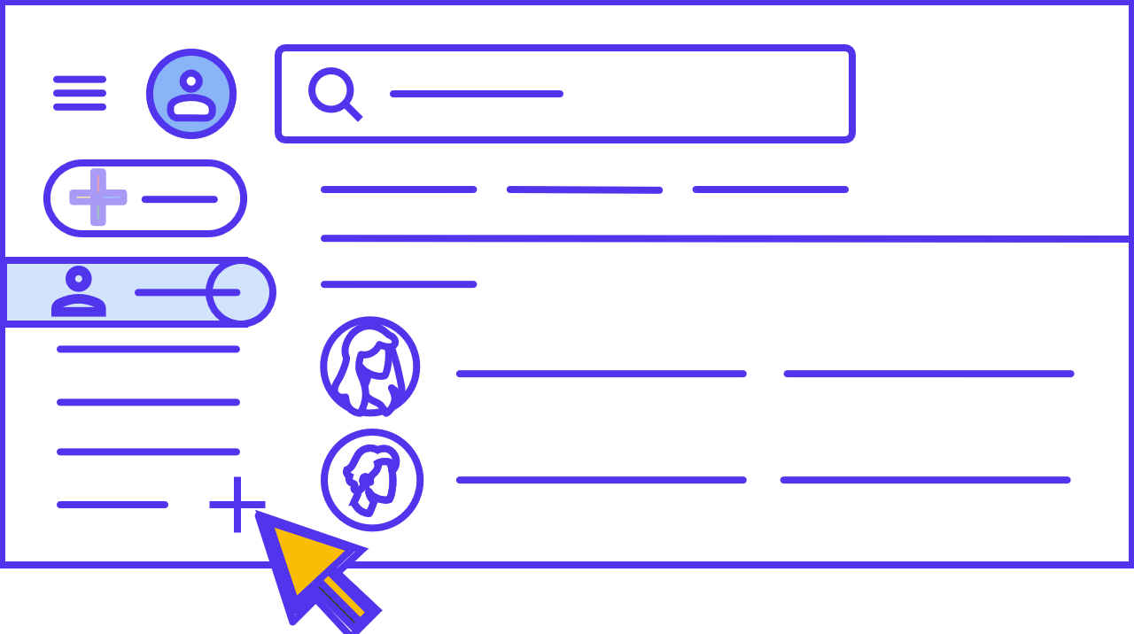

**Add Contacts to a Group**

1. Go to [Google Contacts](https://contacts.google.com/).
2. Select one of the following:
   * **A single contact:** Check the box next to the contact’s name.
   * **Multiple contacts:**Check the boxes next to all the contacts you want to add.
   * **All contacts:** Check the box next to any contact and in the top left, click **Selection Actions****All.**
3. At the top, click Manage labels .
4. Click the group label you want.
5. Click **Apply**.

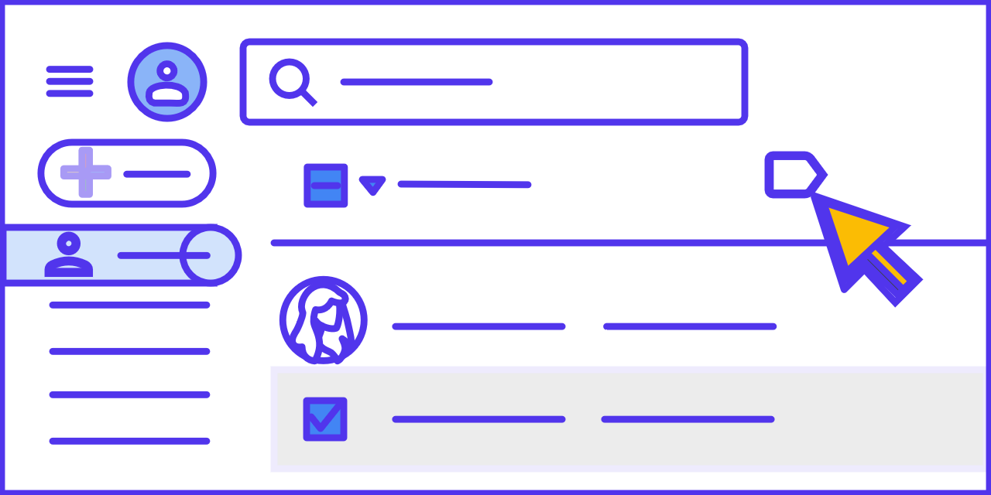***TIP:****If a contact has multiple email addresses, only their default email address is added to the label group. You can use the Contacts app  on an Android device to change the default email address for a contact.*

**Remove Contacts from a Group**

1. Go to [Google Contacts](https://contacts.google.com/).
2. At the left, click a group name.
3. Select contacts to remove by checking the boxes that show up next to their names.
4. At the top right, click Label .
5. Uncheck the group name.

# **Create a Taskbar Shortcut in Edge**

**Enter the website address** you want to create a shortcut to (for Papersave you can copy and paste the address from the shortcut link you currently have)

1. Click on  menu for options.
2. Hover on the **More Tools** option from the list.
3. Click on the **Pin to Taskbar** option.

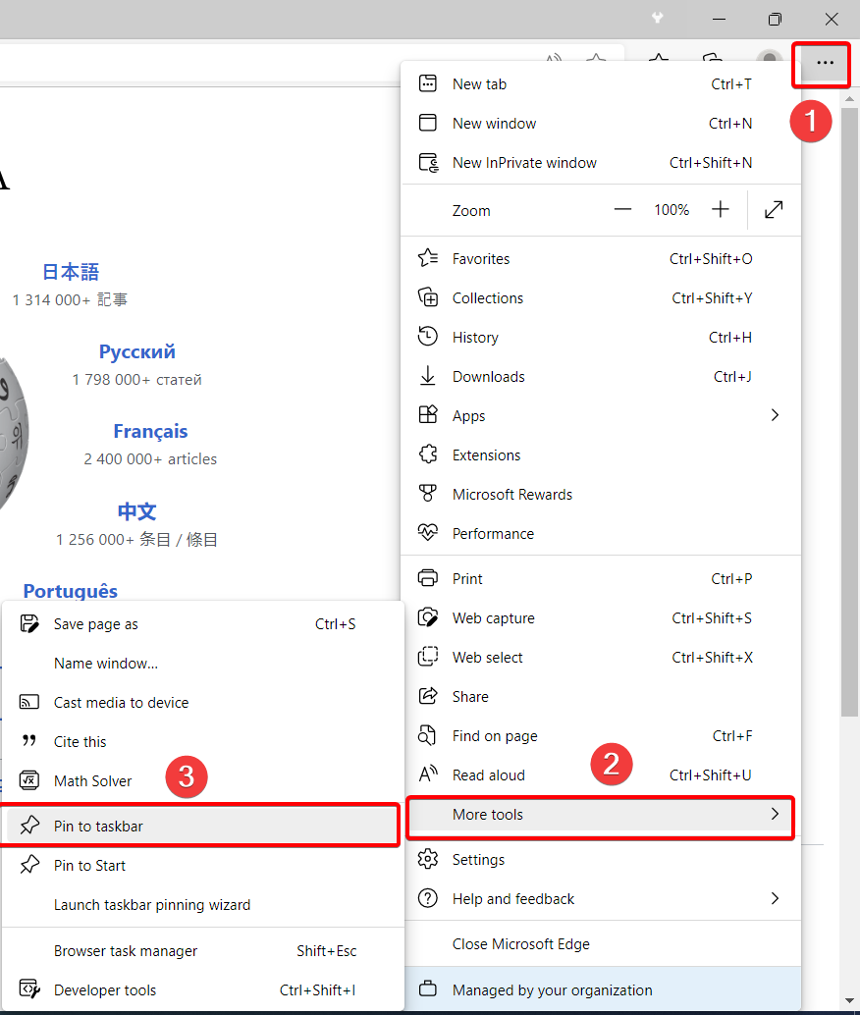

In this example I created a **Taskbar shortcut** for Wikipedia. Below you can now see the shortcut link to Wikipedia’s website on the bottom of my screen.



# Create an Email Filter in Gmail

1. Open [Gmail](https://mail.google.com/).
2. In the search box at the top, click the Show search options   icon.



1. Enter your search criteria.
2. To check that your search criteria will work correctly, see what emails appear by clicking **Search**.

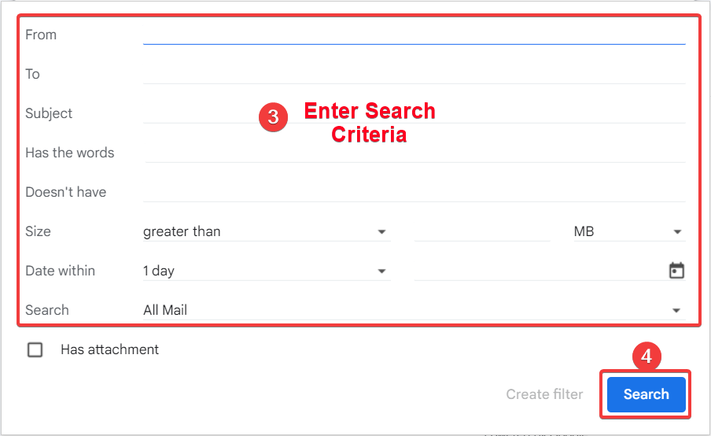

1. At the bottom of the search window, click **Create filter**.

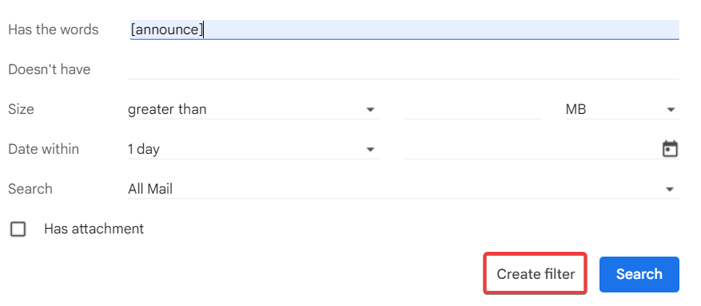

1. Choose what you’d like the filter to do.
2. Click **Create filter**.

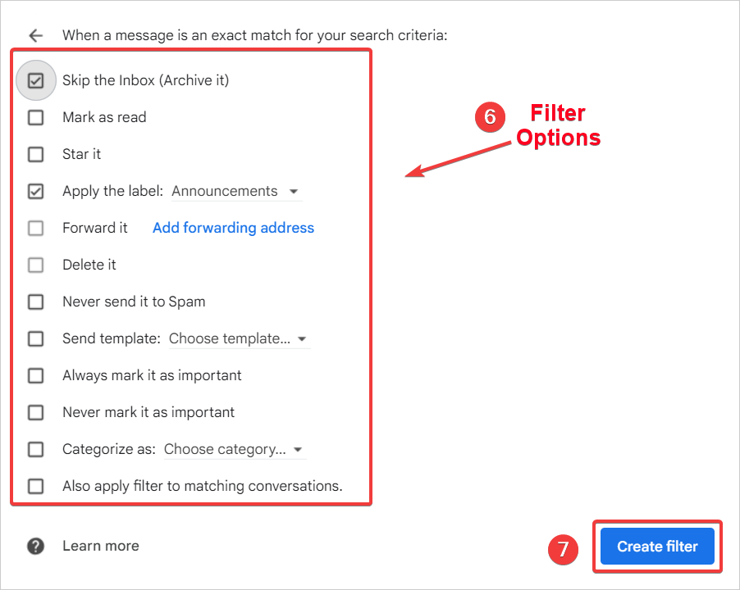

***NOTE:****Only new messages will be affected when you create a filter to forward messages. ​Additionally, when someone replies to a message you've filtered, the reply will only be filtered if it meets the same search criteria.*

**Use a particular message to create a filter**

1. Open [Gmail](https://mail.google.com/).
2. Check the checkbox next to the email you want.
3. Click More.
4. Click **Filter messages like these**.

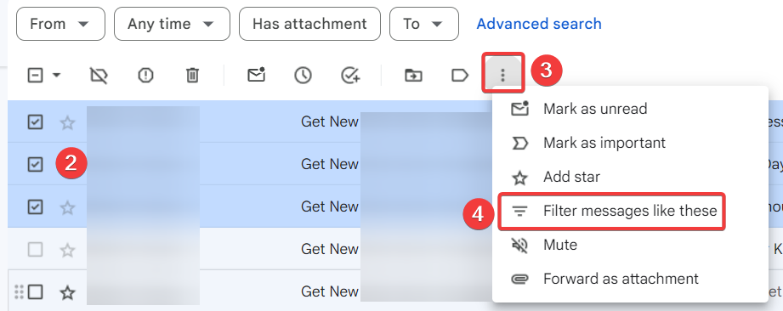

1. Enter your filter criteria.
2. Click **Create filter**.

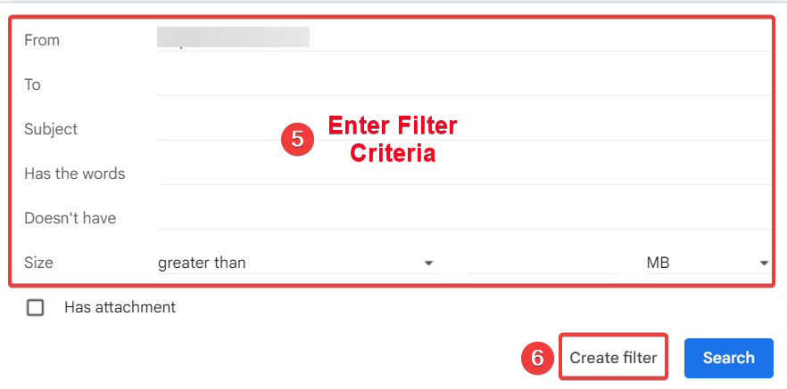

# Create Custom Paper Size for Printer

Enter a custom paper size in the printer server properties in *Windows Devices and Printers*.

1. Open **Print server properties**.
   * 1. Search for and open **Printers & scanners**.
     2. Scroll down, and then click **Print server properties**.

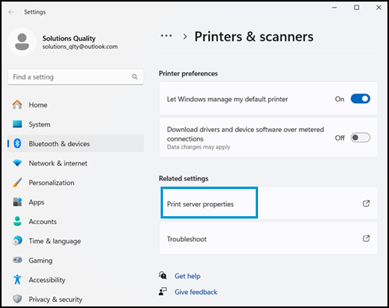

1. If the User Account Control window displays, click **Continue**.
2. On the **Forms** tab, select the **Create a new form** check box, and then type a new, unique name for the custom paper size in the **Form name** box.

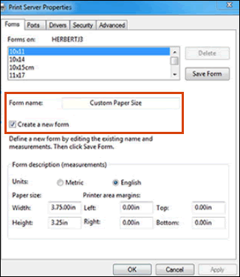

1. Select **Metric** or **English** as the measurement unit, and then enter **Width** and **Height** dimensions. Keep the margin settings at 0.00.
2. Click **Save Form**, and then confirm the paper is in the **Forms on** list. If your printer does not support the custom size, it does not display in the list. Check the printer specifications for supported paper sizes.
3. Click **OK** or **Close**.
4. Load the custom paper into the main tray, and then slide the paper width guides in until they rest against the edges of the paper.
5. Open the item you want to print, click **File**, and then click **Print**.
6. In the Print window, click **Preferences**, **Properties**, or **Printer Properties**.
7. Use one of the following methods to select your custom paper size:
   * Click the **Paper/Quality** tab, and then select the new custom paper size from the **Paper Size** menu.
   * Click the **Advanced** tab to find and select the new custom paper size.
   * Click the **Document** tab, and then select the **User Defined Size** from the **Paper Size** menu.

# Delegate Email Account

Whether you are leaving by choice or just taking an extended leave of absence, you should delegate your email account to someone. Typically, this is your manager/supervisor, but in the event of an extended absence, you could delegate it to someone in your department.

If you are leaving UD, complete this delegation process any time that is convenient prior to your departure. The following describes how to assign a delegate to your email account.

1. Click the settings gear from the main Gmail webpage
2. Click **See all settings**

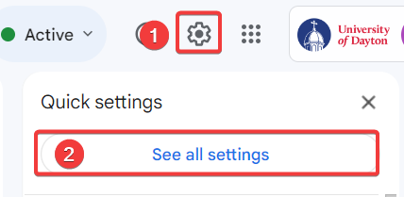

1. Click the *Accounts* tab

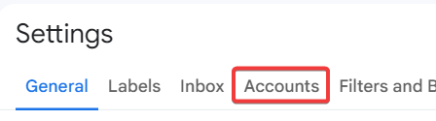

1. Click **Add another account** under the *Grant Access to your account* section

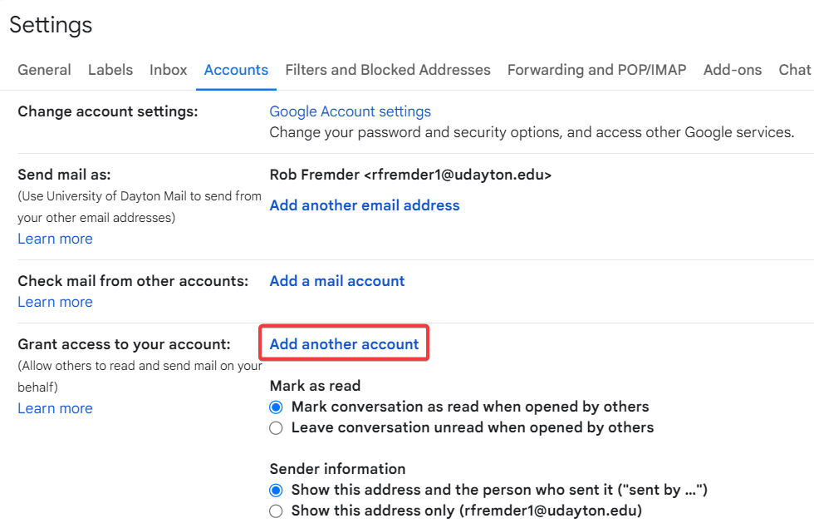

1. Enter the **Email address** of the person to whom your email account is to be delegated
2. Click the **Next Step** button

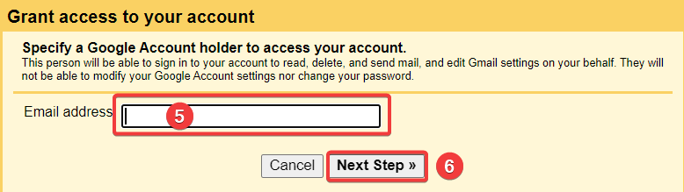

1. Click the **Send Email to grant access** button

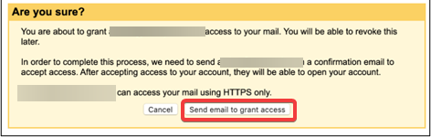

# Download a Zoom Recording

1. Navigate to go.udayton.edu/zoom and log in with your UD credentials.
2. Click on the ***Recordings*** tab.

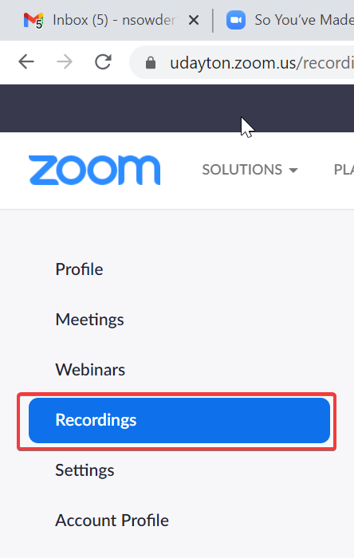

1. Find the video you wish to download in the list and click:

* Click **More** and then **Download**. This will start downloading your video.

***NOTE:*** This will most likely download the video file and an audio transcript file

**OR**

* Click on the link under the *File Size* column and continue the guide below if you don’t wish to download both files.

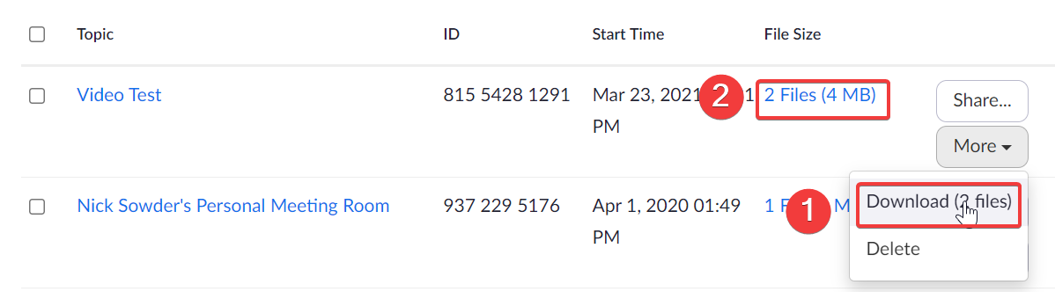

1. Click the link in the *File Size* column to be taken to the page shown below, from here you can choose to download the files individually.

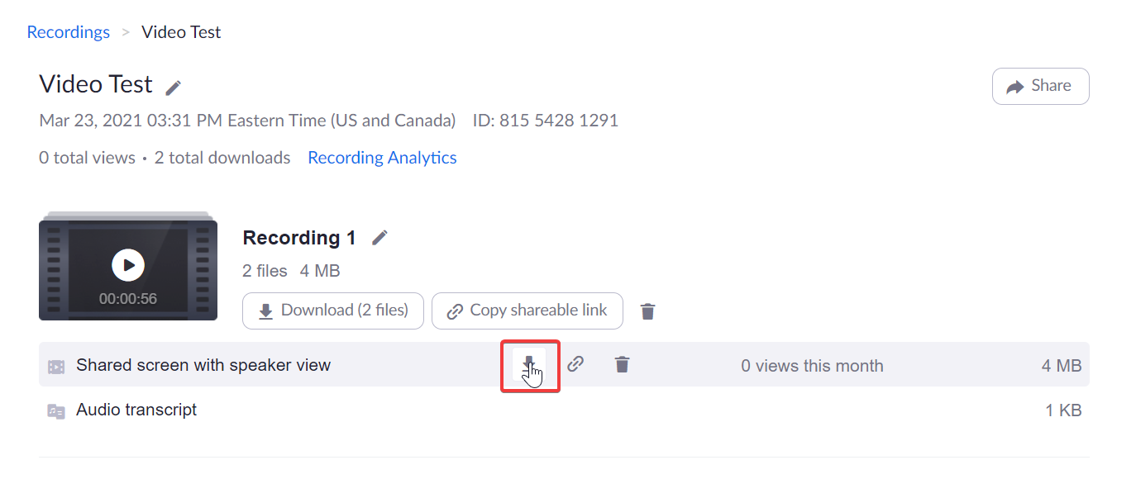

The video will be saved to wherever your browser stores downloaded content. Most of the time this will be the *Downloads* folder.

More information about Zoom video recordings can be found on their support site at <https://support.zoom.com/hc/en/article?id=zm_kb&sysparm_article=KB0067567>.

# Download and Install GlobalProtect VPN

1. 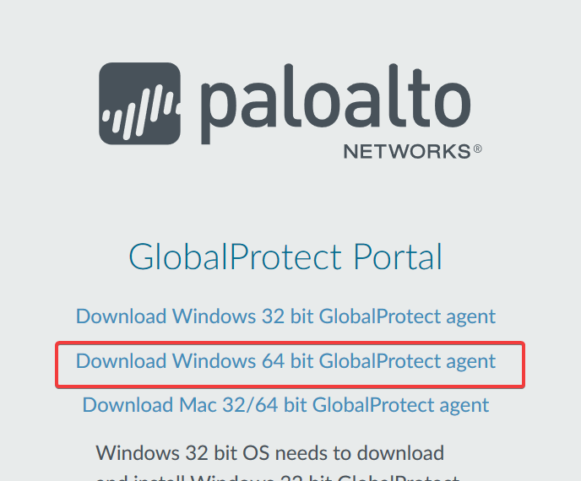First check to see if you have Global Protect already installed by clicking the Windows button in the lower left-hand corner and typing “GlobalProtect”
2. If you see the GlobalProtect app, click on it, and skip to step 6, continue with step 3.
3. Navigate to udvpn.udayton.edu and log in with your UD Credentials
4. Select the Download link for the Windows 64-bit (Unless of course, you are on a Mac)
5. When the file is finished downloading, run it and follow the command prompts to install.
6. Once installed, the Global Protect box will appear, enter udvpn.udayton.edu and click **Connect**

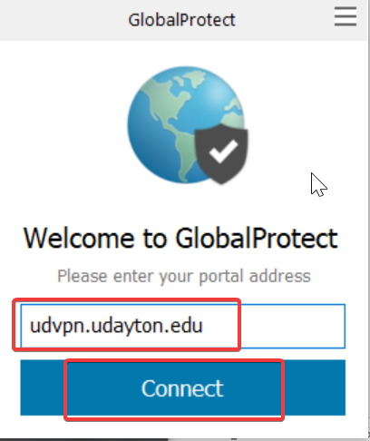

1. You will be prompted for your UD credentials, enter them and confirm the Two Factor Authentication.
2. You are now connected to the VPN.

# Duo Mobile Installation and Activation

1. Navigate to a UD login (like Porches), enter your UD username and password, and wait for the Duo 2-Factor to appear.
2. Select **Add a new device**

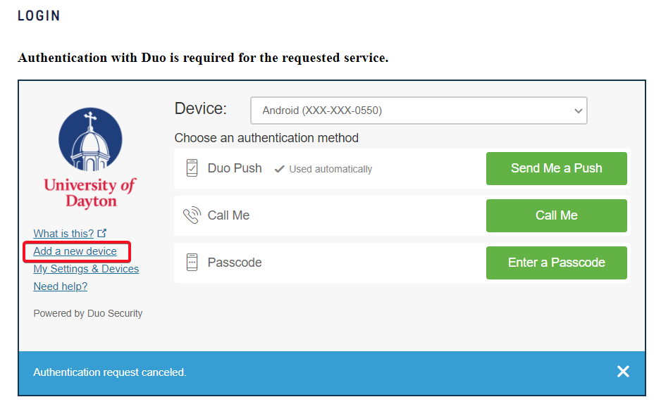

1. You will have to approve a 2-factor push after selecting the above option.
2. Select **Mobile phone** and click **Continue**

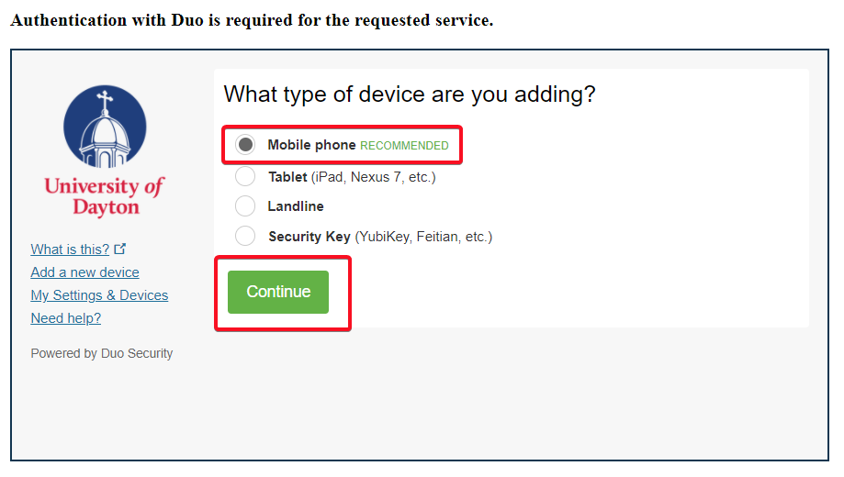

1. Enter your phone number and check the *This number already exists* box if it appears. Click **Continue**

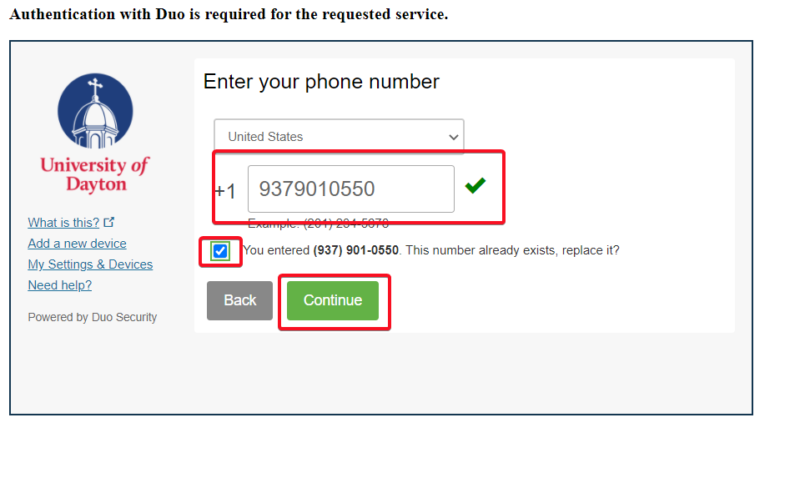

1. Select the phone type (iPhone, Android, Windows Phone or Other) and click **Continue**

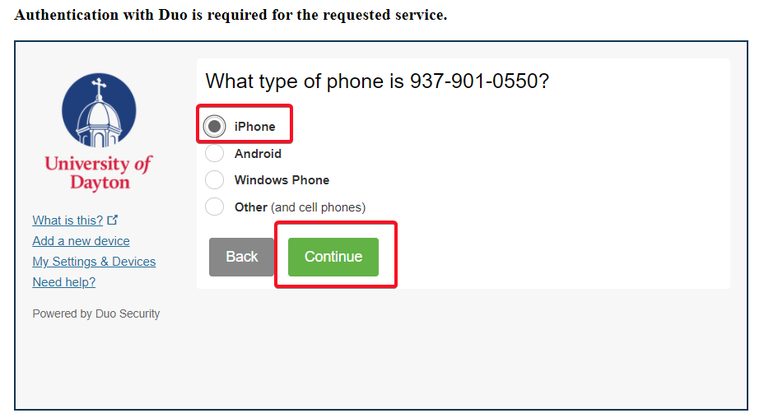

1. Follow the instructions to download the Duo Mobile app from the app store. Once the app is downloaded click **I have Duo Mobile installed**

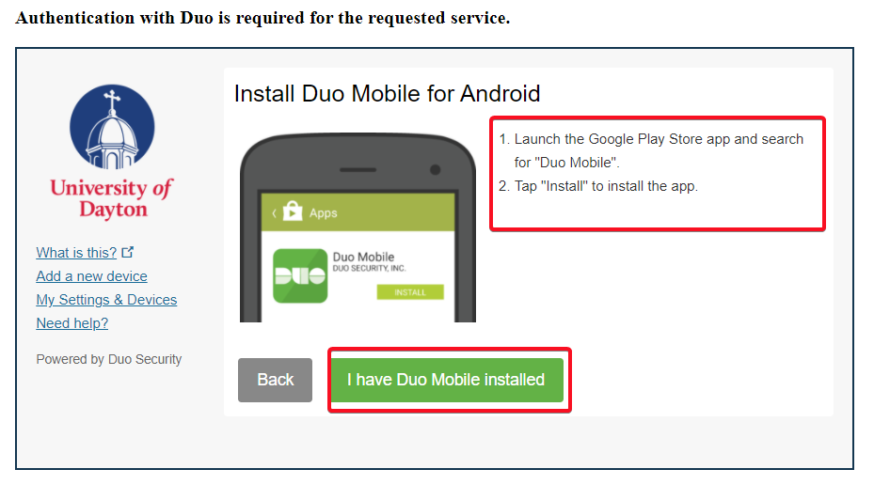

1. Follow the instructions to open the Duo Mobile app and tap the “**+**” button. This will activate the phone’s camera, point the camera at the QR code on the screen.

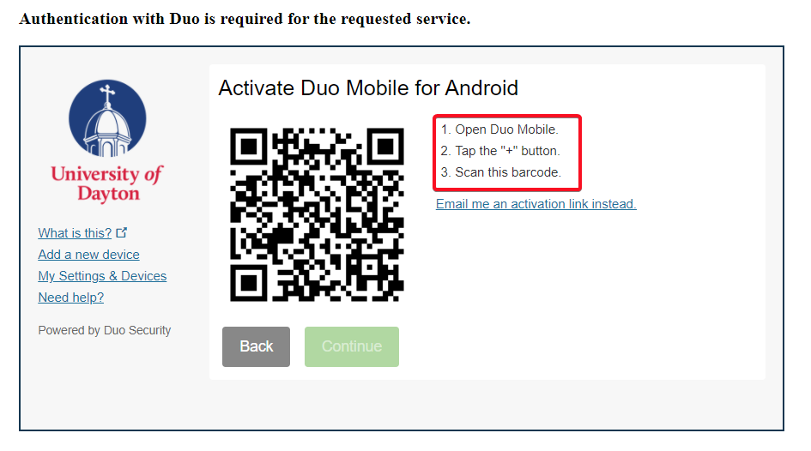

1. Once the QR code is scanned, you will see a check mark. Click **Continue**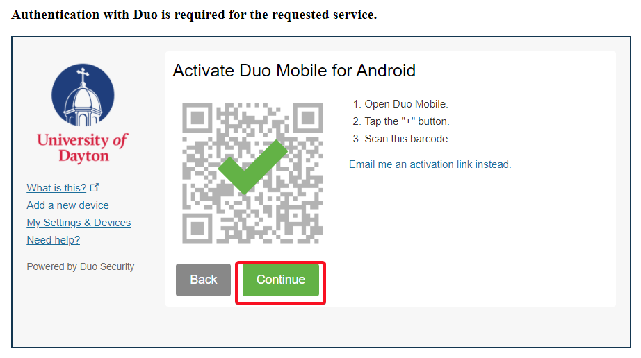

Your new phone will now be able to receive pushes.

# Eduroam Wi-Fi Windows 11

1. Click on the Globe or Wireless icon at the bottom right-hand corner of the page
2. Select the left-pointing arrow

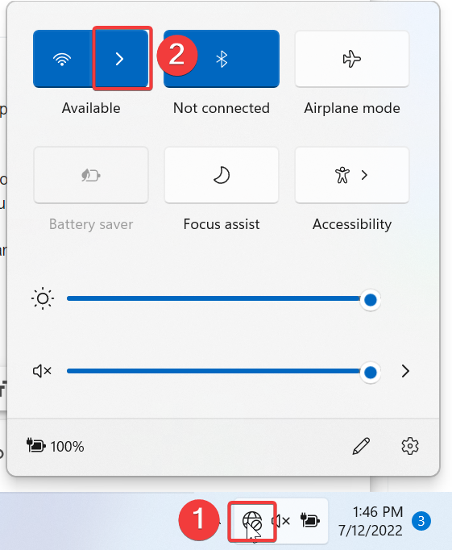

1. Select **UDconnect**

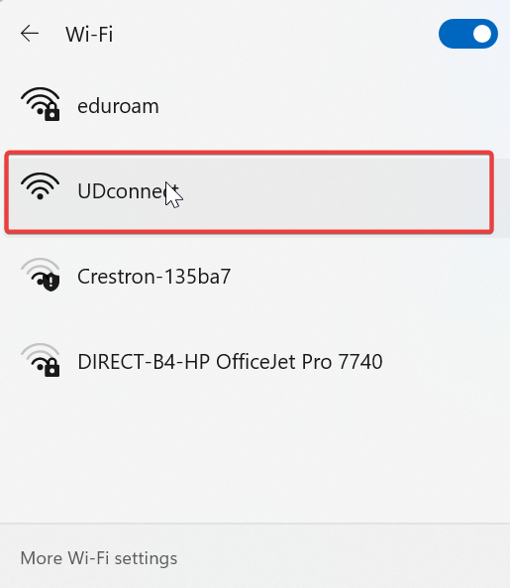

1. If your default browser window doesn’t open to the page shown below, open a web browser and enter the URL “**logoff.udayton.edu”.**

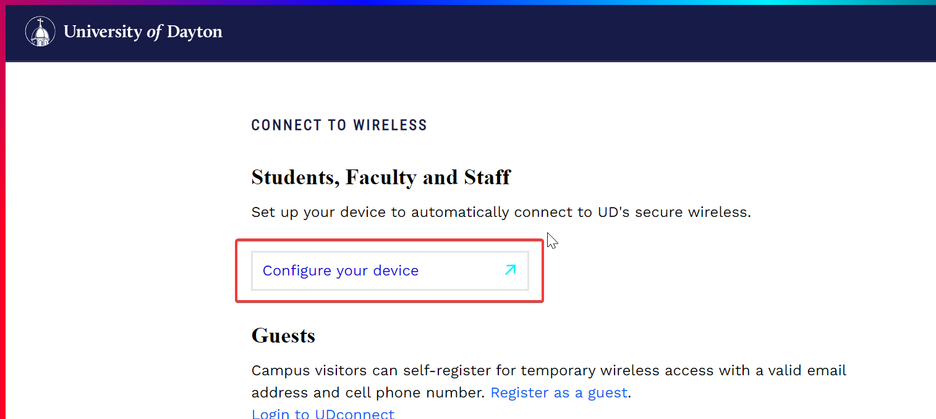

1. Select **Windows 10 & Above**
2. Click **JoinNow**

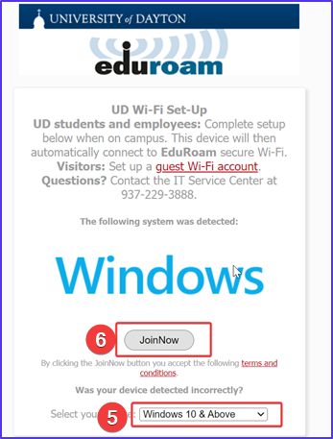

1. The Eduroam file will download, click on it to run it and select **Yes** to any Windows prompts that appear

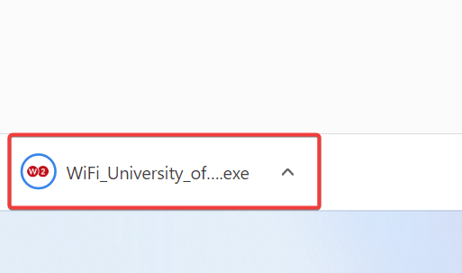

1. Sign in with your UD **Username** and **Password**
2. Click **Next**.

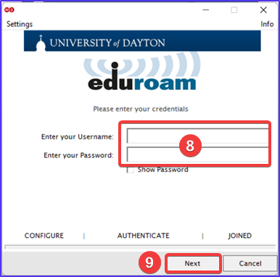

Once the blue bar moves to *Joined*, click the **Done** button. You are all set!

# Enable Google Chat Notifications

1. Click on the Windows icon or the search icon in the lower-left corner of the screen.
2. Start typing “Notifications”
3. Select **Notifications** **&** **actions** **settings** when it appears.

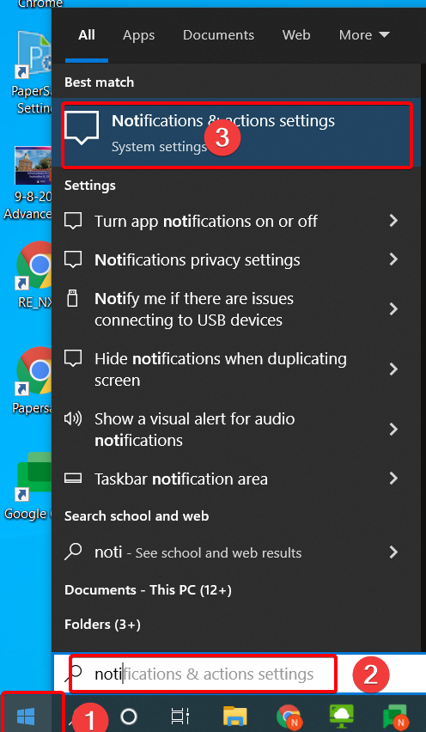

1. On the *Notifications & actions* screen click the *Sort by* drop-down and select **Name**

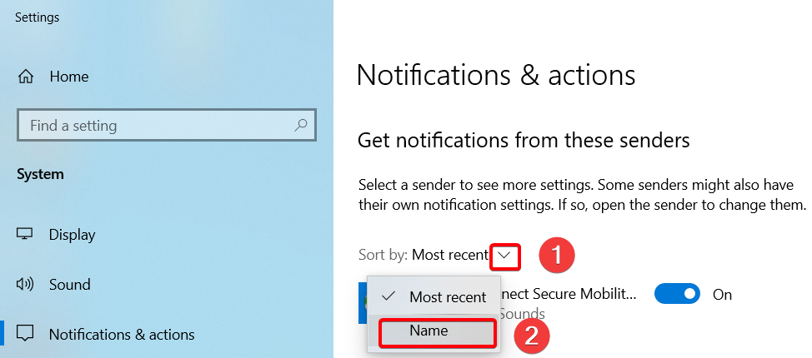

1. Find **Google Chrome** and toggle it to “**On**”

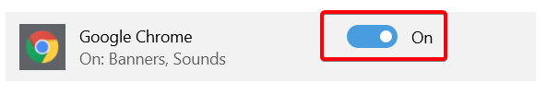

# Grant Box Folder Access

1. In your browser navigate to **go.udayton.edu/box** and log in.
2. Find the folder you want to share and click on the **Share** button

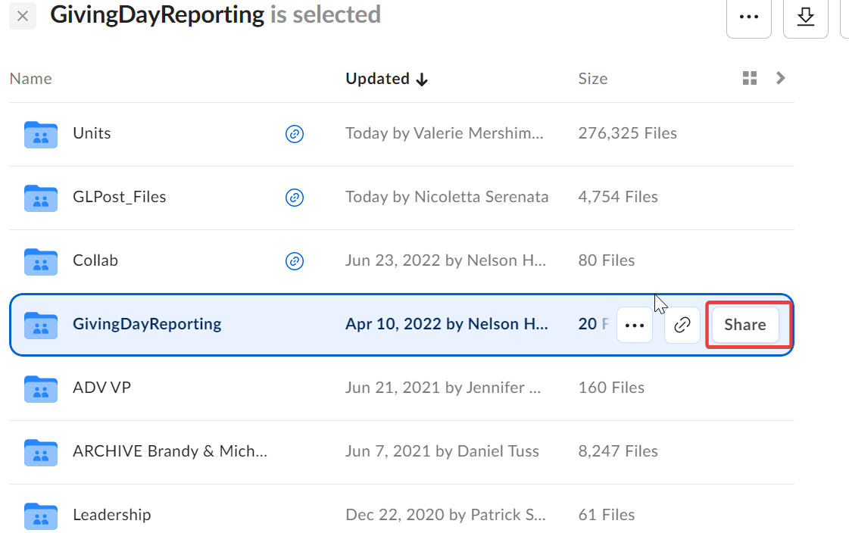

1. Start typing the name or email of the person you want to share it with. A list of names with populate, select the correct person from the list
2. Click on the **Invite as Editor** drop down button
3. Select the permission level you would like to give that person

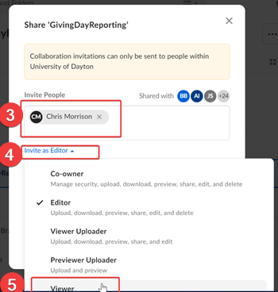

1. Click the **Send** button. That person now has access to that folder.

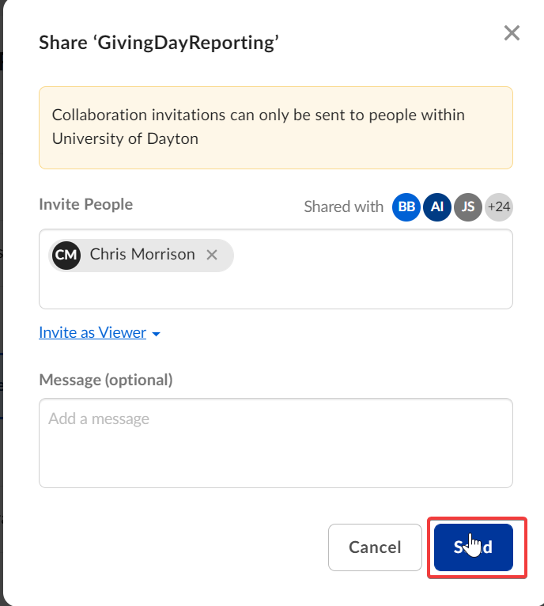

# Import Bookmarks

1. Click on the 3 dots in the upper right-hand corner of Chrome
2. Hover over ***Bookmarks***
3. Click on ***Bookmark Manager***

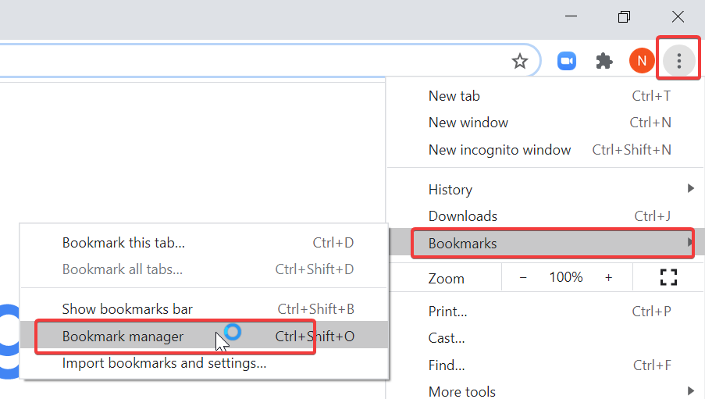

1. Click on the 3 dots in the upper right-hand corner of this new screen.

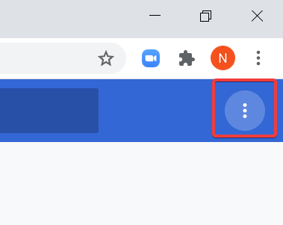

1. Click ***Import bookmarks***

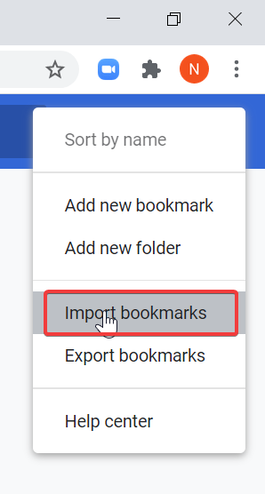

1. Find and select the bookmark file you wish to import
2. Click **Open**

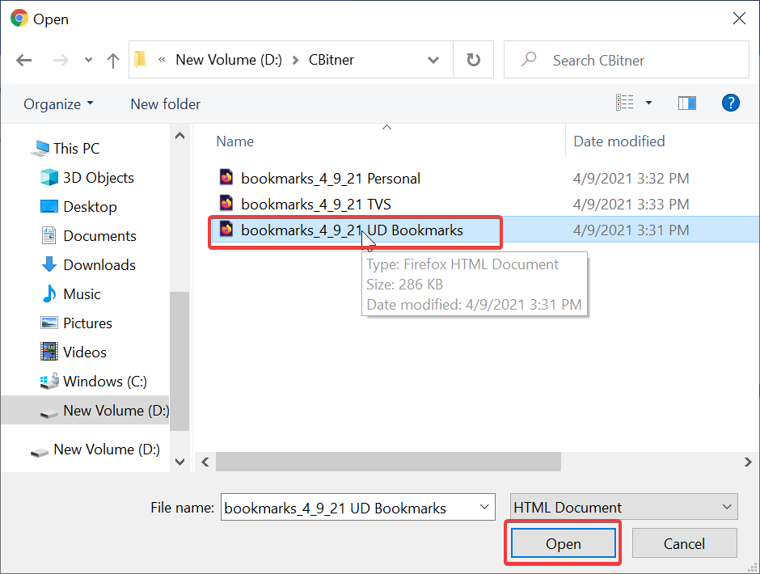

# Install Approved Software from the Portal Manager

1. Go to the Windows search bar and type **Portal**.  The Portal Manager App appears in the Best Match section of the search results.  Click on the **Portal Manager** link.   
     
   ***NOTE:****If you can't find the Portal Manager on your computer,*[*contact the IT Service Center for assistance*](http://udayton.teamdynamix.com/TDClient/1868/Portal/Requests/ServiceDet?ID=27499)*.*  
     
   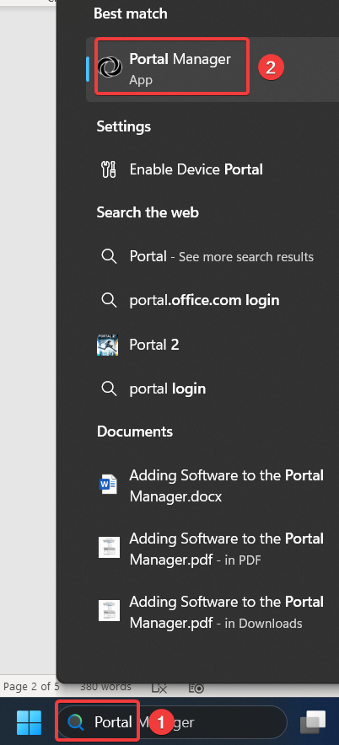  
     
   ***NOTE:****Mac users - Use the****SpotLight****search function and type****Portal****in the search bar. Click on the****Portal Manager****link.*  
   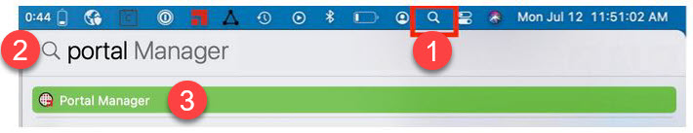
2. Locate the software package you want, click the **Install**link, and follow the installation prompts.  
     
   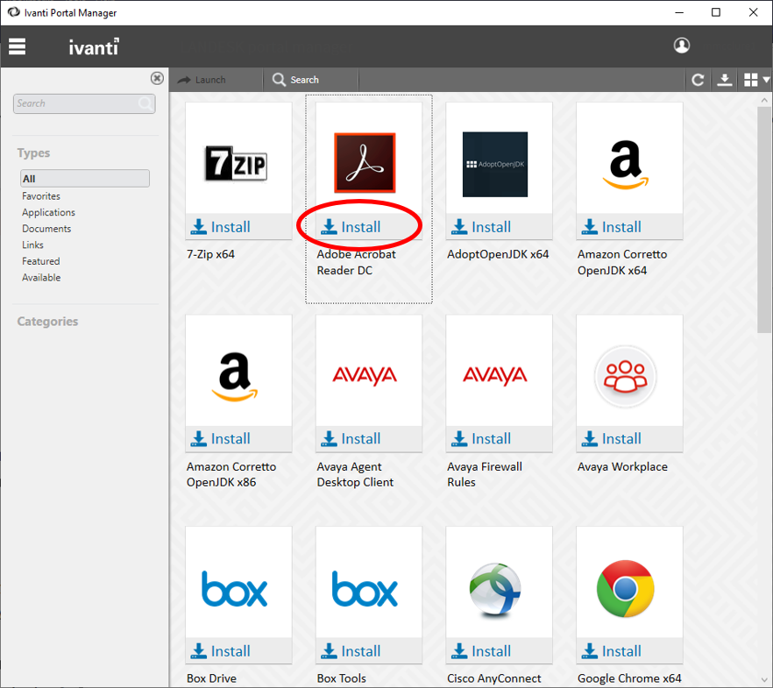

## Update Your Portal Manager App

In early 2020, UD released a new version of the Ivanti Portal Manager agent. Since many staff began working remotely around this time, several computers didn't receive this update and haven't been receiving automated software updates.

The good news is that this is easy to correct - you can download the updated Portal Manger software manually from whatever version of Portal Manager you currently have installed. The bad news is that you won't know you're on the old version unless you check. Below are the directions for checking your version and updating it if needed. **If you have questions or have problems updating,**[**contact the IT Service Center for assistance**](https://udayton.teamdynamix.com/TDClient/1868/Portal/Requests/ServiceDet?ID=27499).

1. Click on the window in the lower left corner of your screen and type “portal.” Portal Manager should appear as an option in the list of available software; click to launch the Portal Manager    
     
   ***NOTE:****Mac users - The Portal Manager is located in****Launchpad****.*
2. Look for **Ivanti Agent - Windows Default** or **Ivanti Agent - Public Agent** (depending on the version of the Ivanti Portal Manager agent you currently have installed) in the list of available software (shown in the screenshot below).
   * If you see the Ivanti Agent listed, click to install. When complete, you'll be on the most recent version.
   * If you **don't**see the Ivanti Agent listed, you're on the right version already. No action is needed!

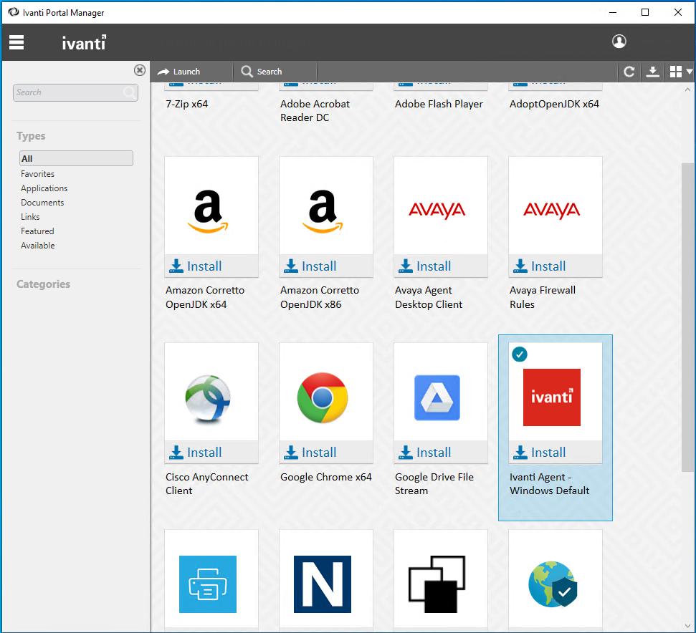

# Install Google Chat App

1. Go to **chat.google.com** and log in (some pop-ups may appear if you’ve never logged in before, just click through them)
2. Click the icon boxed in red below

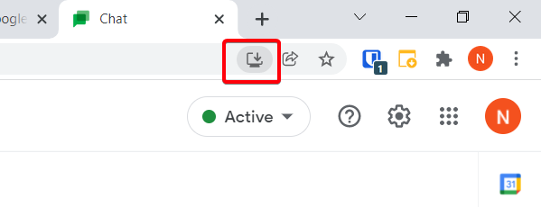

1. The below pop up will appear, click **Install**

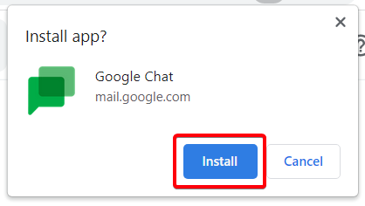

1. This will open the Google Chat application; it is recommended that you pin it to your task bar for easy access.
2. To pin, when the application is open right-click on the chat icon at the bottom of the page
3. Select **Pin to taskbar**

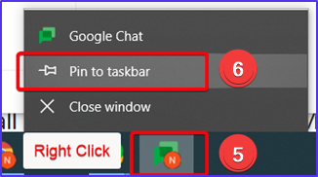

# iPhone/iPad Personal Hotspot

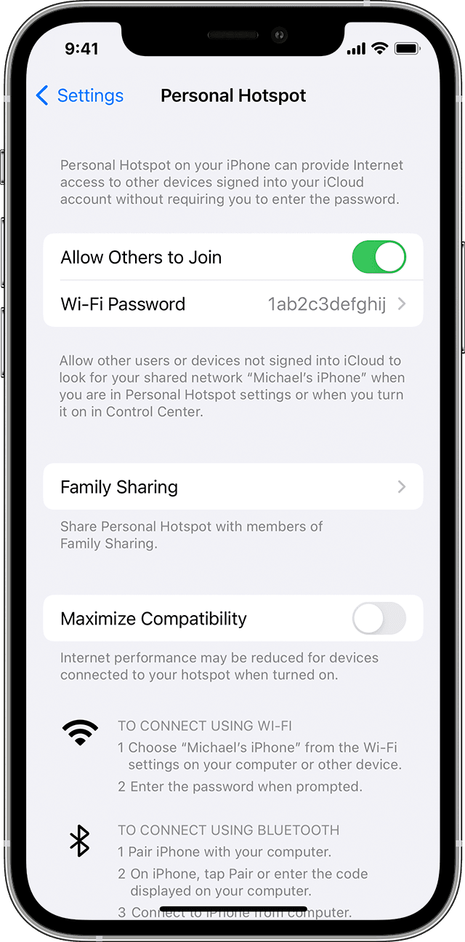A Personal Hotspot lets you share the cellular data connection of your iPhone or iPad (Wi-Fi + Cellular) when you don't have access to a Wi-Fi network.

## Set up a Personal Hotspot

1. Go to Settings > Cellular > Personal Hotspot or Settings > Personal Hotspot.
2. Tap the slider next to Allow Others to Join.

If you don't see the option for Personal Hotspot, contact your carrier to make sure that you can use Personal Hotspot with your plan.

## Connect to Personal Hotspot with Wi-Fi, Bluetooth, or USB

You can connect to a Personal Hotspot using Wi-Fi, Bluetooth, or USB. And with iOS 13 or later, devices that are connected to a Personal Hotspot will stay connected, even if the screen is locked, so those devices will still get notifications and messages.

When you connect a device to your Personal Hotspot, the status bar turns blue and shows how many devices have joined. The number of devices that can join your Personal Hotspot at one time depends on your carrier and iPhone model. If other devices have joined your Personal Hotspot using Wi-Fi, you can use only cellular data to connect to the internet from the host device.

Use these steps to connect:

### Wi-Fi

On the device that you want to connect to, go to Settings > Cellular > Personal Hotspot or Settings > Personal Hotspot and make sure that it's on. Then verify the Wi-Fi password and name of the phone. Stay on this screen until you’ve connected your other device to the Wi-Fi network.

On the device that you want to connect, go to Settings > Wi-Fi and look for your iPhone or iPad in the list. Then tap the Wi-Fi network to join. If asked, enter the password for your Personal Hotspot.

### Bluetooth

To make sure that your iPhone or iPad is discoverable, go to Settings > Bluetooth and stay on that screen. Then on your Mac, follow the manufacturer directions to set up a Bluetooth connection. Learn more about [using Personal Hotspot with Bluetooth](https://support.apple.com/kb/HT203302).

Personal Hotspot supports Bluetooth connections with Mac and other third-party devices. To connect another iOS device, use Bluetooth.

### USB

Ensure you have the latest version of iTunes and the Finder on your Mac. Then connect your iPhone or iPad to your computer with the USB cable that came with your device. If you see an alert that says tap "[Trust This Computer?](https://support.apple.com/en-us/HT202778)" tap Trust.

Learn more about [connecting a device to your iPhone or iPad's Personal Hotspot](https://support.apple.com/kb/HT203302).

Let your family join automatically

You can set up Family Sharing so that your family can join your Personal Hotspot automatically—without needing to enter the password. Here's what to do:

1. On your device with Personal Hotspot, go to Settings > Personal Hotspot > Family Sharing.
2. Turn on Family Sharing. If you don't see the option, learn how to [set up Family Sharing](https://support.apple.com/kb/HT201088).
3. Tap the name of each of your family members and set whether they need to ask for approval or join your Hotspot automatically.

## Disconnect devices

To disconnect a device, turn off your Personal Hotspot, turn off Bluetooth, or unplug the USB cable from your device.

## Set or change your Wi-Fi password

You need to set a Wi-Fi password in order to set up a Personal Hotspot. To change the Wi-Fi password, go to Settings > Cellular > Personal Hotspot or Settings > Personal Hotspot, then tap the Wi-Fi password.*

Choose a Wi-Fi password that's at least eight characters long and use ASCII characters. If you use non-ASCII characters, other devices will be unable to join your Personal Hotspot. Non-ASCII characters include characters in Japanese, Russian, Chinese, and other languages. ASCII characters include:

* All the letters in English, both lowercase and uppercase
* The digits 0 through 9
* Some punctuation marks

* When you change your password, any connected devices will be disconnected.

# Intelligent Hub Setup (Apple)

UD's Mobile Device Management (MDM) service (currently Intelligent Hub) installs a profile on your mobile device that configures and maintains basic security settings to help protect your privacy and the university's data. Intelligent Hub is required on all University-sponsored devices.

## Intelligent Hub Security Features

After installing and configuring Intelligent Hub, your device will:

* Require a device passcode
* Time out after a period of inactivity and require a password to unlock it
* Sync your email, contacts, and calendar appointments during the first few minutes after installation if email activation is supported on your device
* Check periodically to make sure it isn't rooted
* Display the Intelligent Hub app and the UDayton App Catalog
* Perform otherwise as it did before you installed the MDM

### Step 1: Download the Intelligent Hub Agent app on your iOS device

***NOTE:*** *Intelligent Hub requires that your device is running iOS 9.3.5 or later.*

In the App Store, search for the "Intelligent Hub Agent" app and tap the cloud icon or **Get** to download.

### Step 2: Enroll in Intelligent Hub Device Management

1. Open the Intelligent Hub Agent app
2. Select "Email Address" as your authentication method.
3. Enter your UD email address; tap Next
4. Select your division from the drop-down list; tap Done and Next
5. Enter your UD username and password; tap Next
6. Select ownership for your device: choose "Corporate - Dedicated" if the device is owned by UD or "**Employee Owned**" for BYOD devices; tap Continue
7. On the *Enable Device Management* page, tap **Redirect & Enable** at the bottom of the screen
8. Tap **Allow** to display your configuration profile
9. When the Install Profile page displays, tap Install (if prompted, enter your phone’s passcode)
10. A warning message about device management displays; tap Install
11. Tap Trust on the Remote Management pop-up
12. When the profile has finished installing, the Profile Installed page displays; tap Done
13. Open the Intelligent Hub Agent; you should see an “Authentication Complete” message. Tap **Done**
14. If prompted to allow the Intelligent Hub Agent to send you notifications, tap Allow
15. Enter a passcode for the Intelligent Hub app; tap Create
16. Information about your device displays; you can navigate away from this page

### Step 3: Set a passcode for your device

If you do not already have a passcode, you will be prompted by Intelligent Hub to set one within 60 minutes after your device is enrolled in MDM.

### Step 4: Set your email password and activate your email

When you enroll in MDM, your udayton.edu email is configured on your device. However, you may need to set your email password.

* On the home screen, tap the Mail app to activate your UDayton email; this may take a few minutes the first time.
* If prompted, enter the password for your UDayton email and tap OK.

# IT Loaner Laptops

## Login Credentials

**Bitlocker PIN:** “Dayton1850”

**Username:** “.\Rudy”

***NOTE:*** *Make sure to include the* ***dot*** *and then a* ***backslash*** *before the username* ***Rudy***

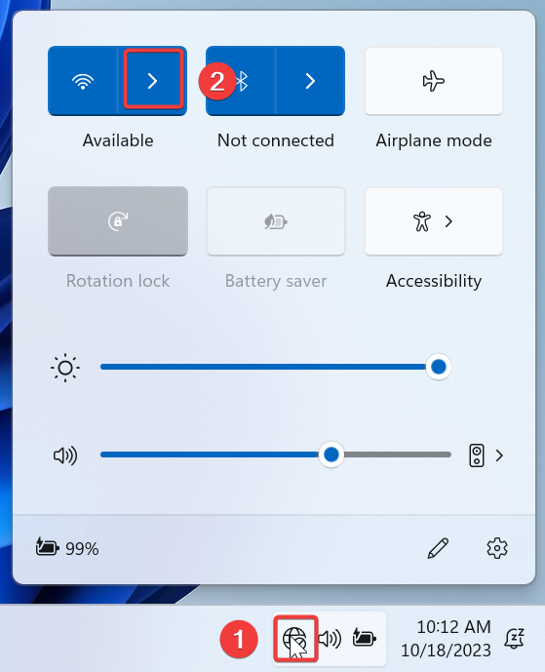**Password:** “Dayton1850”

## Connect to Wi-Fi

1. Click on the Globe icon at the bottom right-hand corner of the page
2. Click the right-pointing arrow next to the wi-fi icon in the upper-left corner
3. 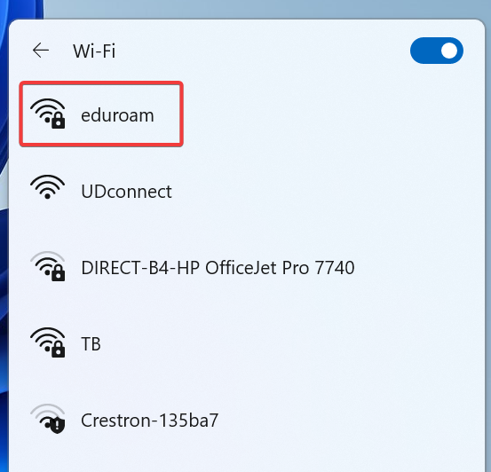Select **Eduroam**
4. Enter your UD username and password
5. 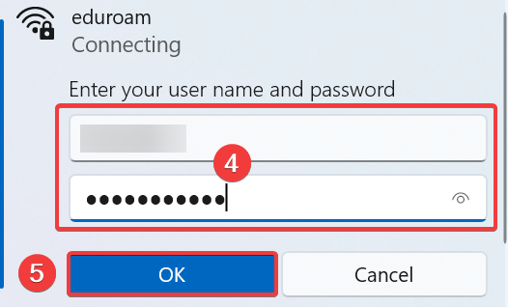Click **OK**
6. Click **Connect** on the *Continue Connecting* message

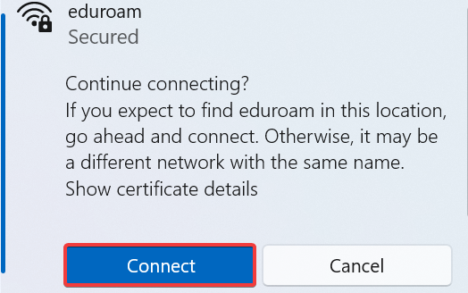

1. If you get the following message, click **Connect**

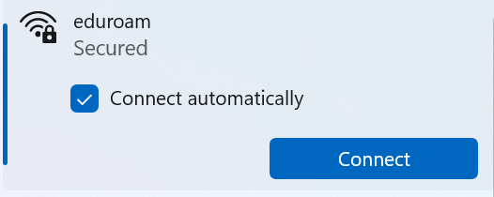

You are now connected to UD Wi-Fi.

***NOTE:*** *It may take a minute or so for the connection to become active.*

***NOTE:*** *Once you’re finished using the laptop, it is recommended that you disconnect from the wireless following steps 1-3 and then click* ***Disconnect****. This is especially true when logging in with the “Rudy” account.*

# Monitors: Quick Guide

## To set your monitors to Dual Screens:

Press the “Windows Key” + “P” at the same time

A menu will appear on the right side of the screen, select **Extend**



## To adjust the order of the monitors so they display in proper order from left to right:

Press the “Windows Key” + “I” at the same time

This will bring up the *Settings* menu, select **Display**

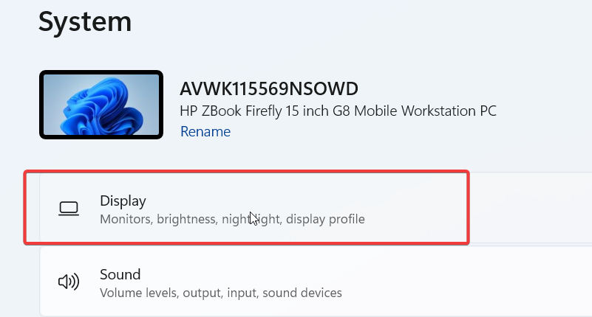

At the top of this screen, you will see your monitors listed.

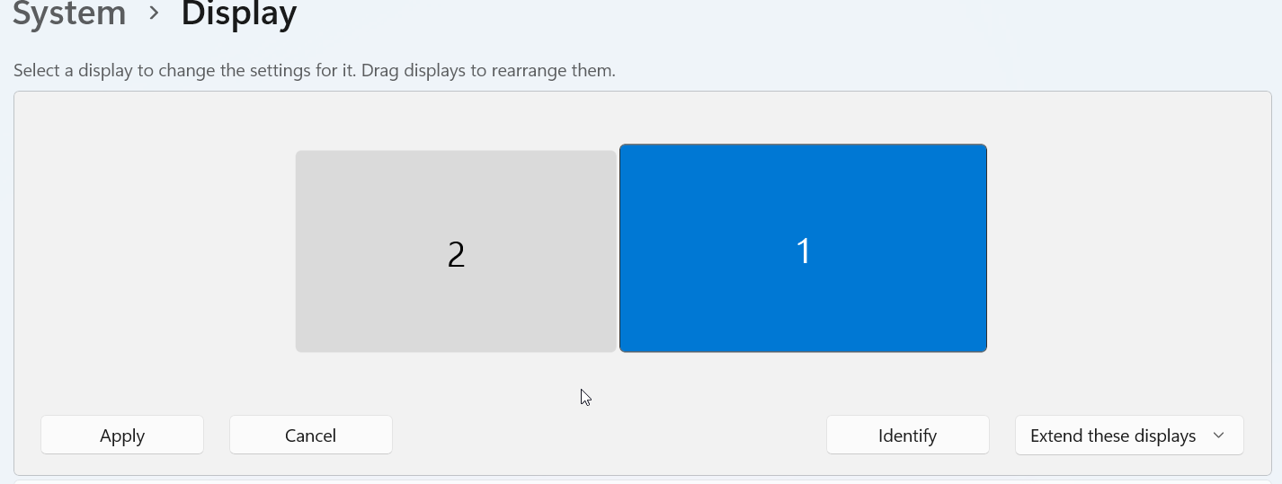

Drag and drop them until they are in the correct order and then click **Apply**

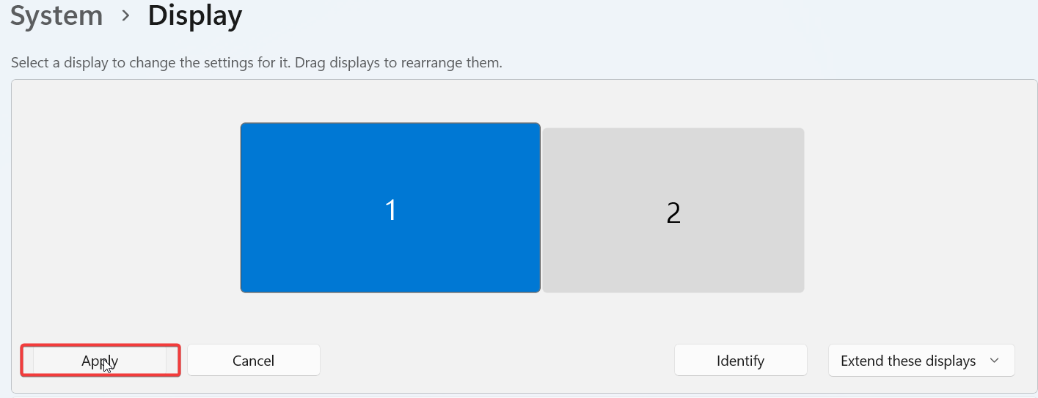

***NOTE:*** *Putting the monitors in the correct numerical order (1, then 2) will not always correctly arrange them. If you are having trouble matching the monitor numbers on the screen above to the physical external monitors you can click on the* ***Identify*** *button*

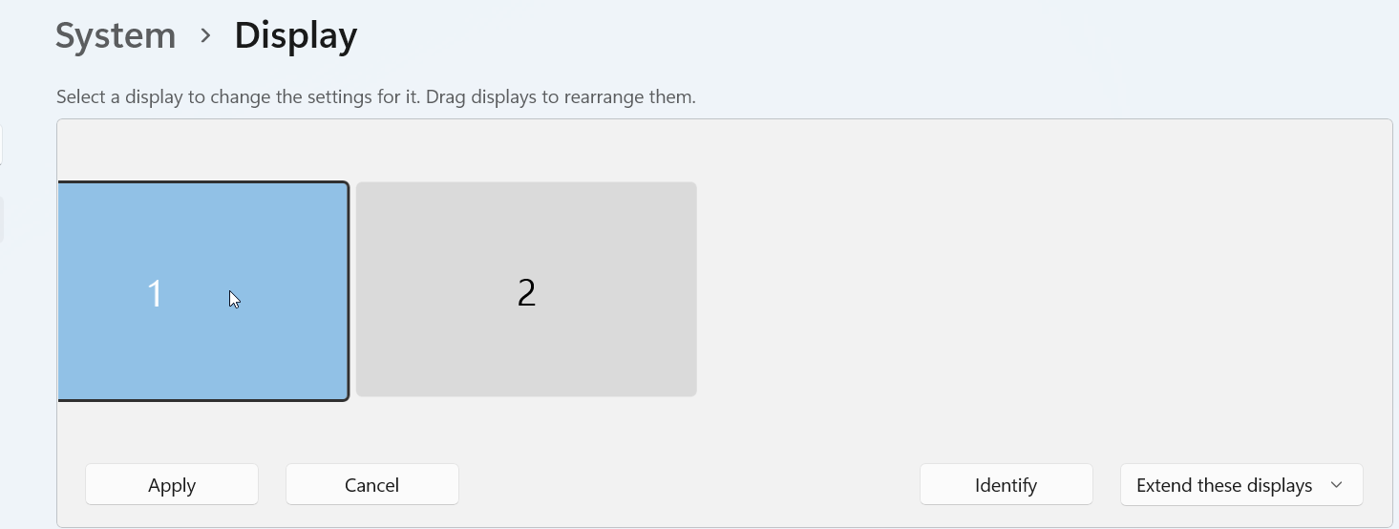

# Pair AirPods with HP Laptop

1. **Put the AirPods into their charging case**

Close the case and wait a few seconds. Ideally, the AirPods should have at least 20% battery before you pair them to your laptop.

1. **Open the AirPods case**

Open the case and leave the AirPods inside while you follow the rest of these steps.

1. **Press and hold the Setup button**

The Setup button is the small, circular button on the backside of the case. Hold it down until you see the LED lights flashing on the inside (older AirPods) or front (AirPods Pro).  
  
The Setup button puts the AirPods into pairing mode, an essential step for pairing any Bluetooth device.

1. **Open the Start Menu**

Click the Windows logo on your HP laptop to open the Start Menu on your laptop. With Windows 10, you’ll find it in the bottom left corner. Windows 11 users will see it in the bottom taskbar.

1. **Go to Settings**

Find the gear-shaped icon and click it to open Settings.

1. **Open Bluetooth & devices**

Windows 11 users should click Bluetooth & devices on the left-hand column. If you’re on Windows 10, click Devices on the Settings icon menu, then click Bluetooth & devices on the left column.

1. **Add a new Bluetooth device**

On Windows 10, click Add Bluetooth to other devices next to the grey plus icon. Windows 11 users must click the blue Add Device button within the Devices row.

1. **Choose Bluetooth**

A pop-up screen will give you the options of Bluetooth, Wireless display or dock, and Everything else.  
  
Choose Bluetooth.

1. **Select your AirPods**

After a few seconds, a list of available Bluetooth devices will load on the Add a device window. Click the icon for your AirPods.

1. **Click Done**

A window will pop up, declaring, “Your device is ready to go.” Click Done.

1. **Start listening to groovy tunes from your HP laptop**

Or watch YouTube videos or whatever it is you were planning to do. Got other devices you need to connect to your HP laptop via Bluetooth? Just follow the same steps. This guide isn’t exclusive to AirPods - the same steps apply to all compatible Bluetooth devices on HP laptops.

How to connect and disconnect your AirPods to an HP Windows laptop

The earbuds should automatically connect when you pair your AirPods to your HP laptop.  
  
If you want to play audio through your phone (or another device), you’ll need to disconnect the AirPods from your laptop first. And to start listening through your PC again, you’ll need to reconnect the AirPods.  
  
But don’t worry. The disconnect-reconnect process is fast and easy - you’ve already done most of the legwork.

* + 1. **Open the Bluetooth menu on your laptop**

Follow the steps outlined above.  
  
In case you’ve forgotten, click the Start Menu and click Settings. Next, click the Bluetooth & devices icon on the left-hand column (Windows 11) or click Devices, then Bluetooth & other devices (Windows 10).

* 1. **Click Connect or Disconnect**

Find your AirPods from the list of Bluetooth devices and click the Connect or Disconnect button.

## Troubleshooting an HP laptop Bluetooth connection with AirPods

Still having trouble connecting your AirPods to your laptop? No need to dig up your HP warranty just yet. There’s a good chance you can fix the issue yourself.  
  
The most common cause of a failed connection is a flat battery. Put your AirPods in their case and charge them up for a few hours before trying again.  
  
AirPods sometimes have trouble syncing, especially when connected to multiple devices. The best way to rectify the issue is to perform a reset.  
  
To reset AirPods and AirPods Pro

1. Put the AirPods into their case and close the lid.
2. Wait 30 seconds and open the lid again.
3. Follow the steps in this post to remove your AirPods from the Bluetooth list and pair them again. Note: this is different to the connect-reconnect process.

### To reset AirPods Max

1. Press and hold the Digital Crown and Noise Control buttons, which you’ll find at the top of one of the ear coverings.
2. Continue holding these two buttons until an amber LED light flashes at the bottom of the same ear covering.
3. Alternatively, to return your AirPods Max to factory settings, press and hold the Digital Crown and Noise Control buttons for about 15 seconds until you see a white LED light.

If your AirPods work perfectly with any device except your HP laptop, there’s a good chance your PC is the culprit. Double-check that your Bluetooth is turned on. Failing that, Windows troubleshooter might help:

1. Click the Windows icon to open the Start Menu (bottom left corner for Windows 10 or bottom taskbar for Windows 11).
2. Click Updates & Security (Windows 10) or System (Windows 11).
3. Click Troubleshoot
4. Click Other troubleshooters
5. Click Bluetooth

With any luck, the troubleshooter will analyse and rectify the issue.

Handy Bluetooth shortcuts for Windows

Try the following shortcuts to save time when pairing or connecting a Bluetooth device in Windows.  
  
On Windows 11:

* Click Show hidden icons in the bottom right tray
* Click Bluetooth Devices
* Click Settings

On Windows 10 and 11:

* Press Windows + A to open the action centre
* Click the Bluetooth icon to toggle Bluetooth on or off
* Alternatively, right-click the Bluetooth icon and click Settings

## Password Reset

1. Navigate to password.udayton.edu and try to log in with your old password.

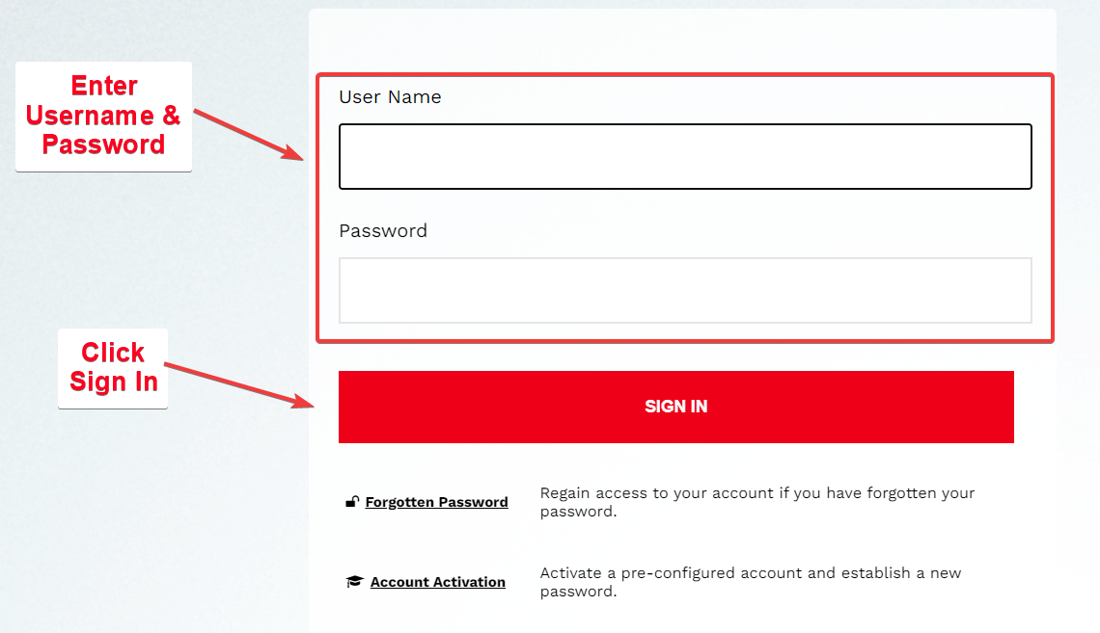

1. If you are able to get in, click the **Change Password** button and enter your old password again.

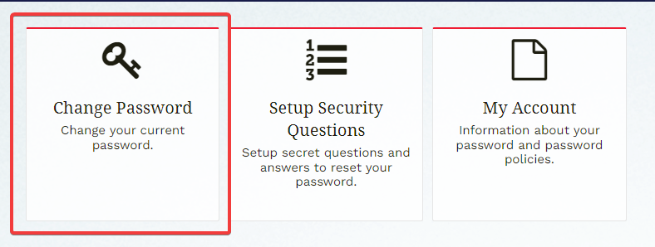

1. You will be prompted to enter a brand-new password.

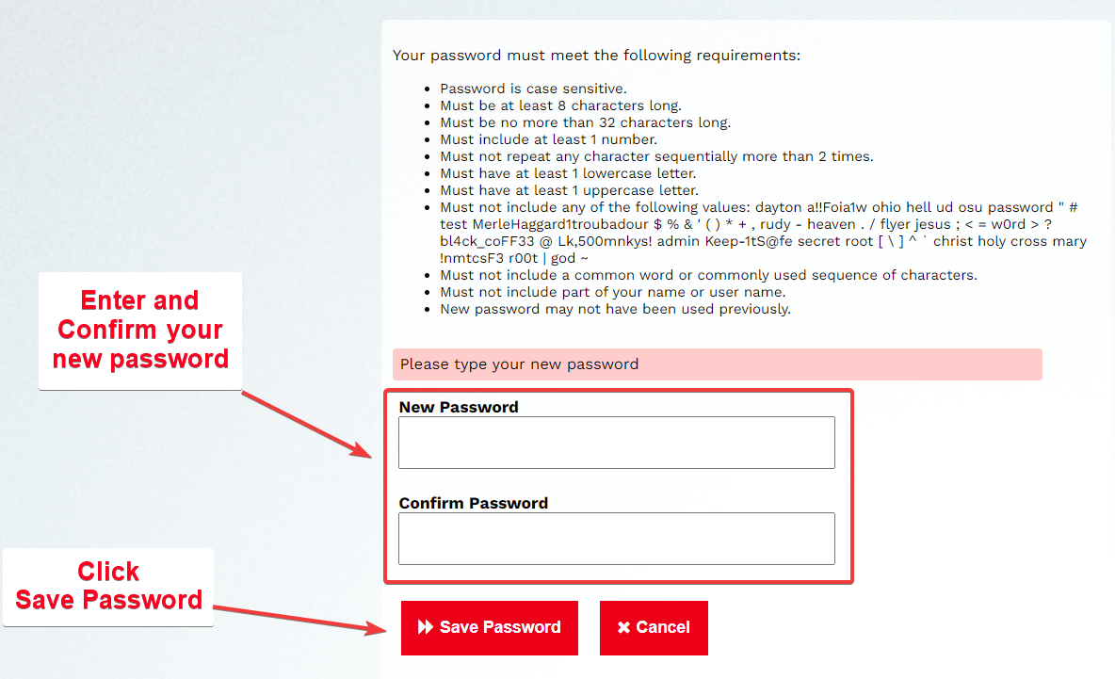

1. If you cannot log in to password.udayton.edu with your old password, select the **Forgotten password** link.

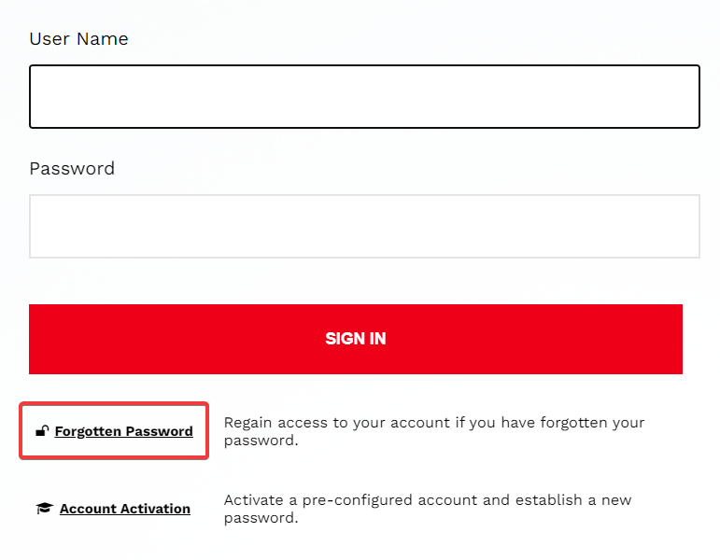

1. Answer the security questions, and you will be taken to a page to reset your password.

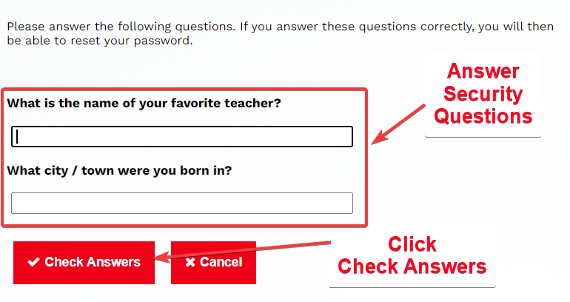

1. If you don’t recall the answer to your security questions, then you will have to call UD IT directly to have them manually reset your password. Their number is 937-229-3888.

# Photos App Doesn’t Open

The purpose of this guide is to troubleshoot issues with the Microsoft Photos app that is installed on Windows 10 and 11. There are two issues that will be discussed: photo that was downloaded from an email or website and the blue box error.

## Files Downloaded from Email/Website

Files (not just photos) that are downloaded from an email message or a website are automatically blocked by Windows Security. The following procedure details how to unblock a file from a trusted source.

1. In File Explorer, browse out to where the file is saved
2. Right-click on the file
3. Select **Properties**

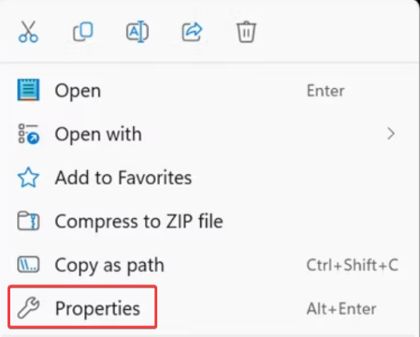

1. Place a check in the box next to *Unblock*
2. Click **OK** and you should now be able to open the file

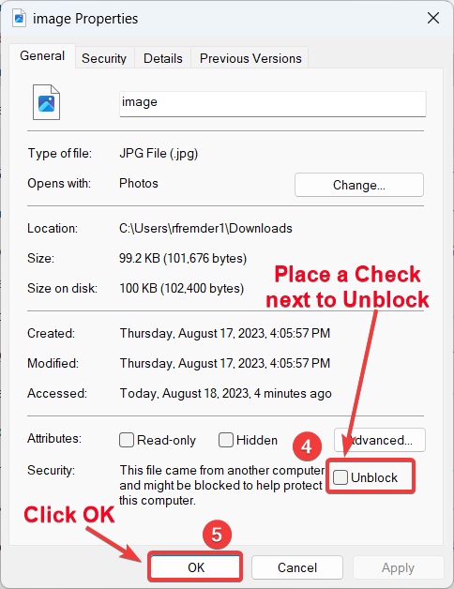

## Change Default App

If unblocking the file didn’t fix the issue, or if you received the blue box error that it can’t be opened, there may be the possibility that the default app has been changed or somehow corrupted. The following provides steps on how to change the default app.

1. In File Explorer, browse out to where the file is saved
2. Right-click on the file
3. Select **Properties**

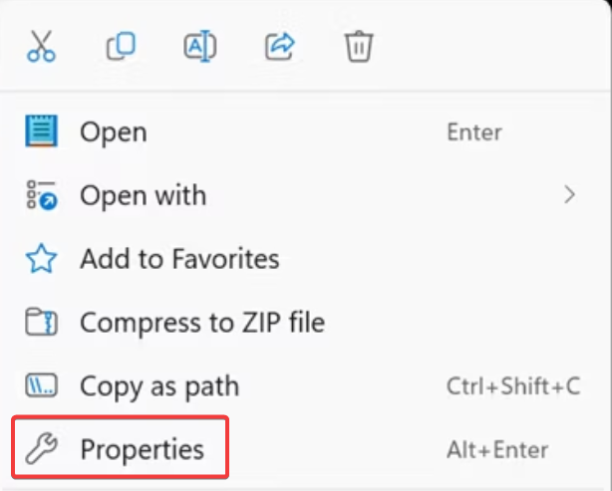

1. Click the **Change** button

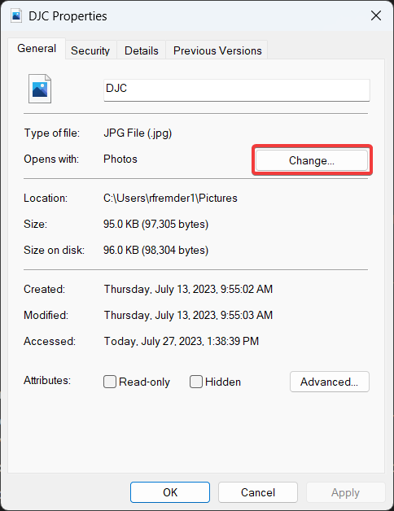

1. If there is no default app listed or if the default app is incorrect, select the correct app from the *Suggested apps* section or scroll a bit to select it from the *More options* section
2. Click **Set default**

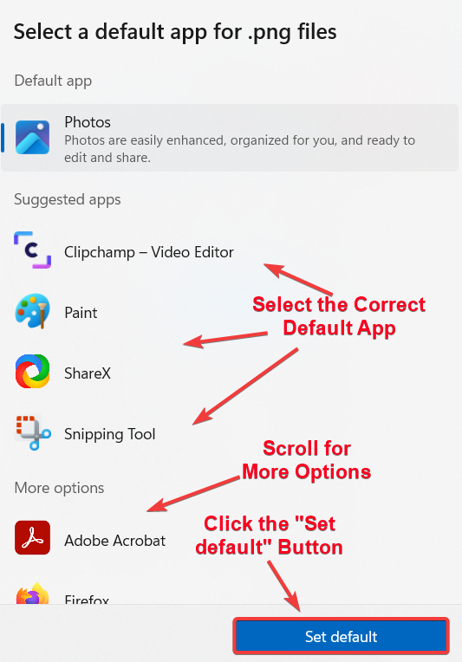

1. Verify that the file opens correctly

## Repair Microsoft Store Apps

Photos is a Windows Store app using Microsoft’s proprietary UWP format that causes all kinds of problems. Use the built-in Windows troubleshooter for Photos and other Windows apps.

1. Right-click the Start menu and select **Settings**

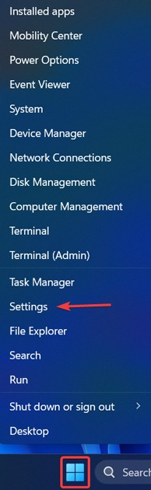

1. Go to the *System* tab and select the **Troubleshoot** option.

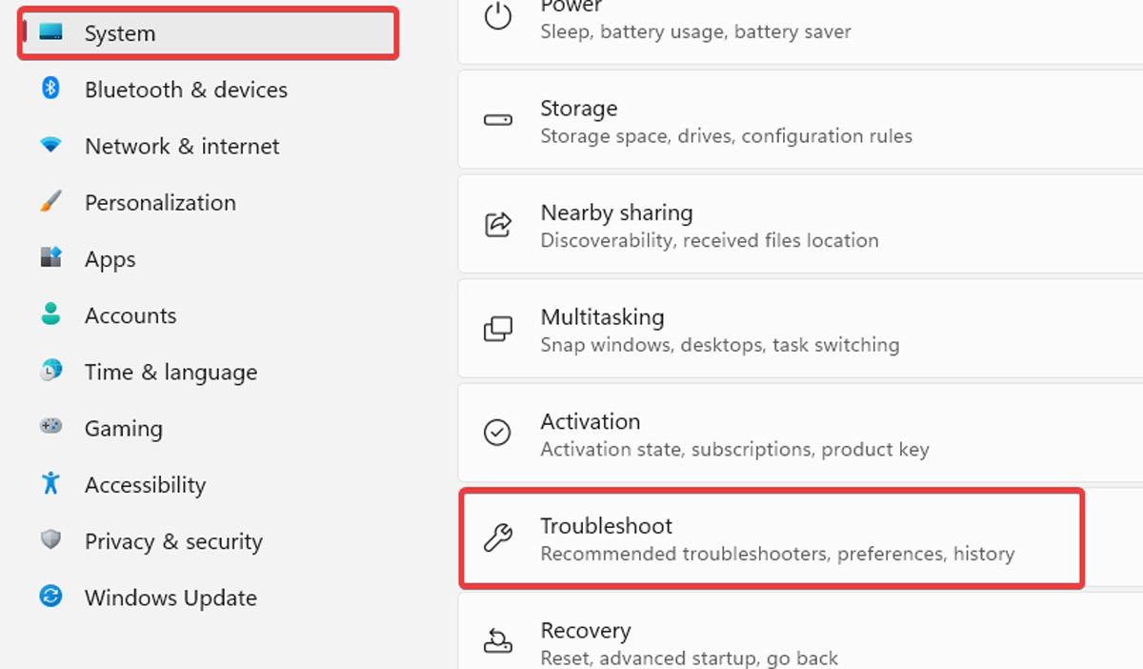

1. Scroll down and select the **Other Troubleshooters** option 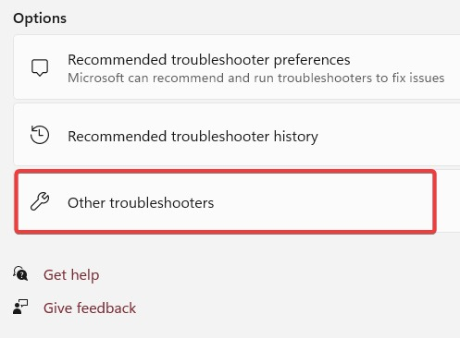
2. Find the *Windows Store Apps* troubleshooterand click the **Run** button next to it

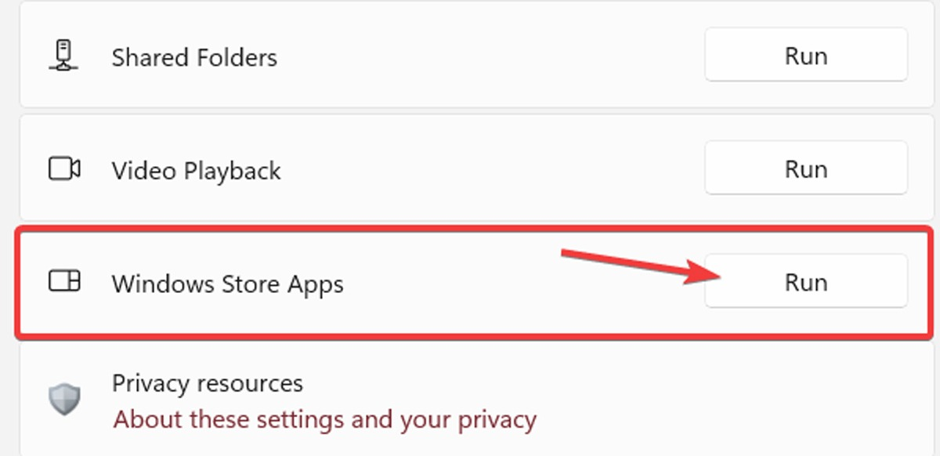

1. Follow the instructions provided by the troubleshooter on your screen. These steps may help fix any issues you’re experiencing with Windows Store apps

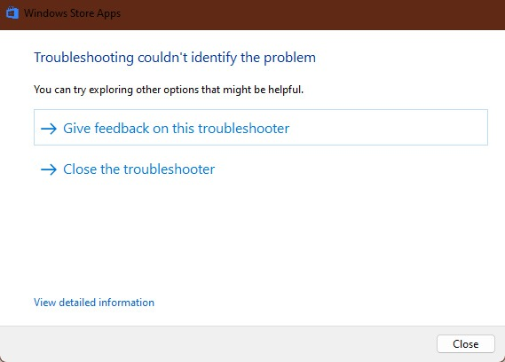

## Update Photos App

If an app hasn’t been updated in a while, it may encounter issues and stop functioning correctly, possibly due to a bug. To resolve this, it’s recommended to check the Microsoft Store for available updates for Photos or any other Microsoft app. Updating can fix bugs and improve its performance.

1. Click on the Start menu, type “Microsoft Store” and click on it

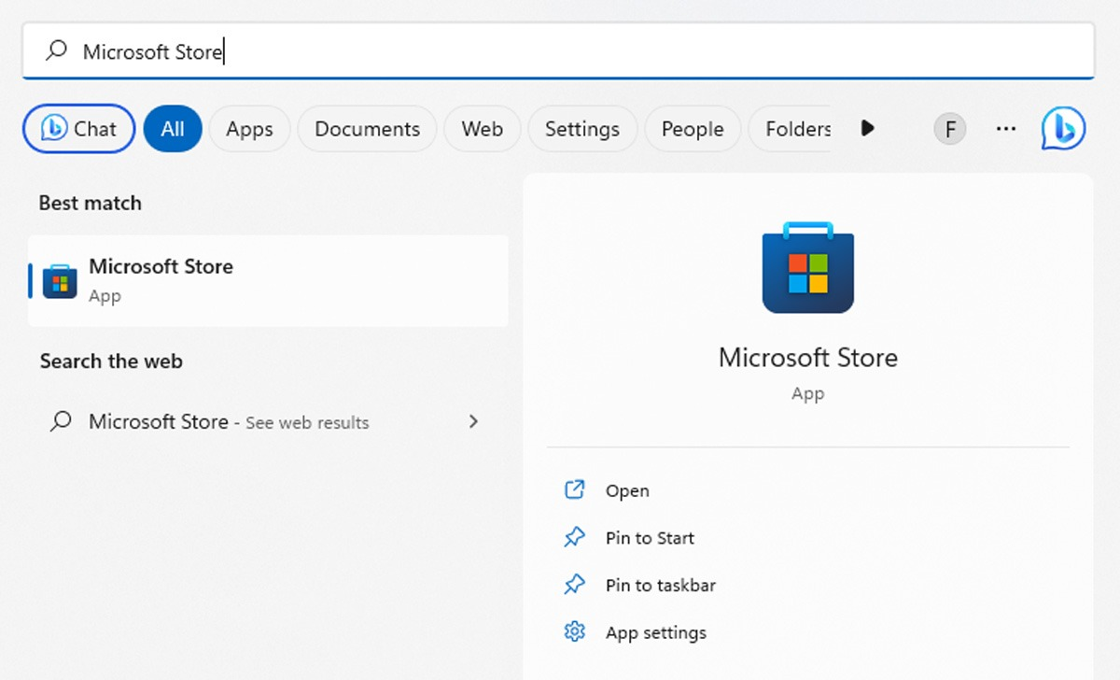

1. Click on the **Library** button located on the left side of the screen.

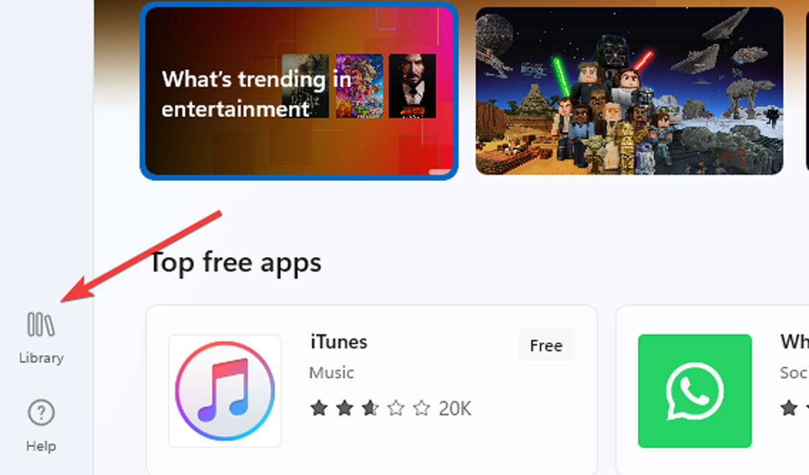

1. Find the Update button next to *Microsoft Photos* and click on it.

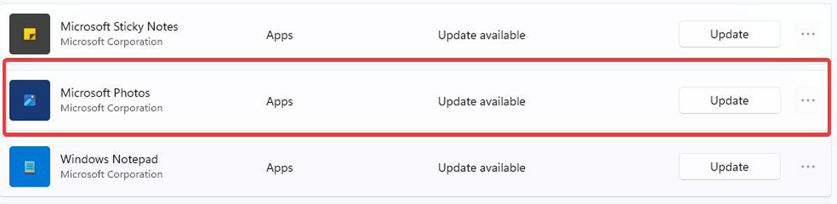

Open the Photos app and check to see whether it is fixed. If not, proceed to reset the app.

## Reset the App

Resetting the Photos app will wipe the app’s cache and reset all its data to default settings. This may require administrator credentials. Reset the app by following the steps below:

1. Right-click on the Start menu and select **Apps and Features**

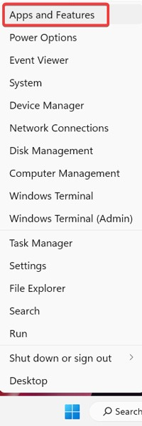

1. Scroll down to *Photos* in the list and click **Advanced options**

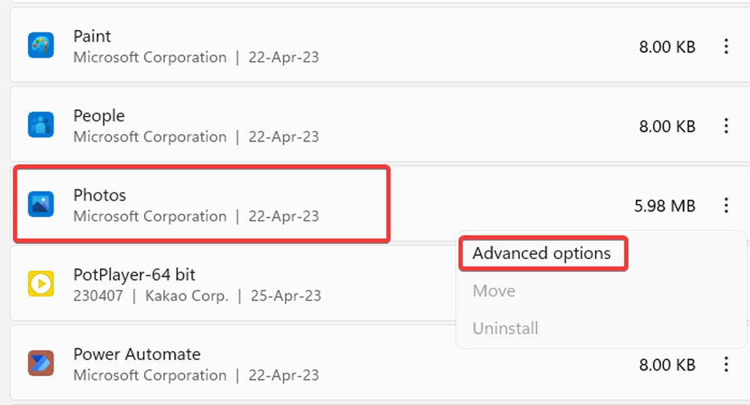

1. Click **Reset**. This will wipe all data from the Photos app, including any saved image presets or settings you may have had, and get it back to its original state.

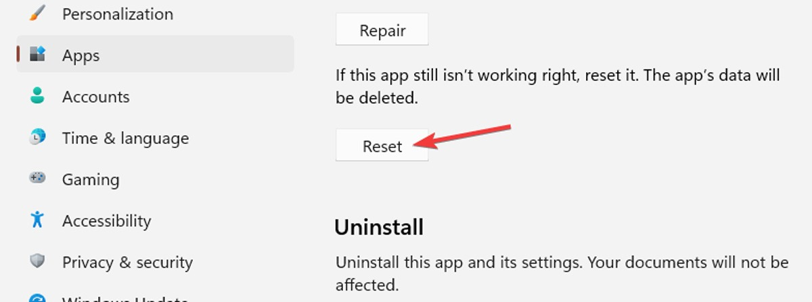

If none of these things resolve your issue, or you run into trouble, put in a TeamDynamix ticket or email adv_it@udayton.edu.

# Raiser’s Edge VDI View

There are two ways to access the read-only version of Raiser’s Edge on the VMWare Horizon VDI. The first method (recommended) is to access it by going to vdigateway.udayton.edu and accessing it through your web browser. This way is familiar although a bit more involved. The second method is to use the VMWare Horizon Client app on your computer. Use whichever method is most comfortable, and more importantly, the one that works best for you.

## Method One (Recommended): UD VDI Gateway

1. Open your web browser of choice using whichever method you normally use
2. Type “vdigateway.udayton.edu” (without the quotes) into the address bar near the top left

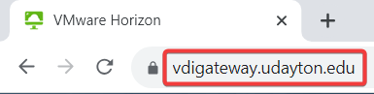

1. Click the **VMWare Horizon HTML Access** option

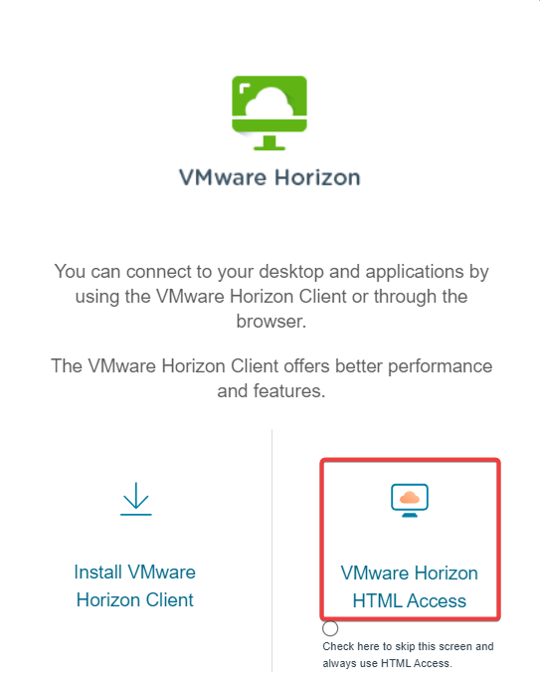

1. Enter your UD username and password
2. Click **Login**

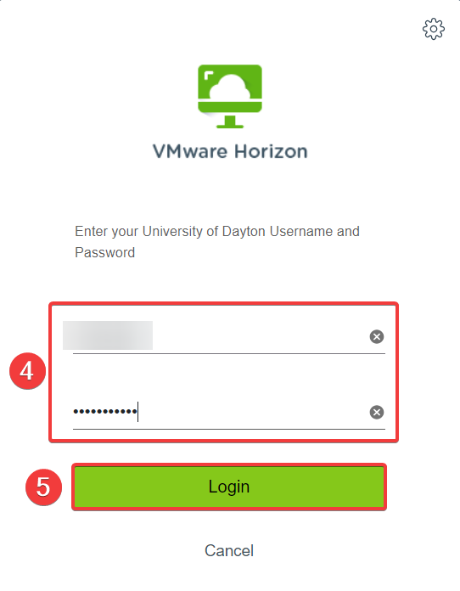

1. Enter the number that corresponds to your method of two-factor authentication (typically “1” for push to your mobile device)
2. Click

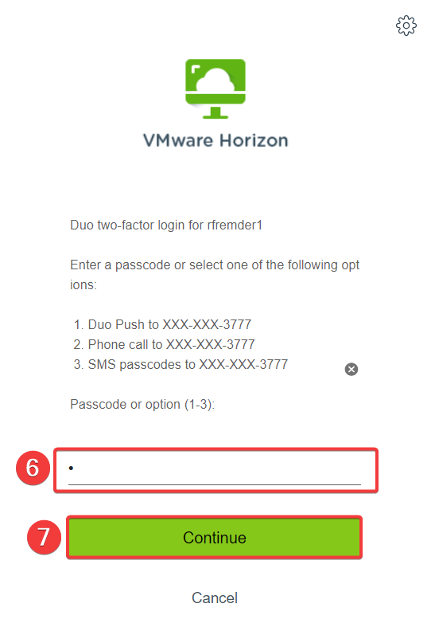

1. Select the **Raiser’s Edge** option   
   ***NOTE:*** *Your options will most likely be different from the ones shown below.*

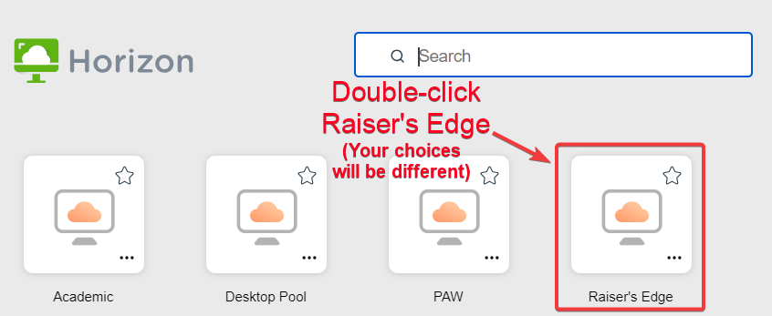

1. Screen option notifications:
   1. On the *Manage windows on all your displays*, select **Allow** to let the program utilize all of your connected displays or select **Block** to limit the program to just one screen

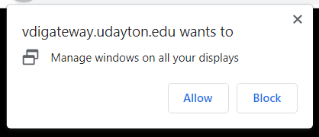

* 1. On the *Fullscreen* pop-up, you can select **OK** to go full screen or select **Cancel** to keep the screen the way it is  
     ***NOTE:*** *In order to get out of full screen, press and hold the* ***esc*** *key on your keyboard.*

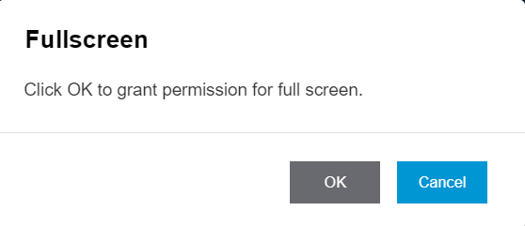

1. Log in to the VDI just like you were logging in to your UD laptop using your regular UD username and password. Press **Enter** on your keyboard or click the right-pointing arrow at the right end of the password field  
   ***NOTE:*** *It will take around a minute to log you in to the VDI desktop. Please be patient.*

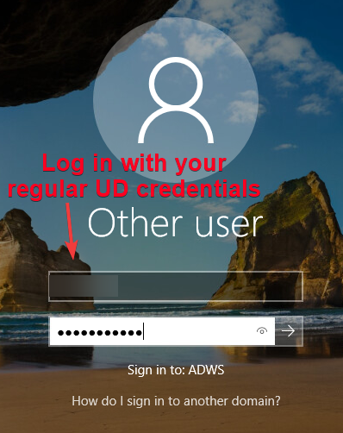

1. Once you have logged in, wait for the desktop to fully load and for the *Sign into Box* screen to pop up. You can opt to log in Box if you would like to utilize it, but it is recommended that you close out of the screen by clicking the “X” in the upper-right corner

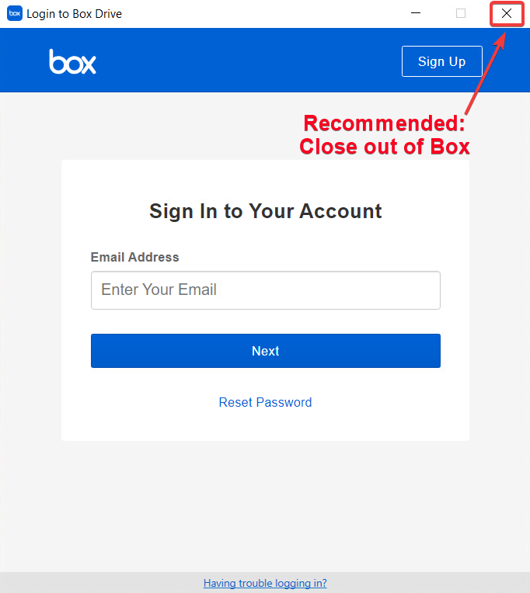

1. Double-click the orange RE icon on the desktop to launch Raiser’s Edge  
   ***NOTE:*** *This may take a moment or two for the screen to load. Please be patient.*



1. Once Raiser’s Edge opens, you can proceed with using RE

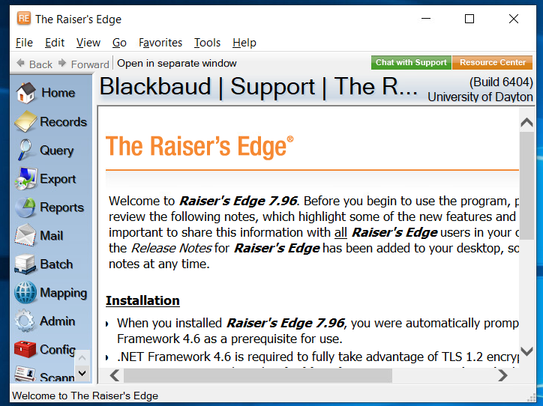

***NOTE:*** *Your Raiser’s Edge options along the left-hand side will look different than those in the screenshot above.*

### Sign Out

It is ***highly recommended*** that you log out of the VDI instance in order to be a good steward of our limited available connections. To do this, follow these steps:

1. Right-click the start button in the lower left corner of the screen
2. Move the mouse up to *Shut down or sign out* and wait for the flyout menu to appear
3. Click **Sign out**

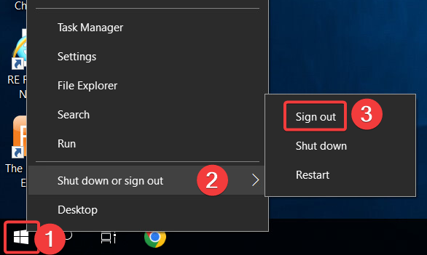

1. Once the VDI signs you out, click **Close** on the *Disconnected* pop-up and close your browser tab

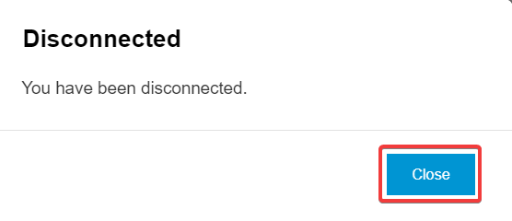

## Method Two: Use the VMWare Horizon Client App

### Verify VDI Client App Is Installed

The VDI Client application desktop icon looks like this:

If you do not already have the VMWare Horizon Client installed on your computer follow the instructions on how to install the VDI application below:

### Install VMWare Horizon VDI Using Portal Manager

***TIP:*** *The Ivanti Portal Manager allows you to download a variety of UD-approved software applications on a UD owned computer without an "administrator" password or assistance from the IT Service Center.*

1. Go to the Windows search bar and type “Portal”
2. The Portal Manager App appears in the Best Match section of the search results.  Click on the **Portal Manager** link.   
     
   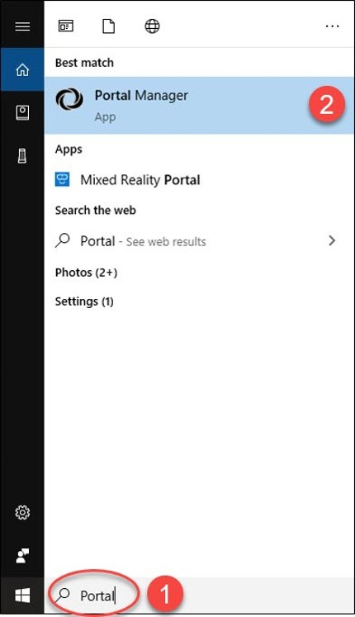

***NOTE:****Mac users:*

* 1. *Use the SpotLight search function*
  2. *Type “Portal” in the search bar*
  3. *Click the****Portal Manager****link*  
      

1. Scroll down through the list to *VMWare Horizon Client*, click the **Install** link, and follow the installation prompts. 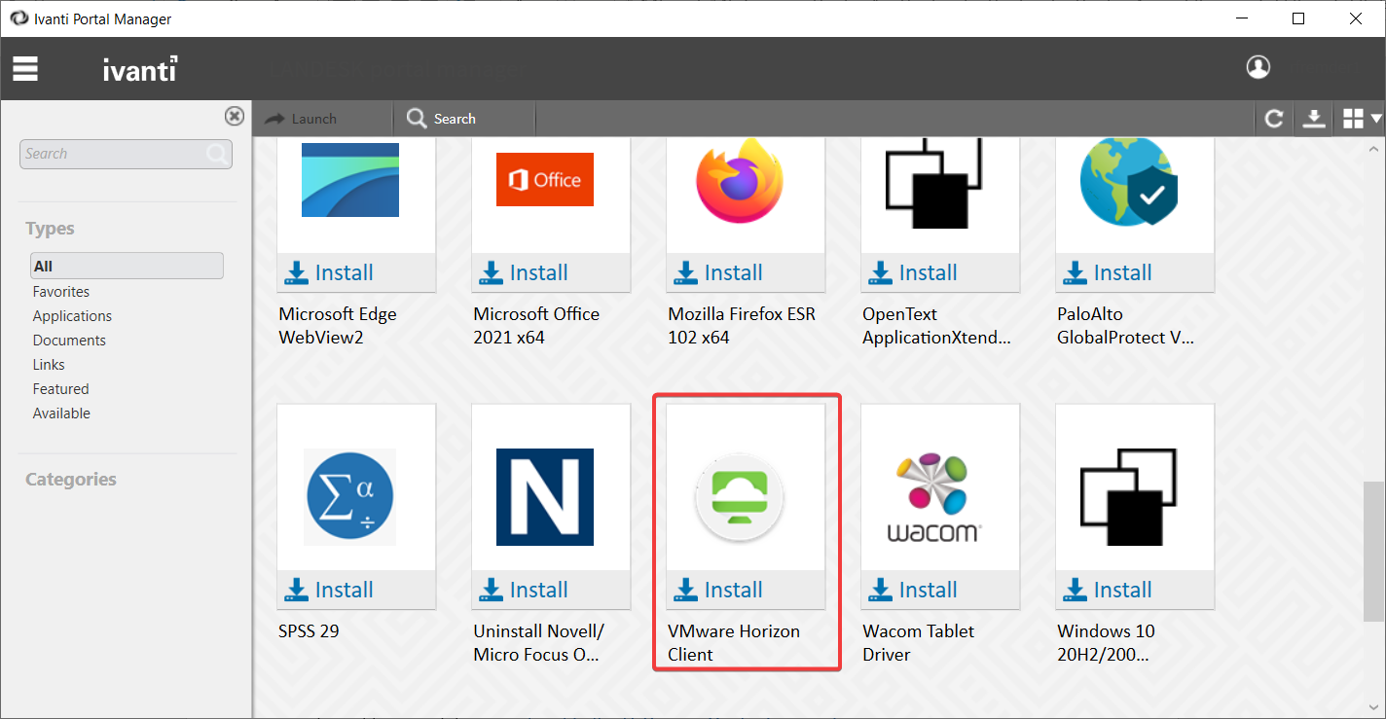

### Log In

1. After installing VDI click the “Windows icon”
2. Type “VDI”
3. Click **VMWare Horizon Client**

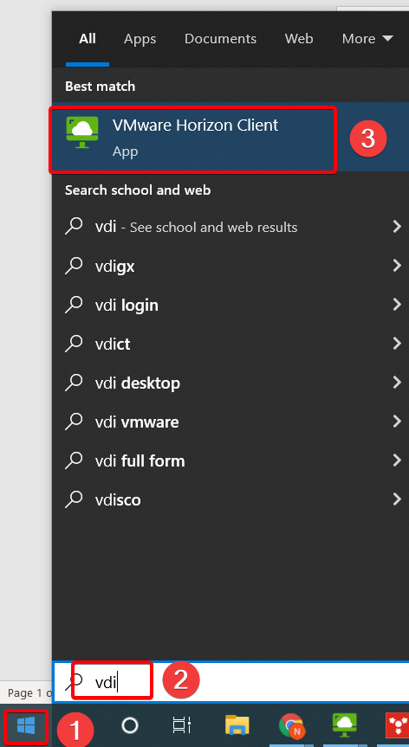

1. Double-click **vdigateway.udayton.edu**

***NOTE:*** If you don’t see this option, follow the **Missing VDI Gateway Steps** below, otherwise, continue with Step 5 on the next page.

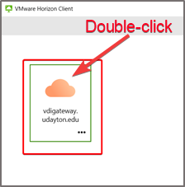

### Missing VDI Gateway Steps (2 Steps)

Only follow these two steps if the VDI gateway is missing in VMWare Horizon Client. Otherwise, continue to step 5 on the next page.

1. Double-click the "**Plus**" icon (Add Server) or single-click the **New Server** link  
   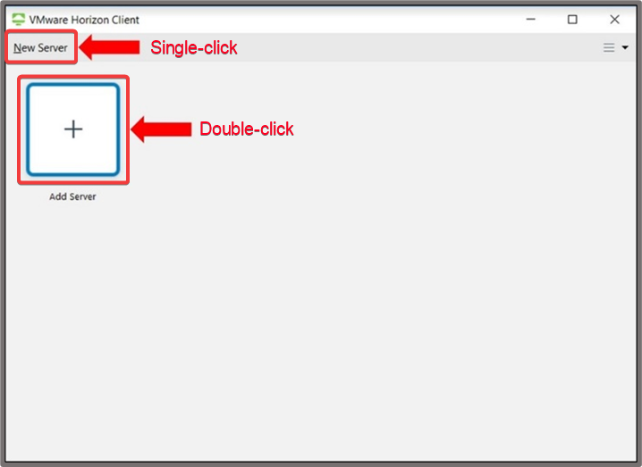
2. Copy and paste **vdigateway.udayton.edu** into the **Enter the name of the Connection Server** field  
   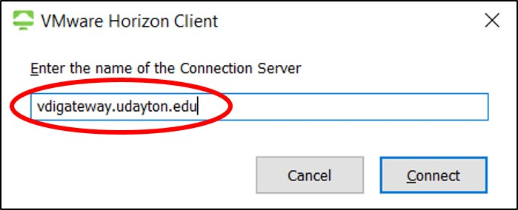

Return to step 4 (above) then continue to step 5 (next page).

### Log In (continued from above)

1. Enter your standard UD username and password and click **Login**

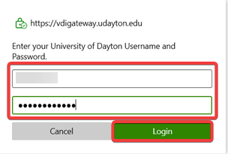

1. Depending on how Duo is set up, you may have to enter “push” or “1” to receive the DUO Two-Factor push and click **Login**

|  |  |
| --- | --- |
|  |  |

1. Double-click **Raiser’s Edge**

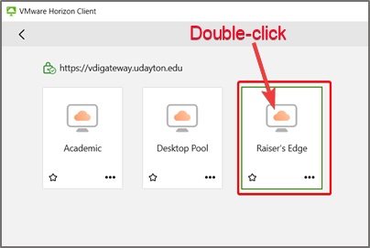

1. Log in with your regular UD username and password

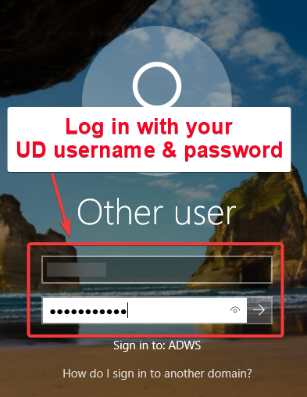  
***NOTE:*** *If you have trouble, you can also access this via* [*https://vdigateway.udayton.edu*](https://vdigateway.udayton.edu) *in your Google Chrome browser.*

1. Find the Raiser’s Edge icon on the desktop and double-click it (see next section Exporting Reports for information regarding Box login)

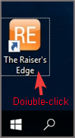

A similar screen should appear, and you now have access to Raiser’s Edge.

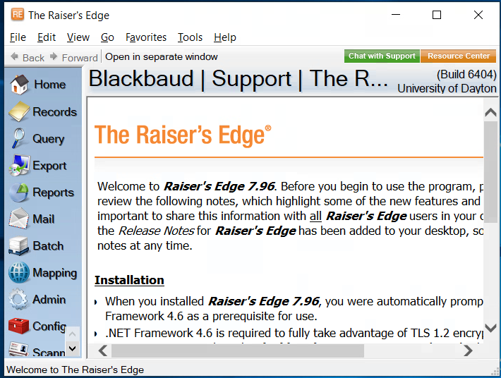

## Exporting Reports

In order to save exported reports from Raiser’s Edge, you should first log in to Box when the screen appears after you initially log in to the VDI. Follow these steps to log in to Box and then save the file to a location on Box. (***NOTE:*** *This may be different than what you were initially instructed. Disregard that and log in to Box.)*

1. Upon first logging in to the VDI, the Box login prompt will appear. This may be before or after Raiser’s Edge comes up depending upon how quickly you opened RE. Enter your UD email address in the *Email Address* field.
2. Click **Next**

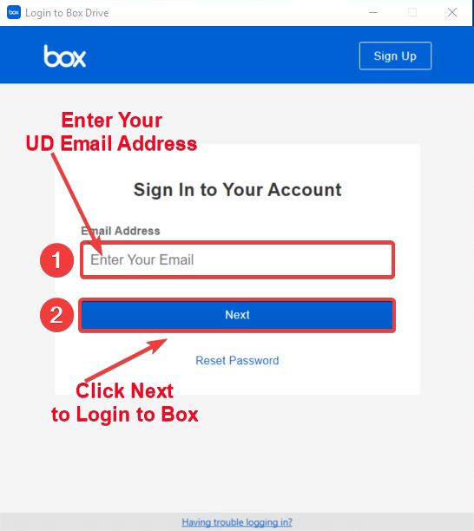

1. Enter your UD username and password in the corresponding fields
2. Click **Login**

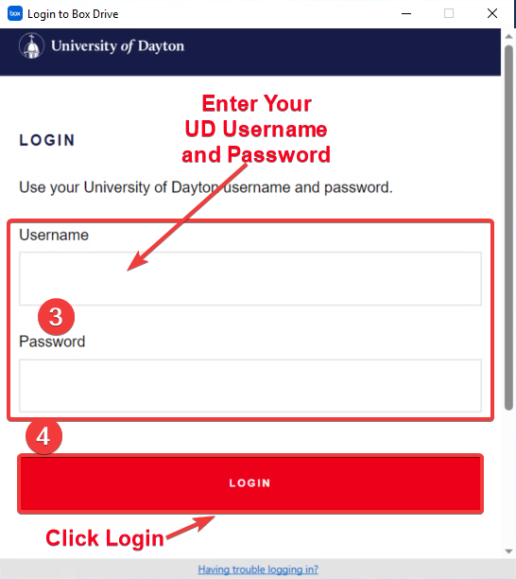

1. Select your Two-factor authentication method of choice

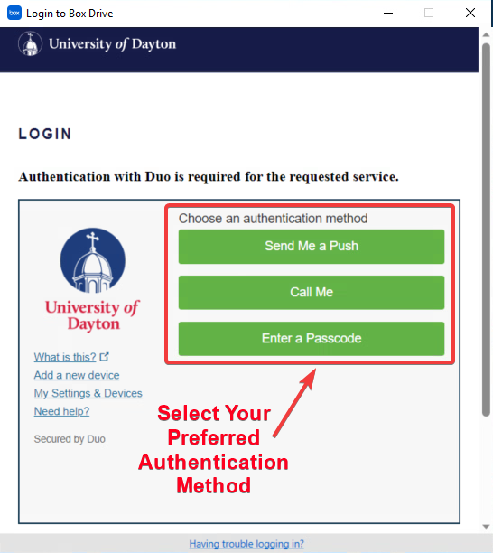

1. The *Welcome to Box Drive* screen will appear. Click the **X** in the upper-right corner (unless you would like to “Take the Tour” of all the wonderful features Box has)

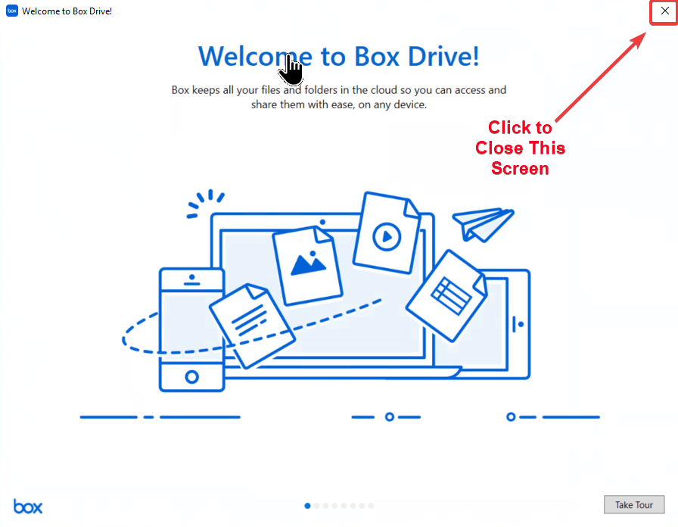

***NOTE:*** *A* ***Box*** *icon will appear on the desktop:*

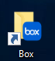

1. One you have closed the previous screen, a File Explorer window will open to display your Box folders

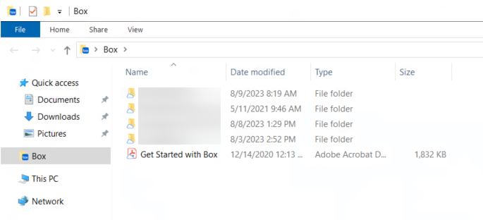

### Export from RE VDI

Follow these steps to export a report, file, query, etc. from RE into a folder on Box.

1. With Raiser’s Edge open, click **Export** on the left-hand column
2. Select the corresponding folder where the item you wish to export resides

***NOTE:*** *A search option is available in the lower-right corner if you know the name of the item you are exporting.*

1. Select the item that you wish to export in the main field
2. Click the **Export** button

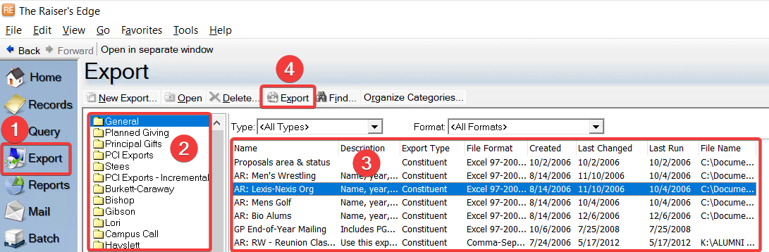

1. Select **Box** in the left-hand column
2. Browse to the location where you wish to save the export
3. Enter a name for the file
4. Click **Save**

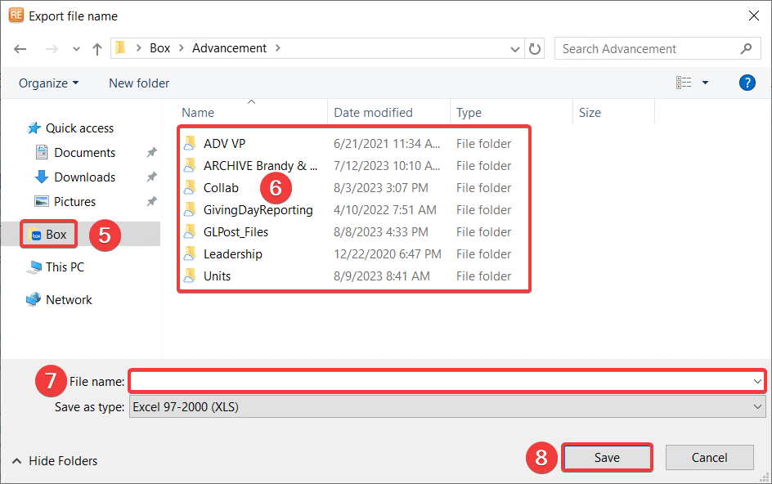

1. Wait while the system processes your request

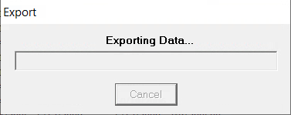

1. When the system has completed the export, a similar screen displays information about the export. Click **OK** to confirm

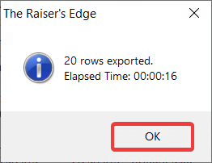

1. On your laptop, you may access the exported file by browsing to the Box folder where you saved it

# RE Microsoft Office Export Error

Example:

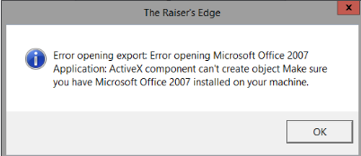

Blackbaud no longer has a contract with Microsoft that supports exporting files in Excel formats.

The fix for this is to export them as CSVs, see below for how to change this setting for a report/export.

## Change File Export Type

1. Open your Export and click **Tools > Export Options**

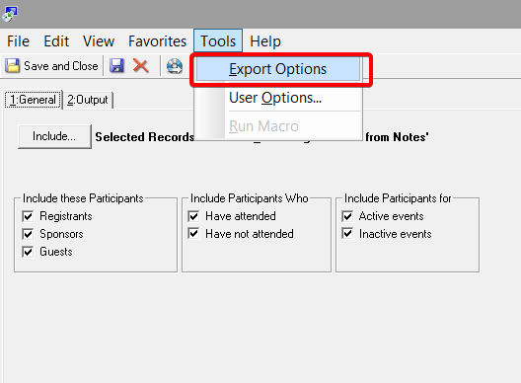

1. Click the drop-down arrow under *Export format*and select **Comma-Separated Values**

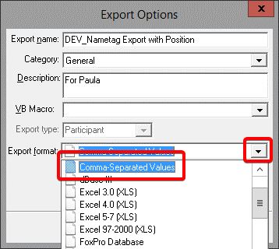

1. Click **OK**

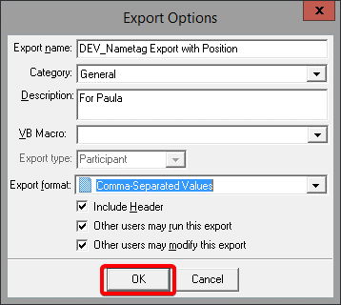

1. Click **Save and Close**

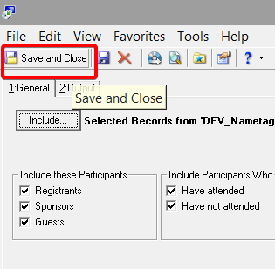

You can now run the export like you normally would. You will not have to do these steps again next time you want to use this specific Export as it will save this setting change. However, you may still have to go through this procedure with other Exports that have not been changed yet.

***NOTE:*** *Be aware if you would like to use any typical Excel features like functions, formulas, etc. make sure after you open the CSV file in Excel to re-save it as* ***Excel Workbook (*.xlsx)*** *file*

# Remote Support from Zoom

1. Go to go.udayton.edu/zoom
2. Click on **Settings** **> In Meeting (Advanced) >**
3. **Remote Support** and toggle it on.

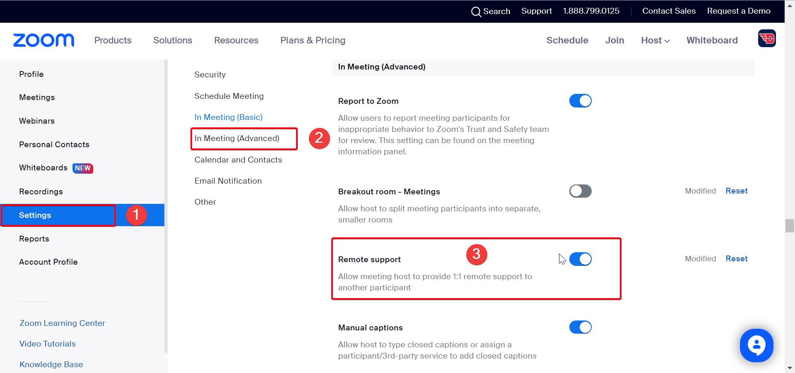

1. When you are on a Zoom meeting you can then click **More**
2. Then click **Support**

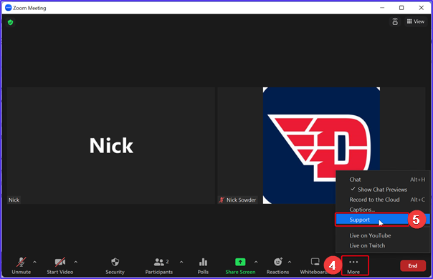

1. The user will be prompted to allow control.

# Restore Deleted Box Files or Folders

1. Navigate to the Box web portal by going to [go.udayton.edu/box](http://go.udayton.edu/box) and log in.
2. Select the Trash icon on the left side of the page.

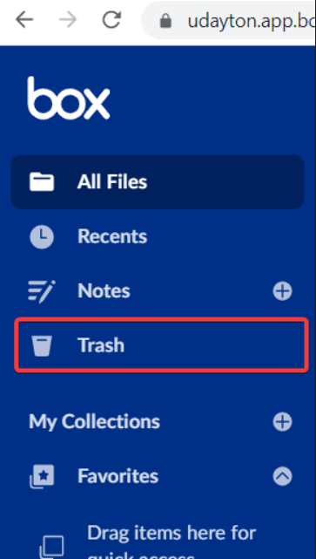

1. Find the file you want to restore and click the "**...**" button next to it and then select **Restore**

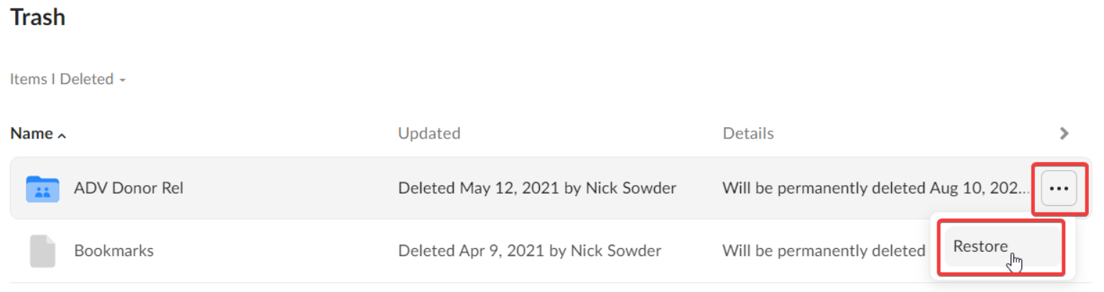

# **Setup Outlook for UD Email**

**This document's purpose is to show those who wish to use Windows Outlook how to set it up on their UD computer.**

## **Setup Outlook**

The following describes the process of setting up Windows Outlook on your UD computer.

1. Enter “Outlook” in the search field in the lower left corner next to the Start button
2. Click **Outlook (new)** app under the *Best Match* heading

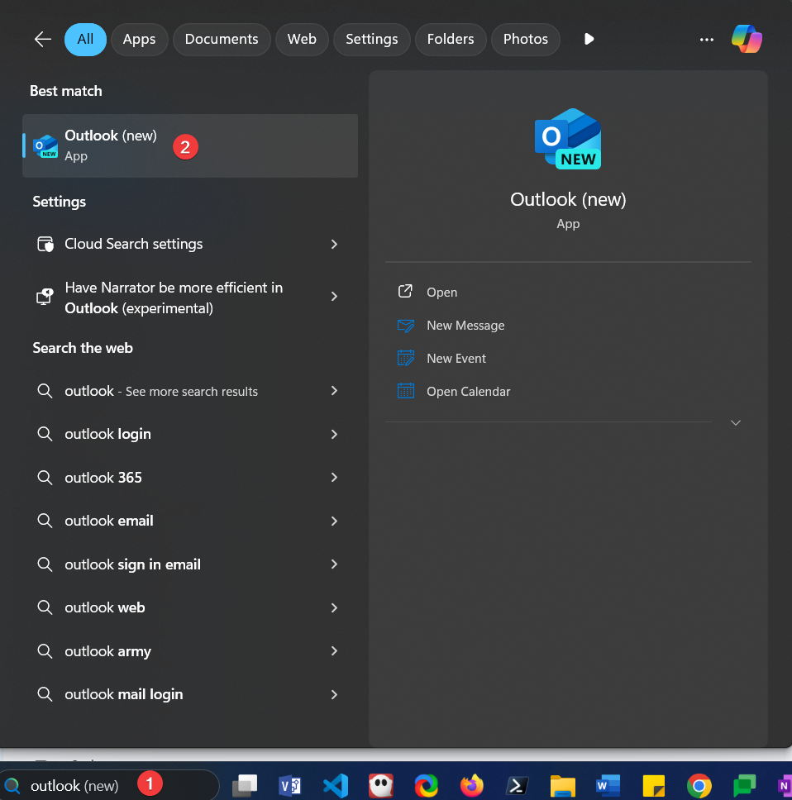

1. Click **OK** if the *newer version of Outlook* box comes up, otherwise proceed to the next step.

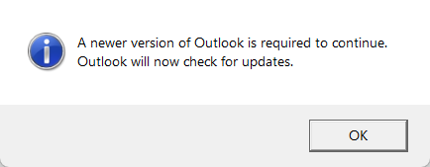

1. Click your UD email account name on the *Sign in with Google* page.

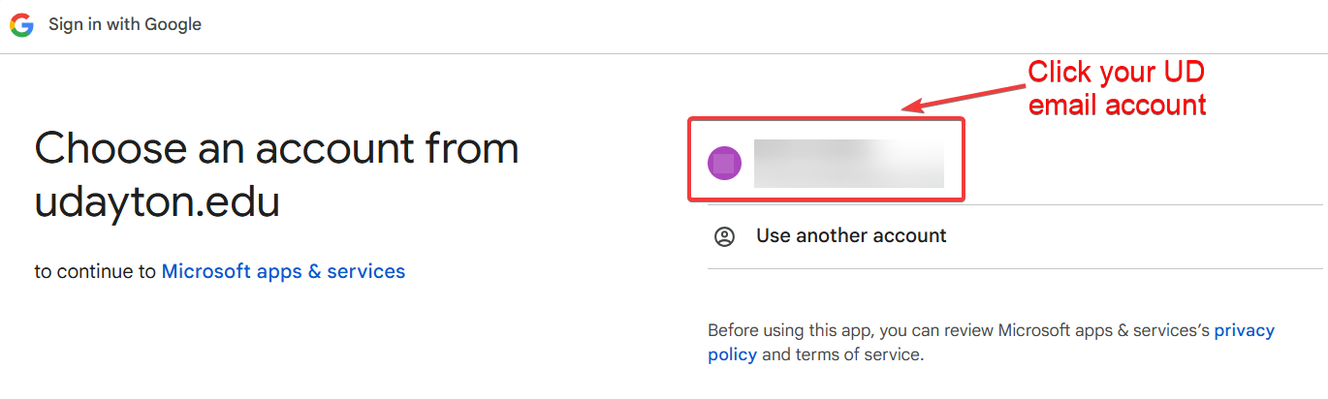

1. Ensure that your email address appears beneath “Sign in to Microsoft apps & services) and click **Continue.**

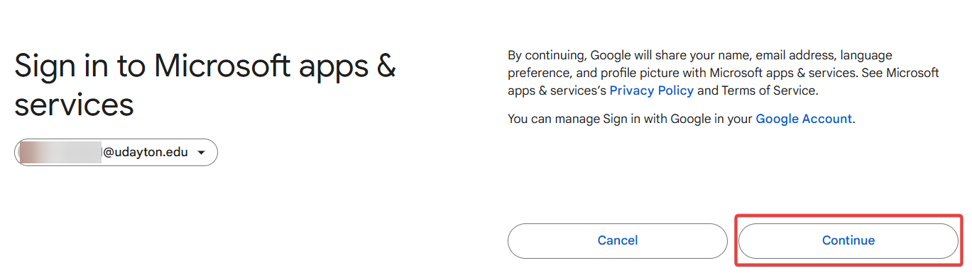

1. Click **Continue** again to indicate that you trust Microsoft services.

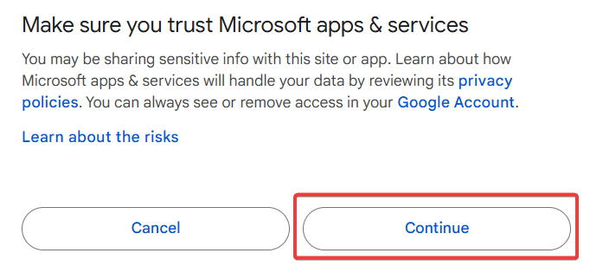

1. A webpage will open and the following notification will appear. Click **Open Outlook (new)**

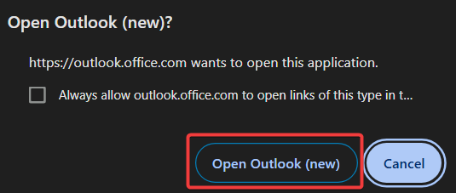

1. The Outlook app will open and welcome you back to the new Outlook. If you wish to see all the features, click through **Next**. Otherwise, click **Not Interested**.

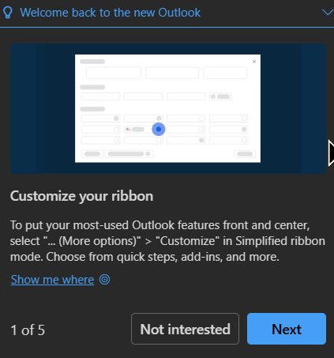

1. The following gives an example of what the new Outlook app looks like.

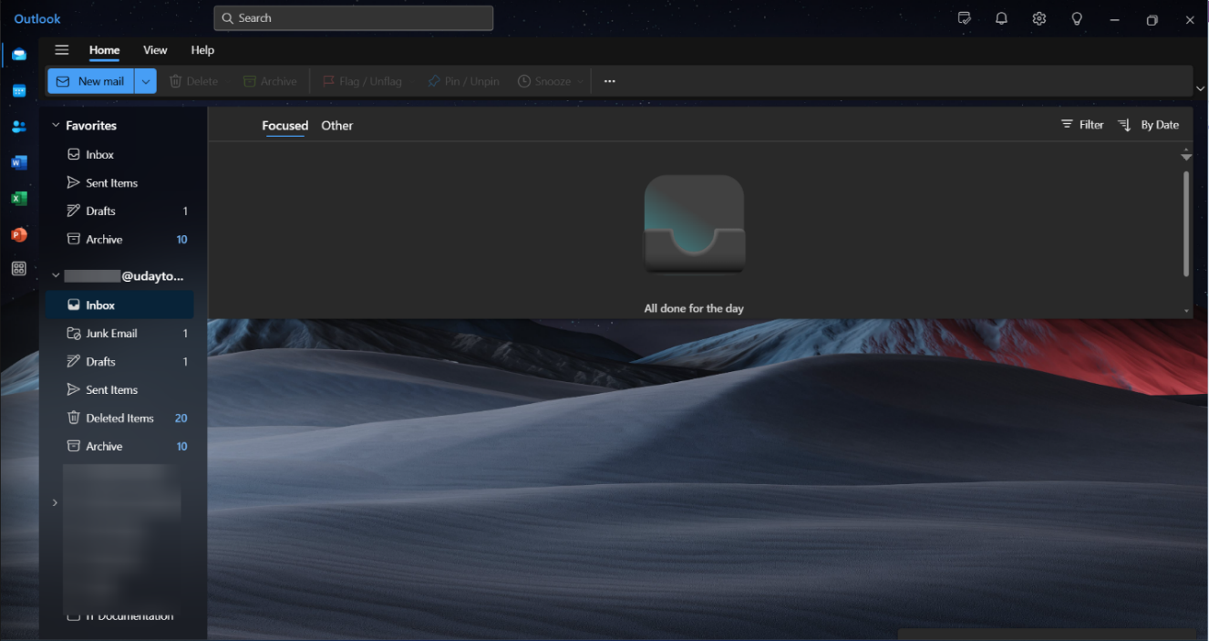

# Share Access to Your Google Calendar

The following instructions detail how to share access to your calendar. There are several access options that you can set based on what the person you’re sharing to needs. In this example we show how to delegate control of your calendar to someone else so that they can add/change events and meetings.

1. On your computer, open [Google Calendar](https://calendar.google.com/).
2. On the left side of the page, click **My calendars**.
3. Hover over your calendar, and click Options 

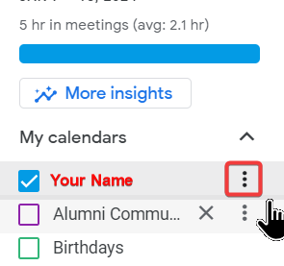

1. Select **Settings and sharing** from the list of options.

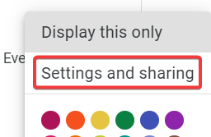

1. In the *Share with specific people* section, click **Add people and groups**.

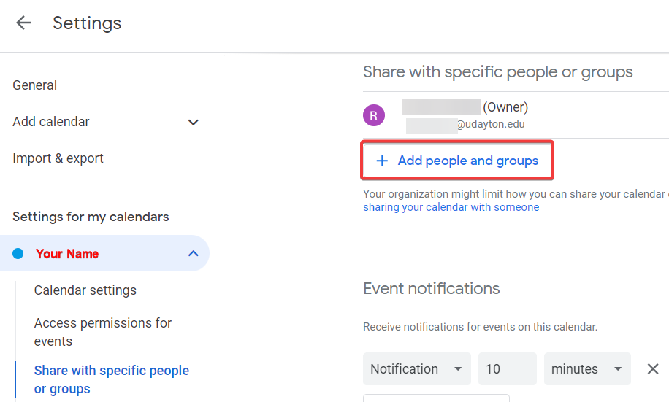

1. Enter the email address of the person or group you want to make an owner.
2. In *Permissions*, select **Make changes and manage sharing**.

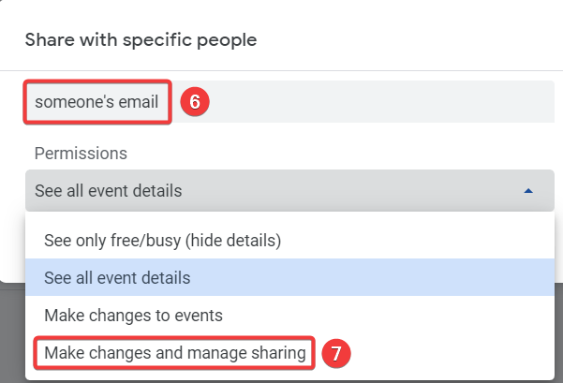

1. Click **Send**.

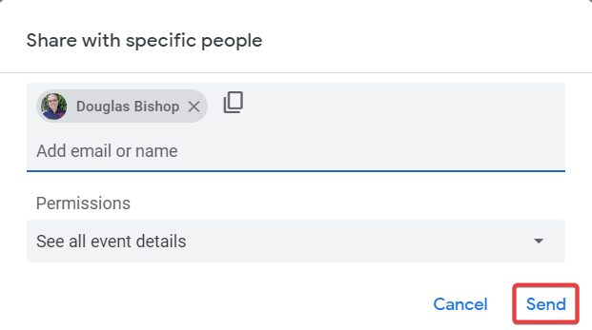

**These instructions detail how to change the settings in a calendar that is already shared to you.**

1. Go to your calendar
2. Click the **Settings** wheel in the upper-right corner

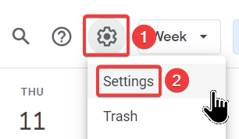

1. Scroll down the *Settings* column on the left side
2. Click your name which opens more setting options

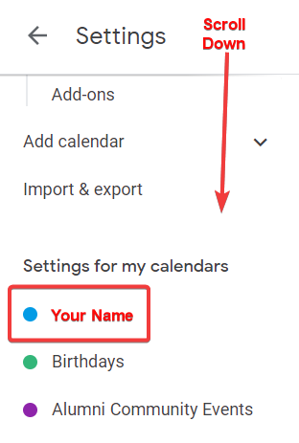

1. Scroll down the middle column to the *Access permissions for events* section
2. There will be a name or email address for the calendar you wish to sync with. Click **Make Changes and Manage Sharing** from the drop-down.

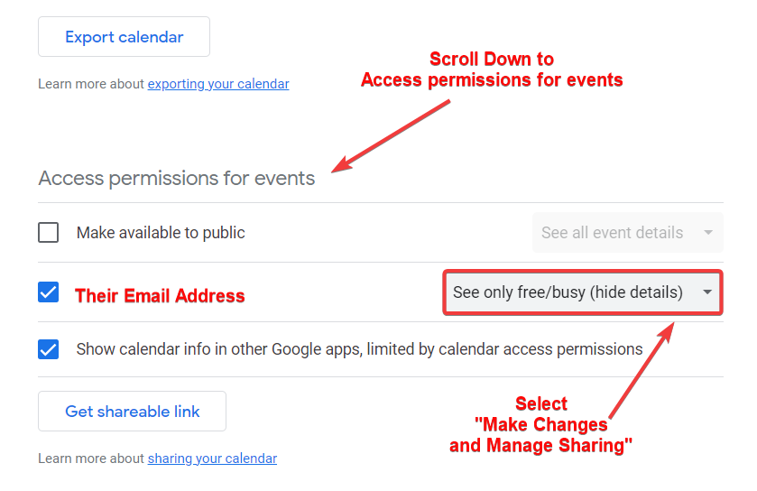

1. Refresh your calendar page (F5 on your external keyboard or fn + F5 on the laptop keyboard), and it will be moved from *Other calendars* to the *My calendars* list.

# Sign in to the Zoom App on Your Computer

1. Click on the **Windows Key** in the bottom left-hand corner of your screen
2. Start typing **Zoom**
3. Click on the **Zoom** app

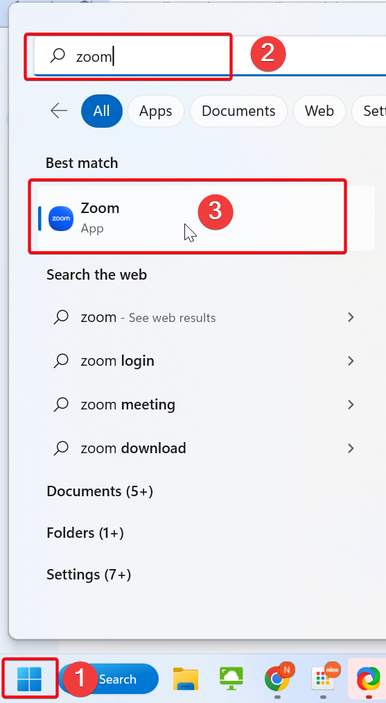

1. Click on **Sign In**

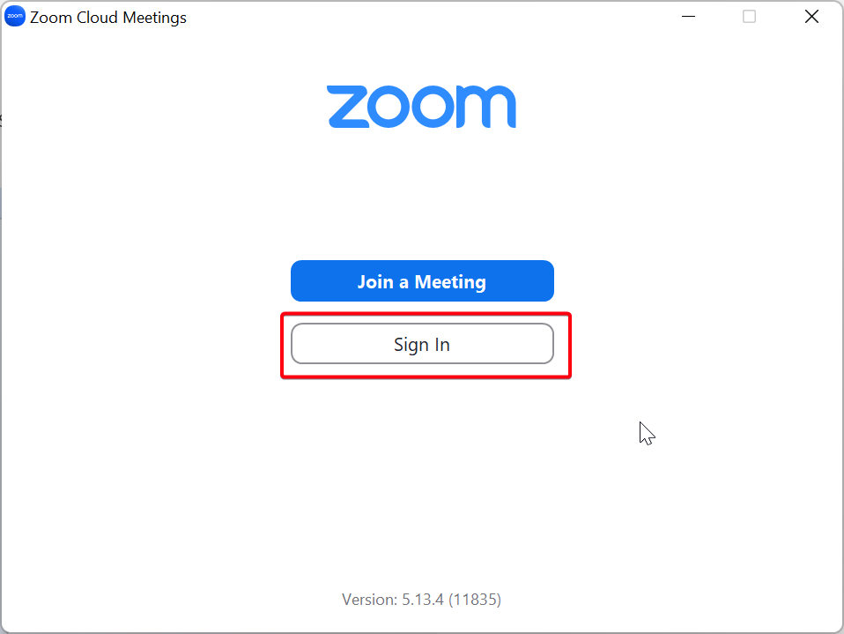

1. Click **SSO** at the bottom of the window

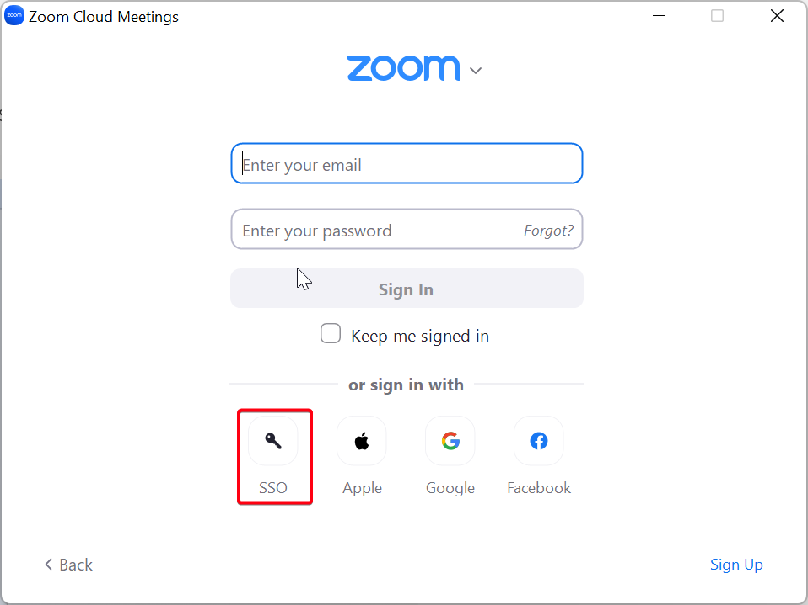

1. If prompted for a **Company Domain** enter “Udayton” (no quotes needed)
2. Click **Continue**

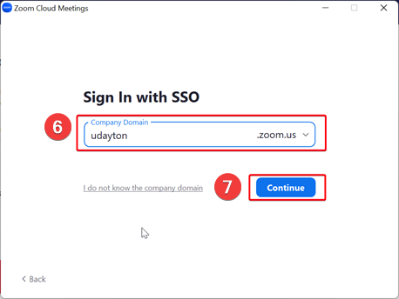

1. This will take you to your standard UD login page.

# TeamDynamix Guide

The Service Catalog contains a variety of services from various departments (e.g., Advancement, HR, Legal Affairs, Office of Diversity and Inclusion, Office of Learning Resources, UDit) and are available to University faculty, staff and students. Services include tuition assistance for dependent child or spouse, work and move requests, procurement and payment services request, 2-Factor Authentication (2FA) token activation, voicemail password reset request, a general IT support request, and more.

## Request a Service

Navigate to the UD Service Catalog by going to [go.udayton.edu/servicecatalog](http://go.udayton.edu/servicecatalog).

1. Click the **Request a Service** link on the *Service Catalog Tools* right sidebar or click on the **Services**link within the bullet list of Service Catalog options.

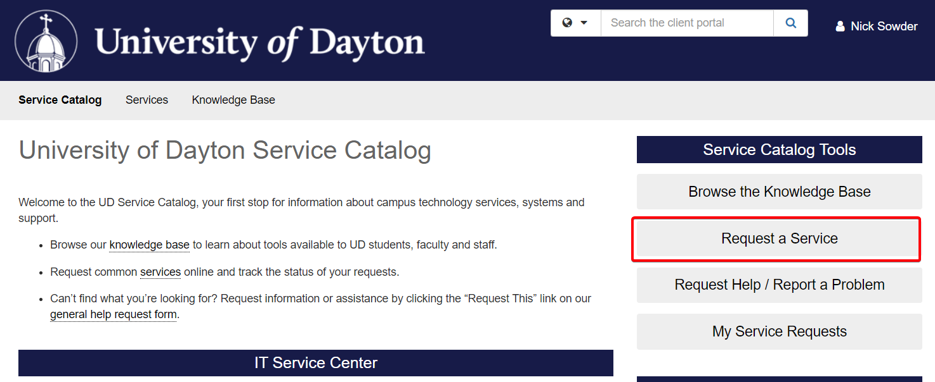

1. Browse through the service categories and click on a category name link. Each category has a short description and is named according to the type of services it contains. Some categories have subcategories with more services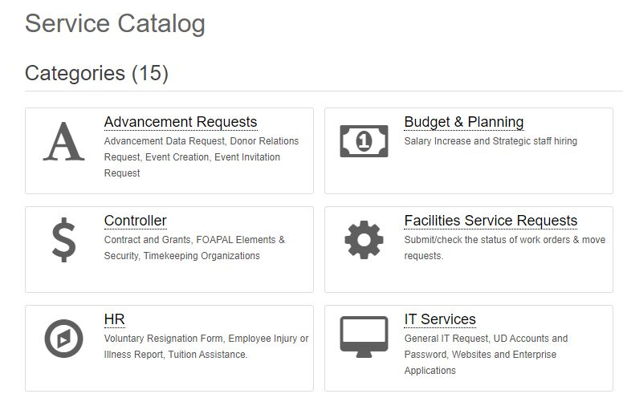
2. Click on a service title link. Each service contains a service overview. If you selected an incorrect service, click on the **Service Catalog** link and locate the appropriate service.  
     
   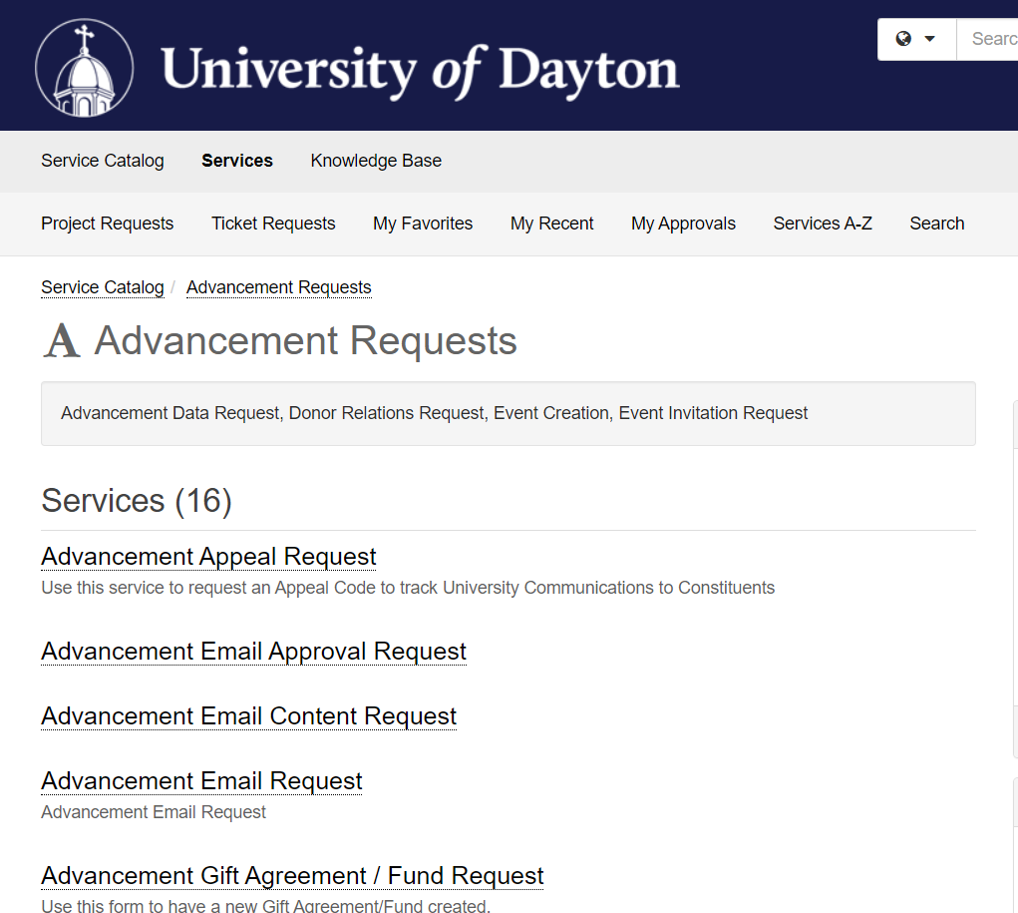
3. Click the **Request This**link and complete the form.  
     
   
4. Click **Request**. Your service request will be sent to the appropriate customer service representatives.

***IMPORTANT!!!****To avoid delays in service, do not randomly select and submit a form. Carefully read the form's description before making a selection.  This will ensure that the form is sent to the appropriate customer service representatives.*

## Search for a Service Request

If you can't figure out where a service is located, use the search option.

1. Click on the search bar.  
     
   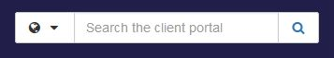
2. Filter the search to Service Catalog requests by clicking on the drop-down list to the left of the search bar and selecting **Service Catalog**.  
     
   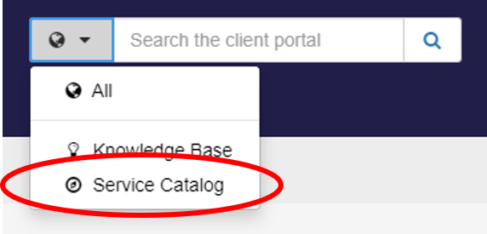
3. Type an item that you would like to search for.  
     
   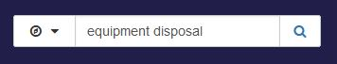
4. Press the <ENTER> key on your keyboard or click the search icon.

## Track a Service Request

Click the **Sign In** link located to the right of the search bar. Enter your university username and password and enter your 2FA (2-factor authentication) credentials.

The status of service requests can be viewed by clicking on the appropriate link within the *My Recent Requests*sidebar.

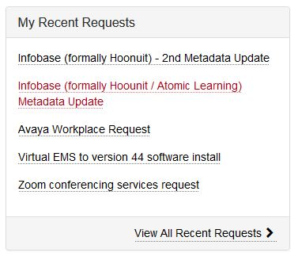

# **UD Email on Your Phone**

**The purpose of this section is to show how to add your UD email to your personal device such as an Android phone, iPhone, or iPad. We will guide you through the steps of using the default app on the phone (such as the Apple Mail app), and we will also walk you through the process of downloading the Gmail app and getting it set up that way.**

**For more information about UD email, visit the following link on the UD knowledgebase:** <https://udayton.teamdynamix.com/TDClient/1868/Portal/KB/ArticleDet?ID=46933>**.**

***IMPORTANT!!!* *As of late September 2024, password-only access to your UD Gmail is no longer supported. This sign-in method utilizes Less Secure Apps (LSAs) that is, as the name suggests, less secure. If you begin running into issues with email on your phone, you may want to follow the instructions to remove it and then add it the more secure way using the “Gmail” option.***

## **iPhone**

**A lot of us use iPhones. They have become the standard by which all other phones are measured. In this section, we will discuss how to add and remove UD email from your iPhone’s default Mail app as well as how to download the Gmail app and get mail set up.**

### **Add to Mail App**

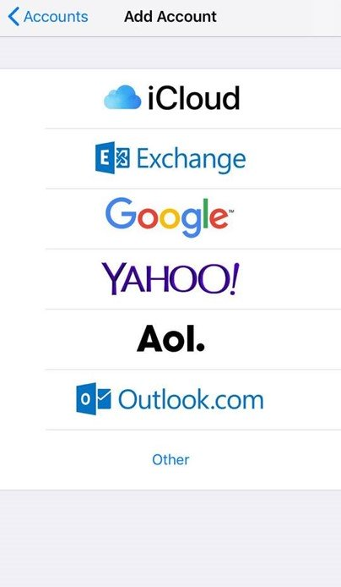**Whether you are using an iPhone, iPad, or one of the ancient iPod Touch devices, follow these steps to get your UD email working on the Mail app.**

1. On your iOS device, open **Settings**.
2. Depending on your iOS version, do one of the following actions:
   * Tap **Mail > Accounts > Add Account**.
   * Tap **Passwords & Accounts > Add Account**.
   * Tap **Mail, Contacts, Calendars > Add Account**
3. Tap **Google**.
4. Sign in using your UD account credentials (use your UD email address). Then do the 2FA, as normal.
5. Close the settings and open the **Mail** app.

### Remove from Mail App

The process may look different depending on which device you’re using, but basically, you do the opposite of what you did when you added the email account.

1. On your iOS device, open **Settings**
2. Depending on your iOS version, do one of the following actions:
   * Tap **Mail** > **Accounts**
   * Tap **Passwords & Accounts**
   * Tap **Mail, Contacts, and Calendars**
3. In *Accounts*, select your UD email account.
4. Tap **Delete Account** in red. If requested, provide confirmation.

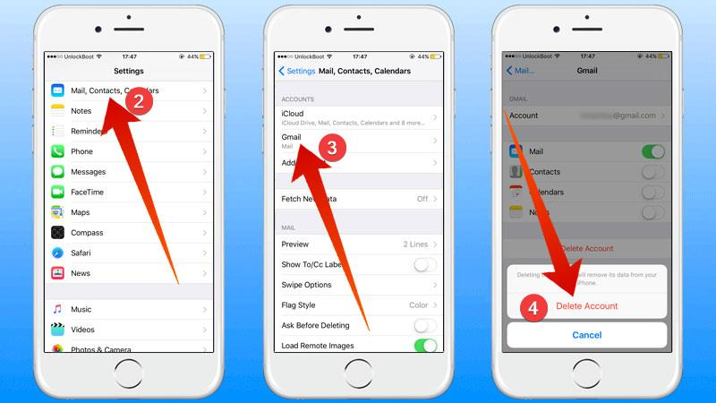

### Add to Gmail App

1. Open the **App Store** app and search for Gmail. Locate the app entitled *Gmail - Email by Google* and tap the **Get** button next to it.

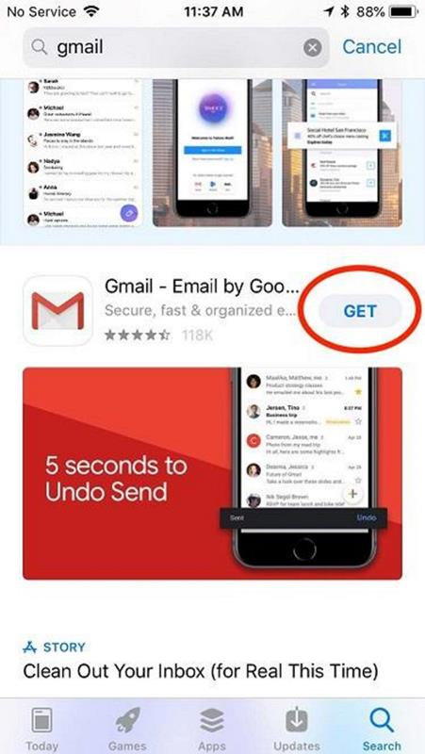

1. Open the Gmailapp and tap **Sign in** if prompted.
2. Tap **Add account** on the following screen.

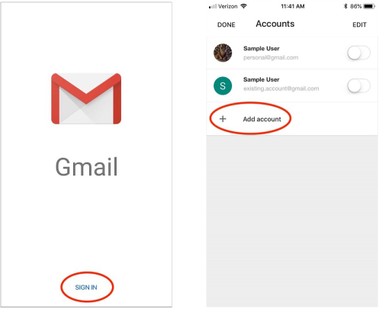

1. Select **Google** from the list of providers. A popup will tell you that "Gmail" wants to use "google.com" to sign in. Tap **Continue**.

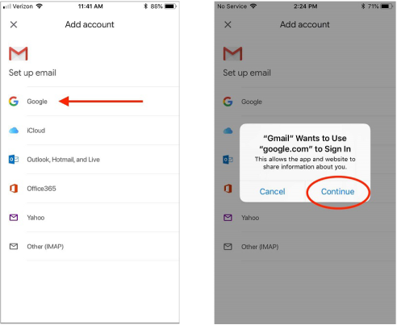

1. Enter your UD email address in the *Sign in* field and tap **Next**.

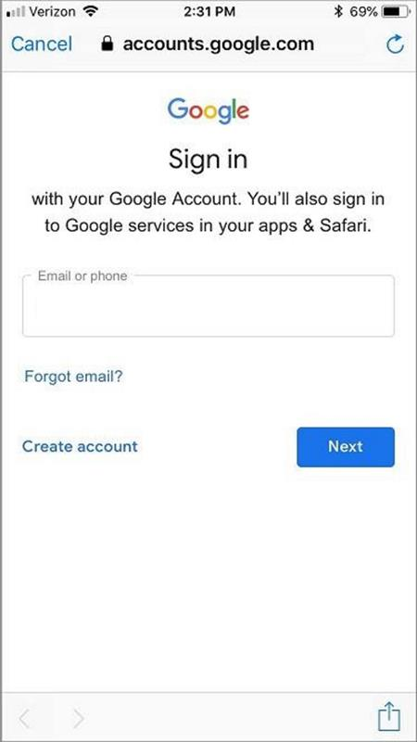

1. You will now be prompted to log into your account again via Online Services. Enter your username (without the '@udayton.edu') and password, and tap **Login**.

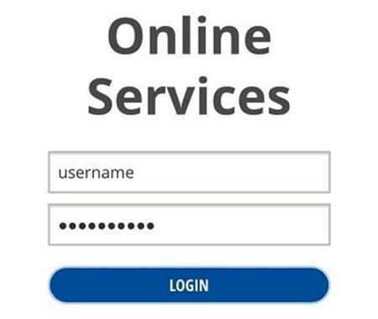

1. Once logged in, you should now see your UD email account appear in the list of accounts. Make sure that the slider next to it is green, and tap **Done**.

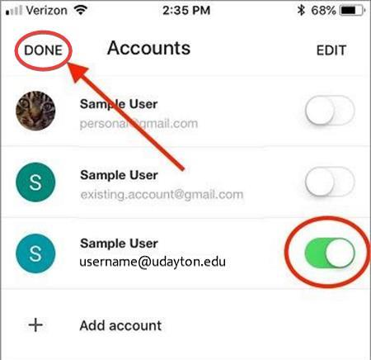

1. Gmail will ask you if you want to turn on Notifications. Tap **Allow** or **Don't Allow** depending on your preference.

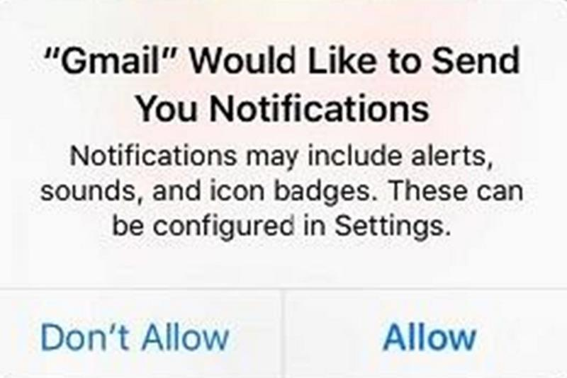

1. You may be shown a splash screen that says "Gmail has a fresh new look." Tap **Next**, and you will then be asked to choose between 3 different views that show varying levels of detail. Tap **OK** once you've made your selection.

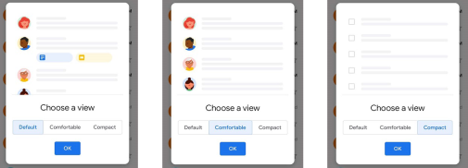

1. Your email should now be all set up! If you have other accounts on the Gmail app, you can tap the circle with your initial in the top-right of the screen to switch between them.

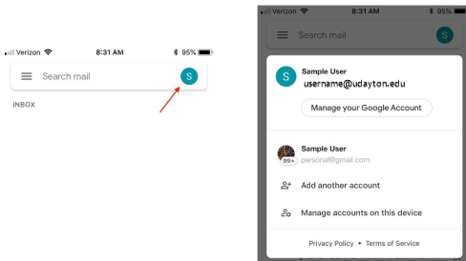

1. If you want to sync your Calendar items and Contacts to your device as well, you can open your Settingsapp, scroll down to **Passwords & Accounts** and tap it.

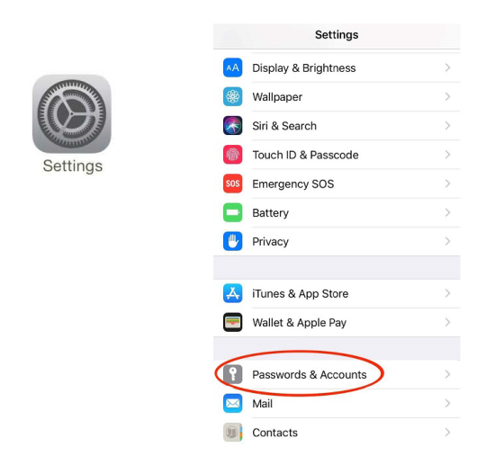

1. Tap **Add Account**, then select **Google**from the list that follows.

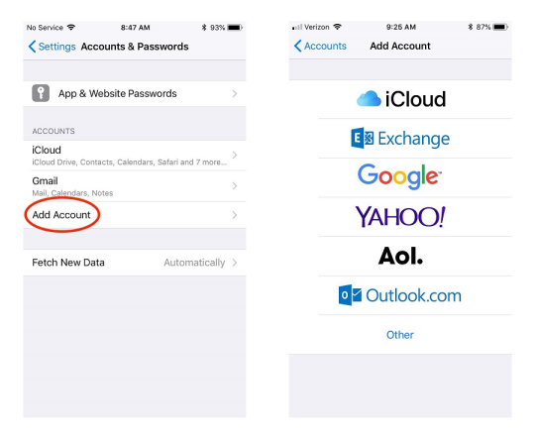

1. Just as you did earlier, you will need to sign into your Google account. Enter your email address and tap **Next** when prompted.

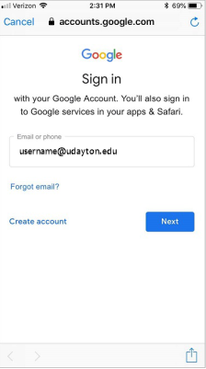

1. Sign into your UD Online Services using your username and password. Tap **Login** once you're finished.

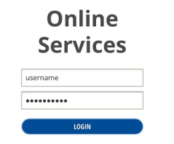

1. Make sure Contacts and Calendars are both toggled **ON** in the list that follows, and that Mail is toggled **OFF**.   
   ***NOTE:*** *Mail should be toggled OFF since you are using the Gmail app.*
2. Tap **Save**. Your calendar items and contacts should now populate locally on your iOS device.

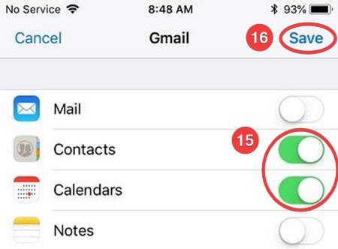

## Bonus: Account or Profile-Driven (User) Enrollment

The following steps (steps only, no screenshots) are bonus content, should not be undertaken, and are NOT recommended. They are provided for Power Users who wish to devote their entire phone to the University of Dayton. This will enroll you into UD’s Google Workspace and subject your phone to having administrative management from UDit. Again, this is not recommended and not something for the faint of heart.

### Account-Driven Enrollment

This will install UD’s Google Device Policy app and configuration profile. Tap to enable **Google Device Policy** to get apps that UDit approves for work.

1. On your iOS device, tap **Settings > General > VPN & Device Management > Sign In to Work or School Account**.
2. Sign in using your UD (Google Workspace) account.

### Profile-Driven Enrollment

1. On your iOS device, open the **App Store** and search for a Google app, such as Gmail.
2. Follow the on-screen instructions to download and install the app.  
   You might need to enter your Apple ID and password.
3. When the installation is complete, open Gmail .
4. Tap **Sign inGoogleContinue**.
5. Sign in using your Google Workspace account.  
   Your Google Workspace account is the account that you use for work or school.
6. If you want to receive notifications from Gmail, tap **Allow**.
7. If you’re prompted to download a configuration profile, tap **Next**, or choose an option:
   * To let your administrator manage the whole device, tap **Continue with device enrollment**.
   * To let your administrator manage only work apps and data, tap **Continue with user enrollment**.
8. Follow the Steps below to download the configuration profile.

### Install the Configuration Profile

1. Tap **Allow** to download the configuration profile.
2. Tap **Close >** open your **Settings** app.
3. If you followed the previous steps for profile-driven enrollment, tap **General> VPN & Device Management**.
4. Depending on your administrator's settings, do one of the following actions:
   * Tap **General > Profile > Google Apps Device Policy Profile**.
   * Tap **Profile Downloaded**.
5. Tap **Install**.
6. If prompted, enter your device passcode and tap **Install**.
7. Depending on your administrator's settings, do one of the following actions:
   * Tap **Install > Trust**.
   * Tap **Continue >** sign in with your work account.
8. Tap **Done** or **Continue**. If your administrator needs to approve your device, you’ll get a message at your work or school email address.
9. If you see a prompt to install the Google Device Policy app, tap Install and follow the prompts. For details, follow the steps below to install the Google Device Policy app.
10. Close your **Settings** app.

To get work apps, tap to enable **Google Device Policy**. Tap **Menu** > **Apps**.

### Install the Google Device Policy App

1. Choose an option:
   * If your device prompted you to install the app, tap **App Store**.
   * If you didn’t see a prompt, open the **App Store** and search for **Google Device Policy**.
2. Follow the on-screen instructions to download and install the app.  
   You might need to enter your Apple ID and password.
3. Tap to enable Google Device Policy, read and swipe through the information screens, and tap **Continue**.
4. If you want to receive notifications from the app (recommended), tap **Allow**.
5. Tap **Get started** and sign in using your Google Workspace account.  
   Your Google Workspace account is the account that you use for work or school.
6. Tap **Accept** to agree to the Terms of Service.
7. If you haven’t already done so, tap **Download** and follow the steps to install the configuration profile.

## Android

There are many different phones that run an array of different versions of the Android operating system. This guide will give a general description of the steps to get your UD email working on whatever email app that is installed on your phone. The majority of the time, the default email app is Gmail. There are many others that can be used including Outlook, Samsung Email, Proton Mail, and Blue Mail (the app the author of this guide uses). For the purposes of this guide, we will only focus on the Gmail app.

### Add to Gmail App

As stated above, the assumption for this section is that you already have the Gmail app installed on your Android phone.

1. Open the Gmail app
2. Tap your profile picture in the top right
3. Tap **Add another account**
4. Select **Google**
5. Follow the on-screen steps to add your account

### Remove from Gmail App

1. **Open the Gmail app**
2. **Tap your profile picture on the top right**
3. **Tap Manage accounts on this device**
4. **Tap Accounts or Users & accounts**
5. **Select your UD email account**
6. **Tap Remove account**
7. **Tap OK**
8. **Enter your device's PIN, pattern, or password if prompted**

# UD Wireless

## Windows 10

Support for Windows 10 goes away in October of 2025. At that time, it is not recommended to use that operating system.

1. Click on the Globe or Wireless icon at the bottom right-hand corner of the page
2. Select “**UDconnect**”

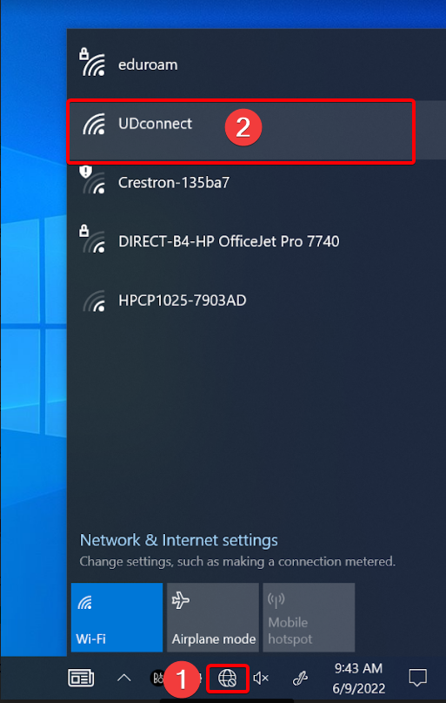

1. Open a web browser and enter the URL “**safeconnect.udayton.edu”**
2. Under the *Guests*section select **Login in to UDconnect**

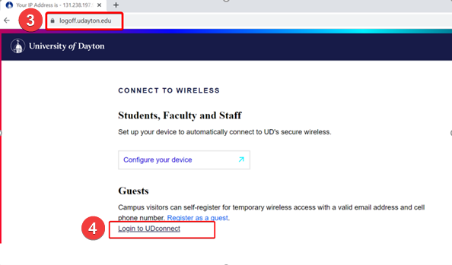

1. Enter your UD username and password then click **LOG IN**

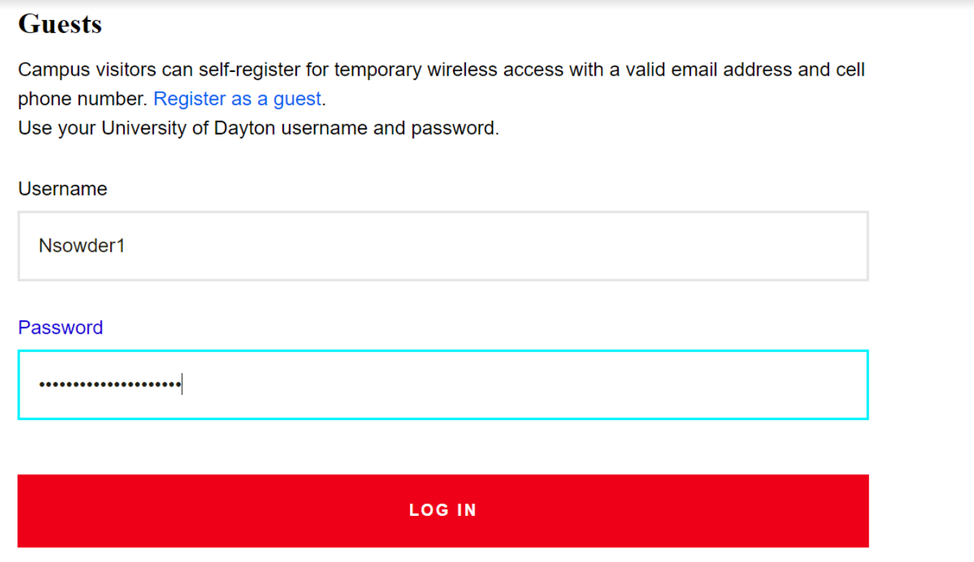

You are now connected to UD Wi-Fi.

***NOTE:*** *It may take a minute or so for the connection to become active.*

## Windows 11

This section shows how to connect to the wi-fi and set up Eduroam using Windows 11.

1. Click on the Globe or Wireless icon at the bottom right-hand corner of the page
2. Select the left-pointing arrow



1. Select **UDconnect**



***NOTE:*** *From this point, guest users can connect to UDConnect, visit safeconnect.udayton.edu in a browser and select the option to register as a guest.*

1. Open a web browser and enter the URL “**logoff.udayton.edu”**



1. Select **Windows 10 & Above**
2. Click **JoinNow**

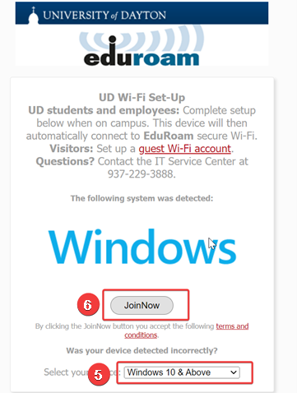

1. Once Eduroam file finishes downloading, click on it to run. Click **Yes** to any Windows prompts that appear



1. Enter your UD **Username** and **Password**
2. Click **Next**

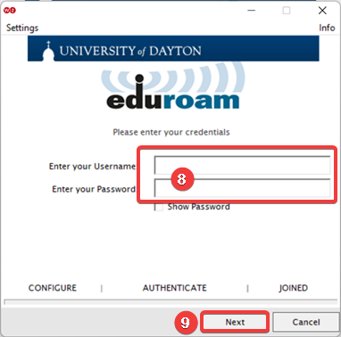

Once it says “Connected” you are all set!

## Update Microsoft Office

This section will show you how to install Office Updates. This is usually handled by UD IT’s monthly updates they push out, but as we all know, sometimes updates cause other things to start acting “wonky” and require attention. Should you find your Office programs aren’t behaving, they might need updated. Here’s how to do that.

1. Open your favorite Microsoft Office program (Word, Excel, PowerPoint). In this example, we are using Excel.  
   ***NOTE:*** *If you already have a document or spreadsheet open, you will need to click* ***File*** *in the upper-right corner.*
2. Navigate to and click **Account** in the lower-right corner

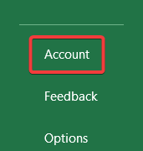

1. Near the center of the screen, click the **Update Options** drop-down
2. Click on **Update Now**

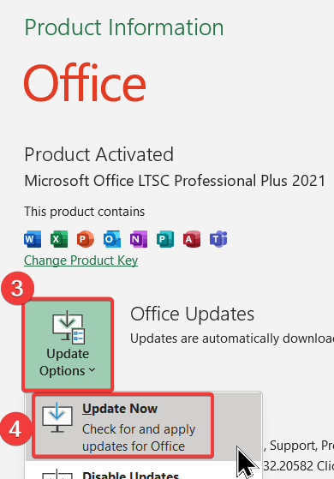

1. You will briefly see a progress bar as it checks for updates

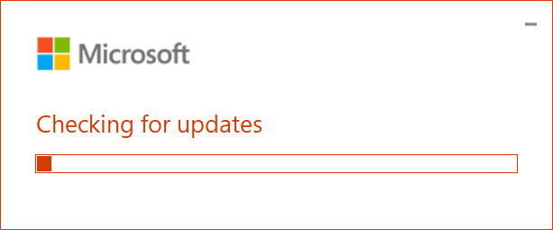

1. If it finds updates, it will inform you to save and close all open Office apps. Once you’ve closed them, the update will proceed. Once you see the screen below, Office has been updated, and you may click the **Close** button. You can then open the Office app that was causing issues to see if it works.

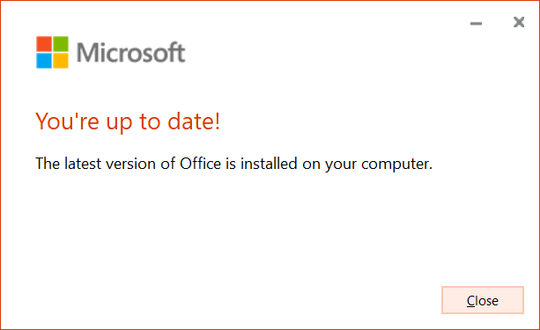

***NOTE:*** *Depending on how your computer is set up and your level of access, you may not have the Update option available.*

# Update Zoom

1. Click on the Windows Icon in the lower left-hand corner
2. Type “Zoom”
3. Select the **Zoom** app.

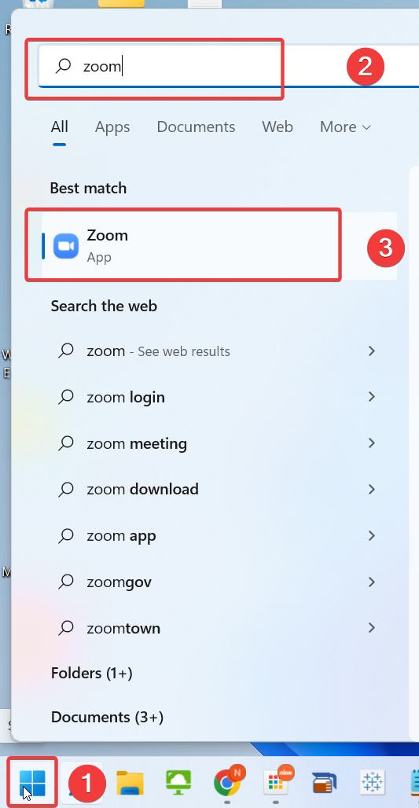

1. Click on your account icon in the upper right-hand corner
2. Select **Check for Updates**

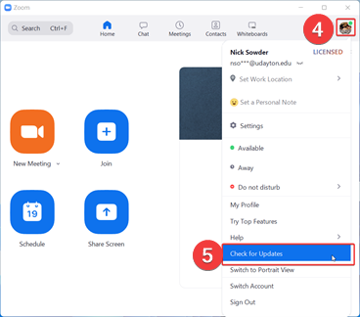

If there are updates available it will install them now. Click **Yes** to any prompts.

# Upgrade Office Using Ivanti Portal

The purpose of this section is to explain how to upgrade and older version of Microsoft Office to the most recent one that is available using the Ivanti Portal. Ivanti is available on all UD-managed computers through a link in the Start Menu. Please note that this upgrade option is only being made available to users who are currently running the Windows 11 operating system.

## Access Ivanti Portal

Use the following process to perform an upgrade of your Microsoft Office. It is recommended that you save all work in Excel, Word, or PowerPoint and close these apps. The upgrade cannot be performed if any Office programs are running. It should also be noted that once the upgrade completes, there is a requirement for the computer to be restarted to finalize the install. The usual UD prompt will appear notifying you to reboot.

1. Move the mouse pointer to the lower-right corner of the screen and click the **Start Button**.
2. In the start menu, click the **All apps** button in the upper-right corner to display all applications

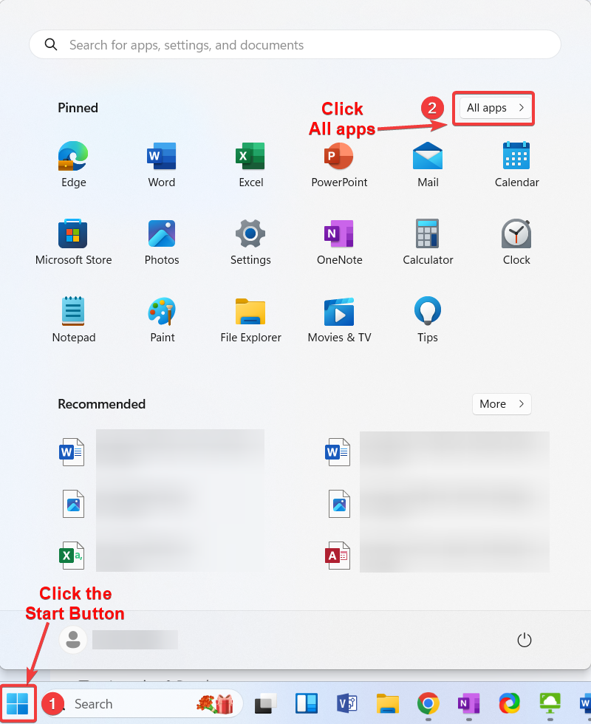

1. Scroll down and click the **Ivanti Management** folder to display the Ivanti apps.
2. Click **Portal Manager**

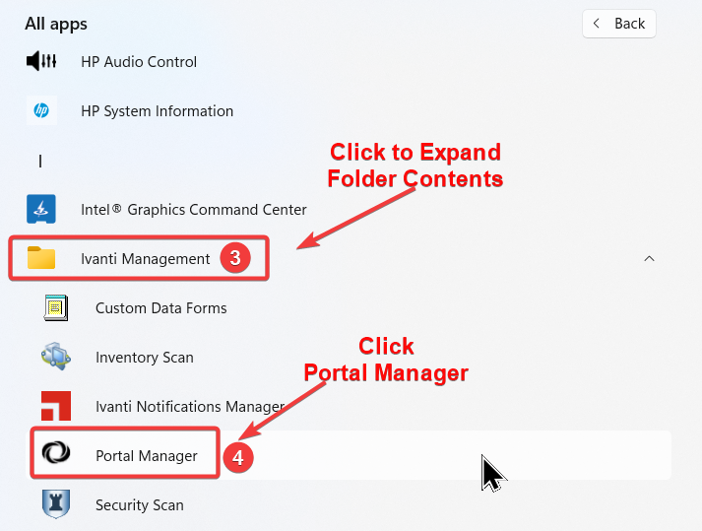

1. In the *Ivanti Portal Manager* window, scroll down and click **Install** for the Microsoft Office entry.

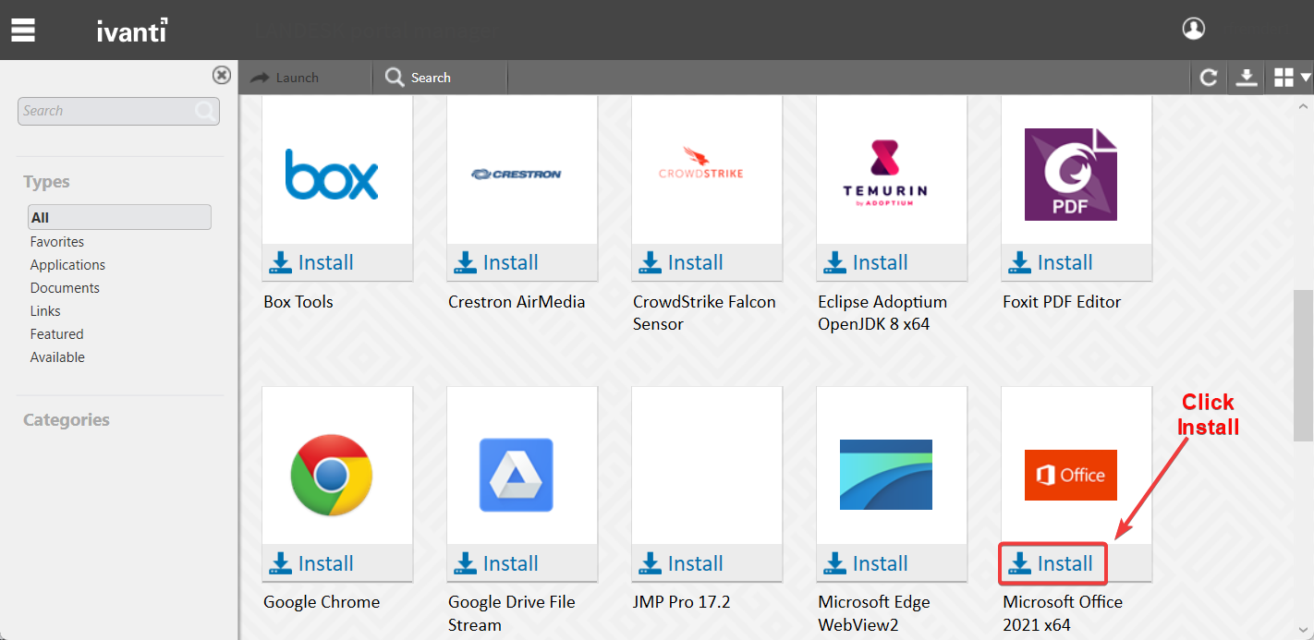

A progress pane will open in the upper-right corner of the Ivanti window. It will first download and then install the new version of Office, removing the old version in the process. This typically takes between 10-20 minutes. When finished, the usual UD reboot prompt will display. It is recommended that you restart at this point. Your Office programs will not function until you do so.

# Using Advancement iPads

The iPad unlock code is “**1850**”

## Log in to Wifi

1. Tap the **Settings** icon

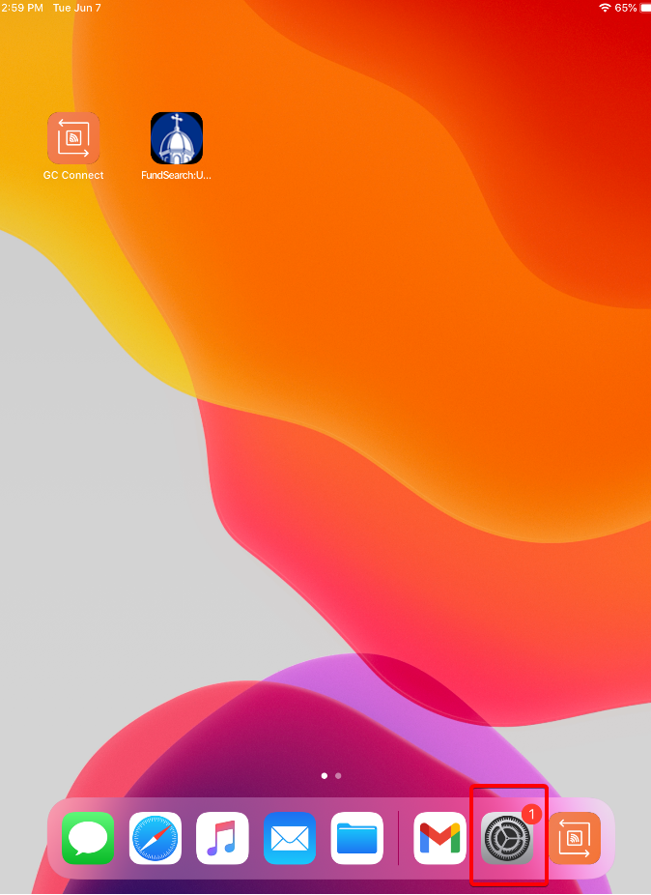

1. Tap **Wi-Fi**
2. Select **UDconnect**

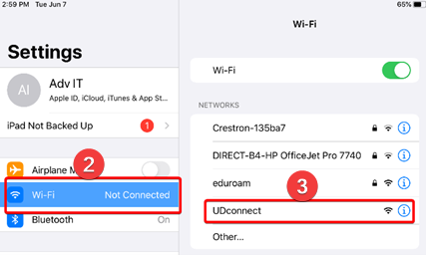

1. Open Safari and go to **logoff.udayton.edu**
2. On the landing page select **Login to UDconnect** under the *Guests*section

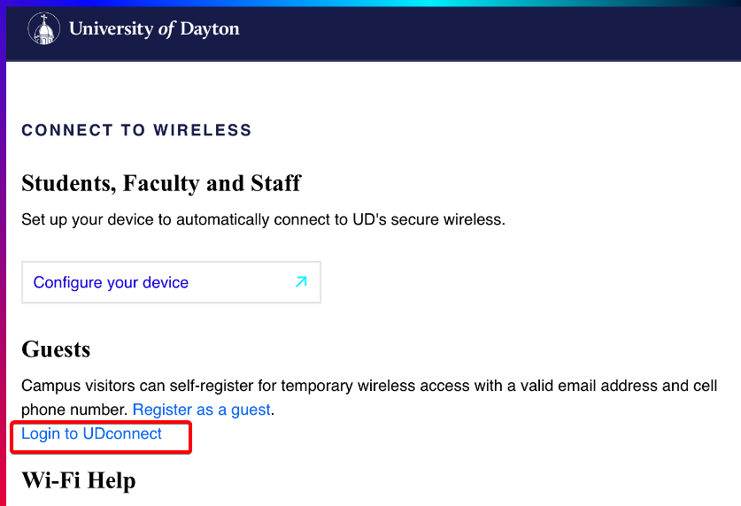

1. Enter your UD username and password and tap **LOG IN**

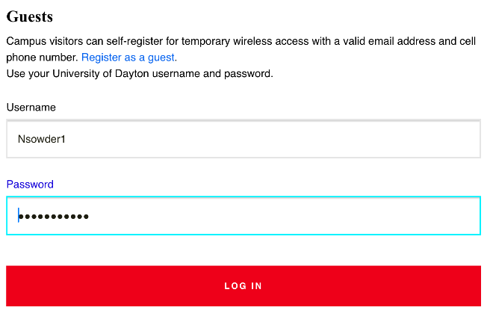

# View Rooms in Google Calendar

There are two ways to view rooms in Google Calendar:

## View rooms when creating an event.

1. Click to create an event in *Calendar* and click on **More options**

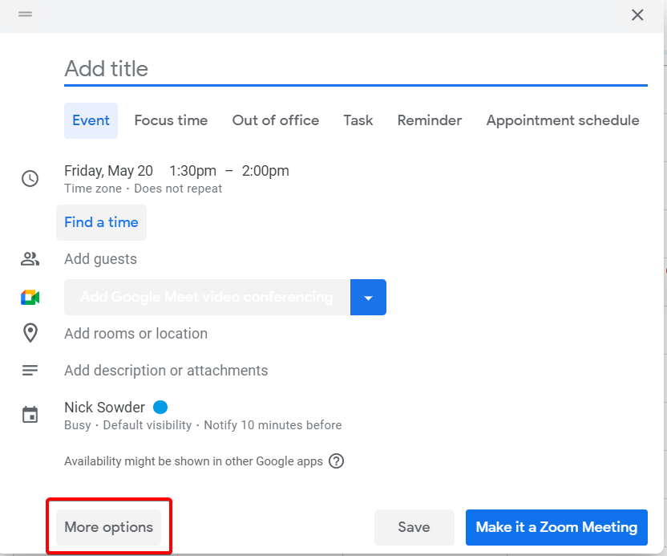

1. Click on the **Rooms** tab. It will show available rooms, you can change the drop down to show all rooms as well.

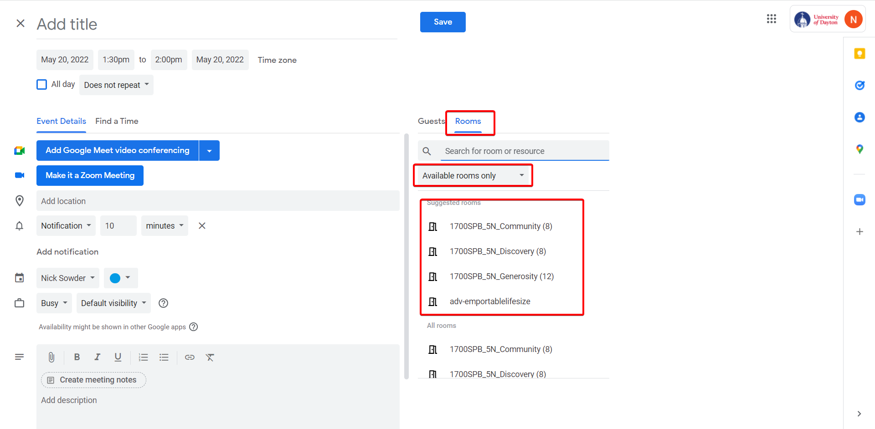

1. You can also search for a specific room by typing in its name

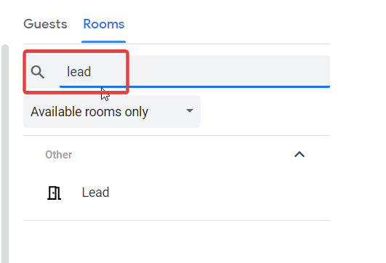

## View rooms from the main Calendar page

1. On the main Calendar screen click on the **+** sign next to *Other calendars*

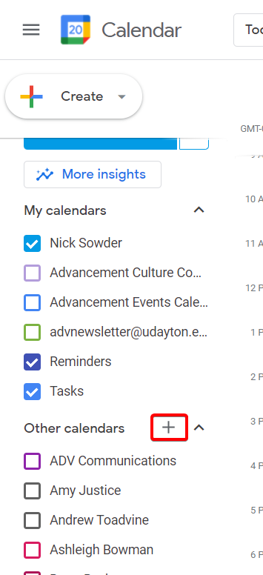

1. In the drop-down menu click **Browse resources**

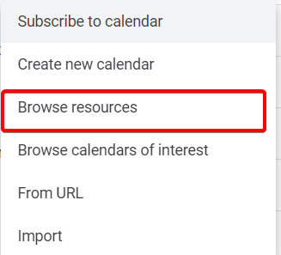

1. You will see the list of rooms and can select the ones you want to show up on your calendar by checking them.

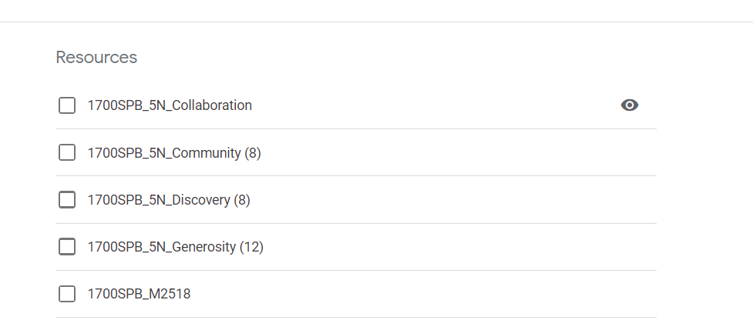

|  |  |  |  |  |
| --- | --- | --- | --- | --- |
| Avaya Aura Messaging Quick Reference Guide | | | | |
|  |  |  |  |  |
| **Message List** |  |  | **Mailbox Commands** |  |
| Play | 2 |  | Login | 8 - 1 |
| Speed Up | 2 - 3 |  | Greetings | 8 - 2 |
| Slow Down | 2 - 1 |  | Disconnect | 8 - 3 |
| Previous Message | 4 |  | Password Change | 8 - 4 |
| Next Message | 6 |  | Go to Message | 8 - 6 |
| Message Commands | 7 |  | Mailbox Options | 8 - 0 |
| Mailbox Commands | 8 |  |  |  |
| Stop Playback / Cancel | # |  | **Greetings** |  |
| Help | * |  | Personal Greeting | 8 - 2 - 1 |
|  |  |  | Extended Absence Greeting | 8 - 2 - 3 |
| **Current Message Playback** |  |  | Personal Verification | 8 - 2 - 9 |
| Skip Back | 1 |  |  |  |
| Skip Forward | 3 |  | **Personal Greeting** |  |
| Call Sender | 9 |  | Review | 8 - 2 - 1 - 2 |
|  |  |  | Record / Rerecord | 8 - 2 - 1 - 5 |
| **Messages Commands** |  |  | Delete | 8 - 2 - 1 - 7 - 6 |
| Reply | 7 - 1 |  | Exit | 8 - 2 - 1 - 4 |
| Play Envelope | 7 - 2 |  |  |  |
| Forward | 7 - 3 |  | **Extended Absence Greeting** |  |
| Reply All | 7 - 4 |  | Review | 8 - 2 - 3 - 2 |
| Compose | 7 - 5 |  | Record / Rerecord | 8 - 2 - 3 - 5 |
| Delete / Restore | 7 - 6 |  | Delete | 8 - 2 - 3 - 7 - 6 |
| Send | 7 - 9 |  | Exit | 8 - 2 - 3 - 4 |
| Message Options | 7 - 0 |  |  |  |
|  |  |  | **Personal Verification** |  |
| **Message Options** |  |  | Review / Play | 8 - 2 - 9 - 2 |
| Urgent On / Off | 7 - 0 - 1 |  | Record / Rerecord | 8 - 2 - 9 - 5 |
| Private On / Off | 7 - 0 - 4 |  | Exit | 8 - 2 - 9 - 4 |
| Timed Delivery | 7 - 0 - 6 |  |  |  |

# GlobalProtect VPN Settings

1. Open the GlobalProtect software on your device by clicking the arrow in the lower right-hand corner by the time. Then click on the globe icon for GlobalProtect.  
    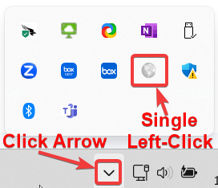
2. Access the software settings by selecting the three-line menu in the top right-corner of the GlobalProtect window.  
   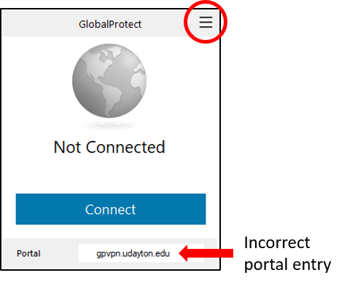
3. Click on the portal listing you need to change (i.e., gpvpn.udayton.edu) and select **Edit**.  
   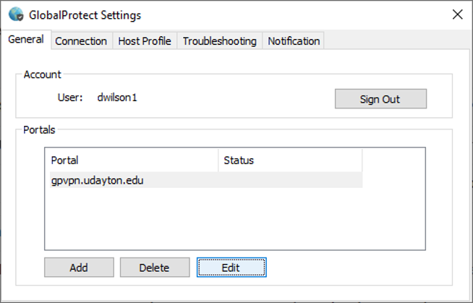
4. Enter the updated portal address: **udvpn.udayton.edu**
5. Click **Save**.

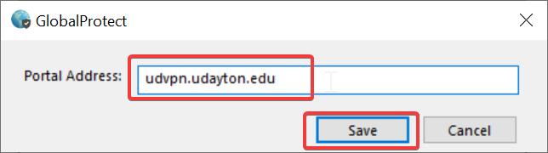

1. Your GlobalProtect software is now pointing to the correct VPN gateway.  
   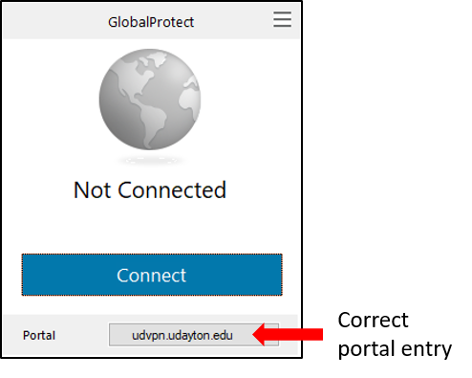

***NOTE:*** *Depending on the version of GlobalProtect that is installed on your computer, the screen may look differently than what is pictured here.*

# **Windows Updates**

**This section is intended for all employees in Advancement. It shows how to manually run Windows updates. The only assumption is that you have a UD-provided computer that runs the Microsoft Windows operating system. Everyone in the division should have this with the exception of our friends in MarComm, who use Apple computers.**

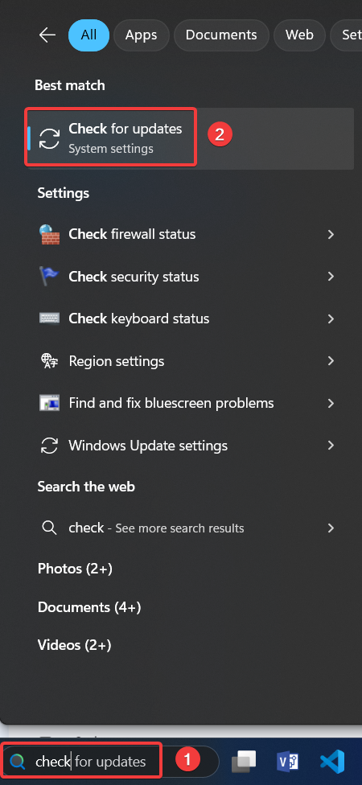**The University of Dayton IT department is responsible for pushing updates to our systems on a monthly basis. However, what they do not push are HP device drivers. Over time, drivers installed on your computer become outdated and can cause odd behaviors such as audio not working, displays acting weird, and general “flakiness” that can make everyday tasks take longer or sometimes not work at all.**

**Historically, Microsoft have made Windows updates available to everyone on the second Tuesday of every month (known as “Patch Tuesday”). They have also been known to push updates out at other times in order to patch what are sometimes referred to as “Zero Day Exploits.” These address urgent updates to the operating system to patch parts of the operating system where bad actors (hackers) can gain access or exploit with a virus.**

**It is therefore recommended to periodically check for Windows updates. The following shows you how to do this.**

## **Run Windows Update**

**While this is a fairly straightforward process, it does take some time to download and install the updates. The good news is that, for the most part, you are able to “set it and forget it” and go about your work.**

1. **In the Search field in the lower left corner beside the Start button, type “Check” (without the quotes)**
2. **Click Check for Updates in the search results**
3. **Click the blue Check for Updates button on the *Windows Update* screen**

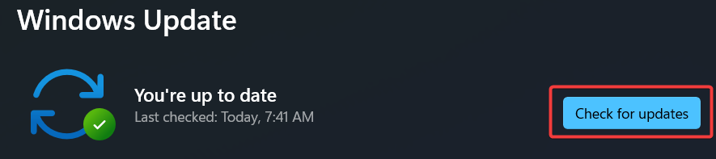

**The following image shows what the screen will look like when the system is downloading and installing the updates.**

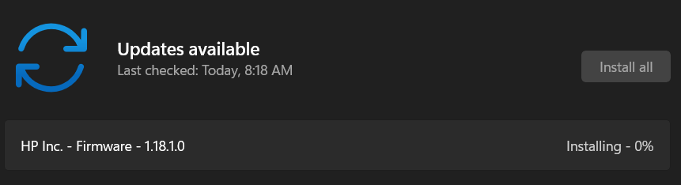

**This next image shows what the screen may look like after all updates are installed and no restart of the system is required.**

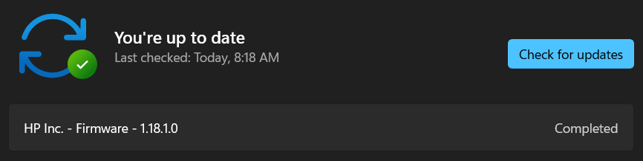

***NOTE: For Firmware/BIOS updates in particular (as shown above), the restart process takes significantly longer. The laptop will appear to be unresponsive and sound like it’s getting ready to launch itself into the stratosphere as the fans ramp up. Please be patient while this process is taking place. It will eventually boot to the BitLocker screen.***

**Make sure that all updates either show *Pending restart* or *Completed*, especially if there were a large amount of updates required. There may be some that show their status as *Retry*. Those are typically duplicate installation attempts of a driver. The following image shows what you will typically see when all updates are completed and the system is ready to restart.**

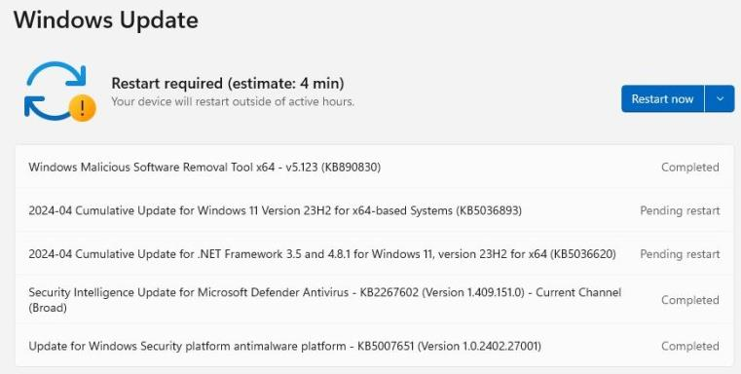

# Zoom Delegate Schedule Privilege

The purpose of this section is to provide the steps required for “Person 1” to delegate scheduling privilege to “Person 2” so that “Person 2” can schedule Zoom meetings on behalf of “Person 1.”

## Setup

Before you transfer ownership of Zoom meetings and webinars, you must assign scheduling privilege to another user.

1. Navigate your web browser to https://go.udayton.edu/zoom
2. Click on **Sign in** and login with your UD username and password (including 2-factor authentication)

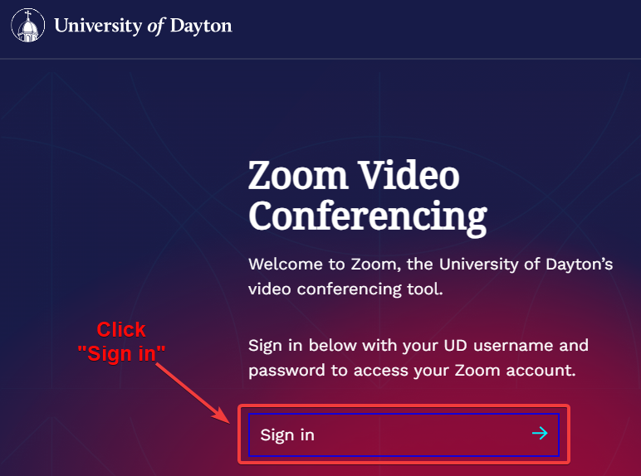

1. Go to the left sidebar and click **Settings**

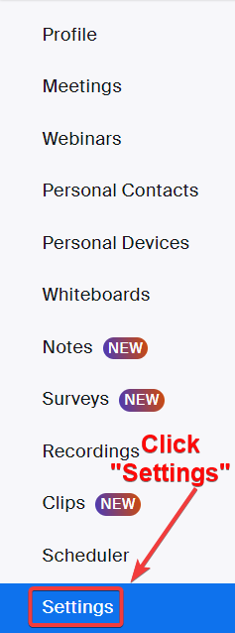

1. Click the *Meeting* tab
2. Select **Other**

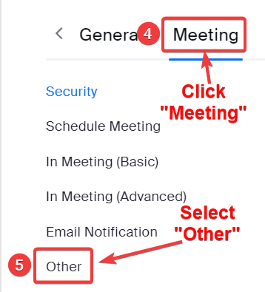

1. Locate *Schedule Privilege*.
2. Next to *Assign scheduling privilege to*, click **Add**.

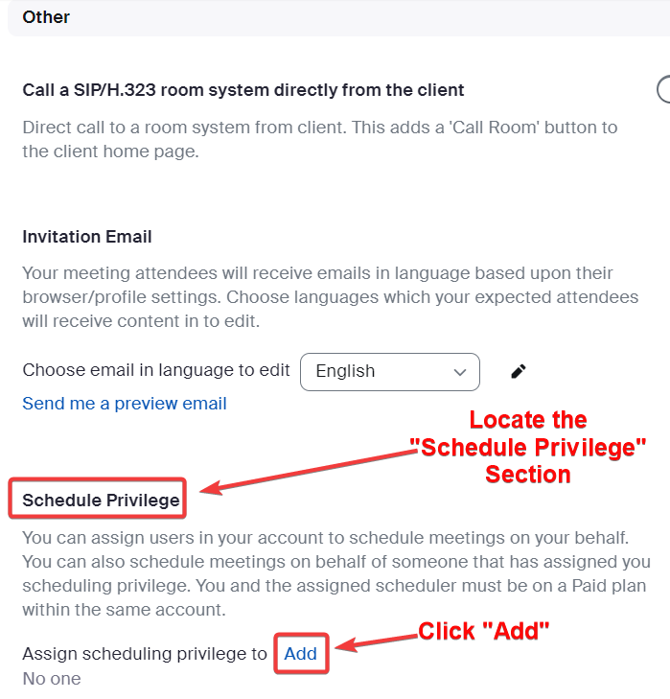

1. Under *Users*, enter the UD email address of the person that you wish to assign scheduling privilege to in the text box.

***OPTIONAL:*** *Click* ***Add*** *to add more users or email addresses to assign scheduling privilege.*

1. Click **Save**.

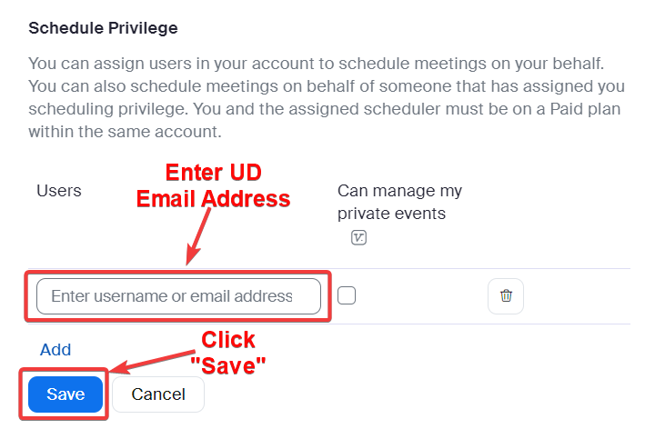

# **Zoom AI Companion**

**The purpose of this document is to let you know that the Zoom AI Companion feature has been approved for use by UDit. The feature was added to Zoom in August with version 5.15, but UDit blocked that feature in order to beta test. After testing and approving, the feature was unblocked and enabled by default. The AI Companion feature has been approved for use by the University. This document gives a very brief description of the features. If you want to turn it off, the steps to do so are included.**

**More information about Zoom can be found on the UD TeamDynamix knowledgebase at the following location:** <https://udayton.teamdynamix.com/TDClient/1868/Portal/KB/ArticleDet?ID=88426>**.**

**Zoom also has a support page specific to the AI Companion located here:** <https://support.zoom.com/hc/en/category?id=kb_category&kb_category=891c5079c3bdf1104b490e8dc00131da>**.**

## **Overview**

**Whether we like it or not, AI is quickly overtaking just about all facets of our lives. Specific to Zoom, there is now an AI Companion piece available and enabled that listens to the meeting and creates a summary that can be shared with just the meeting host, the host and invitees within UD, or all invitees. Additionally, if the meeting is being recorded, the AI can add recording highlights, summaries, smart chapters, next steps and a meeting coach. These features have hover-over help (?) next to them on the settings page that explains what each one does.**

## **Settings**

**So great, right? An AI Companion in your Zoom meetings. How do you get to the Settings page to enable/disable or tweak these features? Here’s how.**

1. **Point your favorite web browser (Google Chrome, right?) to** <go.udayton.edu/zoom>**.**

***NOTE: This resolves to udayton.zoom.us.***

1. **Click the Sign in link as shown below**

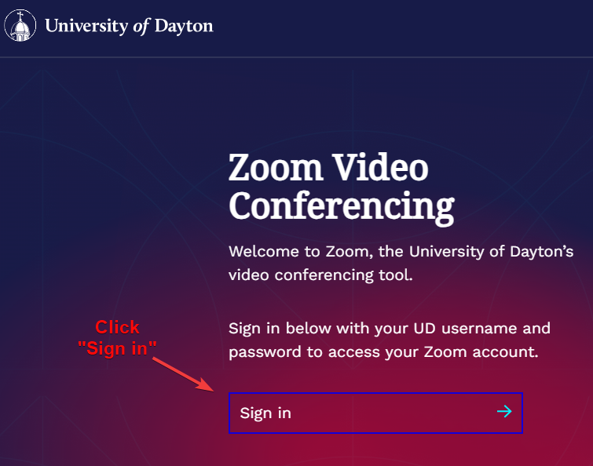

1. **Do the two-factor two-step**

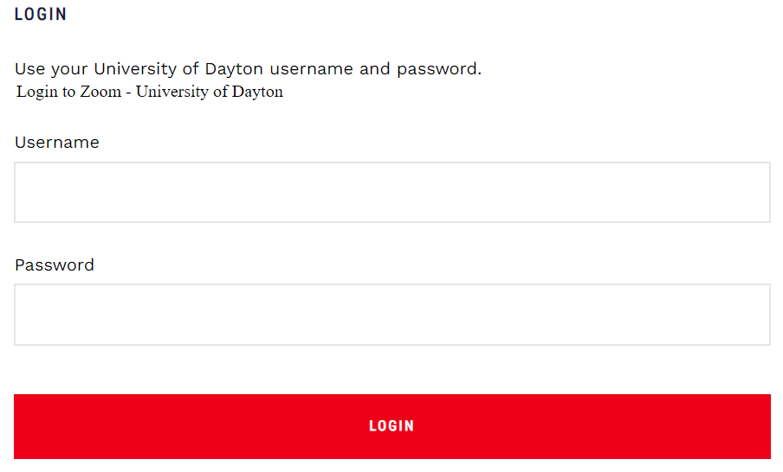

1. **Click Settings in the left-hand column (you may have to scroll down a bit)**

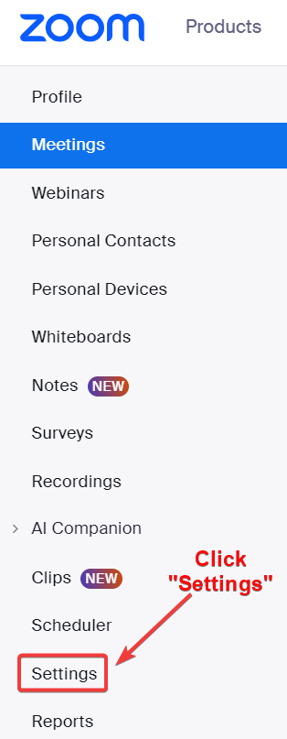

1. **Click the *AI Companion* tab**
2. **Toggle the slider to the left (as shown below) to disable the AI Companion or toggle it to the right to enable it.**

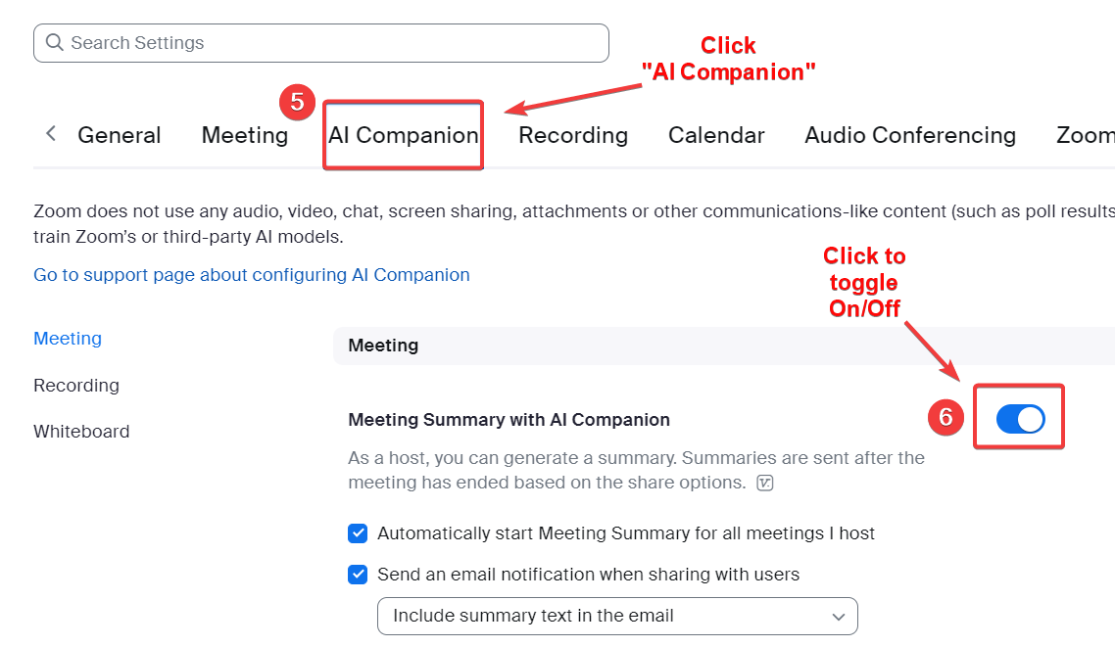

1. **Scroll down to the *Recording* section to enable/disable the Smart Recording feature.  
   *NOTE: Hover over the (?) to view more information about features of Smart Recording***

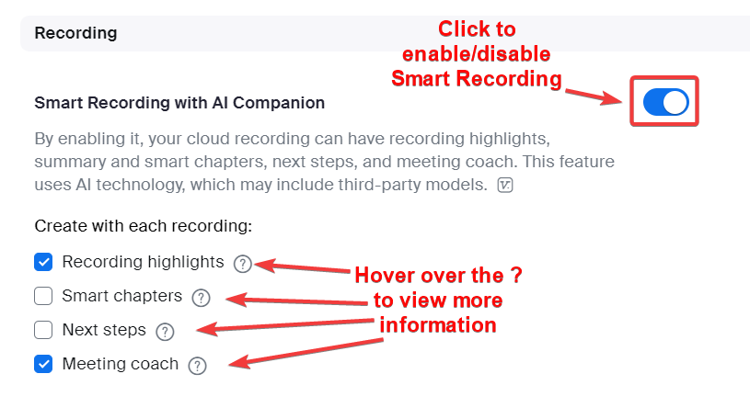

## **Document Revisions, Review, and Approval**

**Revisions**

|  |  |  |  |  |
| --- | --- | --- | --- | --- |
| **Version** | **Date** | **Primary Author(s)** | **Description of Version** | **Status** |
| **1.0** | 11/14/2024 | Fremder | Documents combined and edited | Final |